

Abstract

Healthcare services is one of the essential elements in modern society. They are not only include disease cure and body repair, but healthy status promotion and maintenance on harmony of the systems in our bodies as well. The majority of Hongkongers may have a concept that Western Medicine relieves symptoms for short-term or immediate effect while Traditional Chinese Medicine (TCM) restores the harmony of different parts of our body and keep us healthy in the long run.

Use of information technology (IT) solutions would probably ease TCM practitioners’ daily works as the attentions and needs of TCM are keep increasing. In Hong Kong, no matter what kinds of healthcare services, all the activities will come up with records and documentations. When the business runs for years, the management for records and documentations would become tedious and messy if they are managed manually in hardcopy. A lot of Western Medicine practitioners have adopted some commonly use solutions like The Hong Kong Medical Association’s Clinic Management System 3.0. However, only about a half of TCM practitioners have incorporated IT solution in their business.

There are some major reasons behind that they do not adopt IT solutions. First, there are not enough choice of systems in the market. Second, the existing solution is not cost effective. Third, functions and business rules implemented in some existing solutions may not be useful or may even hinder their work. Fourth, some existing solutions may require a lot of Chinese character typing effort. Last but not least, there is no standard being widely used in the industry for the terminologies used at this moment and the system does not support customization.

Therefore, a system, which is trying to solve the problems above, is developed in this project. The system provides some basic functions like prescription making and patient and system administration, it also provides some advanced functions like suspected overdose alert and drug incompatibility alert. It also supports a certain degree of customization and accept free-text input to solve the problem of no commonly adopted terminology standard. The system can also co-operates with the deliverable of AU-YEUNG Wing Shing’s final year project (project code: 14CS078) to provide value-added function like drug reservation.

Other than the above features, the solution proposed by this project supports multiple clinics and possesses with health records sharing feature. The doctor can login to the system and view their patients’ medical records entered to the system in other clinics by other doctors when permission is granted by patients. This allow the doctor to know the history of their patients and provide a better treatment.

Furthermore, this solution can also help forming the standard for the terminologies used in the TCM industry. All the user can contribute their customized item to the system. The set of items with higher using frequency, which set of items would probably become the standard.

# Acknowledgment

First of all, I would like to thank my project supervisor, Dr. LEE Chung Sing Victor, for his guidance and support on this project. Throughout the year, he provided me with a lot of useful comments on my works and kept track on my project progress.

Next, I would like to thank Dr. YIP Yat Ping, an experienced Traditional Chinese Medicine Doctor, for providing me some professional knowledge. He has shared the methods to make prescriptions and drug classification. He also lent me reference books about drugs and predefined prescriptions. Without his help, the system prototype produced in this project would be done based on imaginations.

I would like to thanks Mr. CHU Pak Hin and Mr. LAM Yiu Ming, Chinese Medicine student and Pharmacy in Chinese Medicine Student respectively, for their useful comments. They shared their experience on using Information Technology solution in Traditional Chinese Medicine Clinic and gave suggestions and feedbacks on the system prototype.

Last but not least, I would like to thank all the individuals who offered their sincere help on this project. Without their help, this project cannot be done smoothly.

# Table of Contents

Abstract 3

Acknowledgment 5

Table of Contents 6

List of Tables and Diagrams 9

1. Introduction 12

1.1. Background Information 12

1.2. Existing Problems 12

1.3. Motivation 13

1.4. Project Objectives and Scope 14

2. Literature Review 17

2.1. HA Clinical Management System 17

2.2. HA Chinese Medicine Information System 17

2.3. KT Chinese Medical Integration System 19

2.4. Clinic Management System by ONE-POS 19

2.5. Summary 20

3. Technology and Tools Reviews 21

3.1. Application Type 21

3.1.1. Windows Application 21

3.1.2. Web Application 21

3.1.3. Conclusion 22

3.2. Reporting tools 22

3.2.1. JasperReports 22

3.2.2. Crystal Reports for Visual Studio 22

3.2.3. Conclusion 23

4. Solution, System and Design 24

4.1. Solution and System Overview 24

4.2. System Functions Overview 25

4.3. Functional Requirement 29

4.3.1. Main System Login / Start Patient Sub-system 29

4.3.2. Patient Management 29

4.3.3. Drug Management 30

4.3.4. Formula Management 30

4.3.5. Clinic Management 31

4.3.6. User Management 31

4.3.7. Patient Queue Management 32

4.3.8. Consultation 32

4.3.9. Reporting 33

4.3.10. Document Reprint 34

4.3.11. Functional Requirements Related to Co-operation between CMCMS and CMPMS 34

4.4. Design 34

5. Detailed Methodology and Implementation 37

5.1. Methodology 37

5.1.1. Drug Name 37

5.1.2. WHO Terminologies and Standards 37

5.2. Implementation 38

5.2.1. Login Form 38

5.2.2. Drug Selection Panel 40

5.2.3. Patient Management 41

5.2.4. Drug Management 45

5.2.5. Prescription Panel 49

5.2.6. Predefined Formula (Formula) 50

5.2.7. Clinic Management 53

5.2.8. User Management 55

5.2.9. Patient Queue 61

5.2.10. Consultation 68

5.2.11. Documents and Reports 78

6. Review 89

6.1. User Testing 89

6.2. Limitations 90

6.2.1. Not Supporting Monitors with Low Resolutions 90

6.2.2. Security Threats when Connecting Database through Internet 90

6.2.3. Change Supporting Database by Users is not Available 90

6.2.4. Customization is not Fully Supported 90

6.2.5. User Authorities and Roles are Fixed 91

7. Conclusion 92

7.1. Achievements 92

7.2. Future Improvement 92

7.2.1. Support Multiple Language for Document Print-outs 92

7.2.2. Auto Generation for User ID and Clinic ID 93

7.2.3. Functions for Patients 93

7.2.4. Implement Penalty Mechanism for Missing Calls 93

7.2.5. Implement Functions for Verifying and Voiding Certificates 93

7.2.6. Allow Customization for Different Clinics 94

7.2.7. Support Different Screen Resolution 94

7.2.8. Improve Drug Selection Panel 94

7.2.9. Connect to eHR 94

References 96

Appendix 99

Appendix A – Monthly Log 99

Appendix B – Patient Status Flow Diagram 102

Appendix C – Prescription Sample 103

Appendix D – Consultation Certificate Sample 104

Appendix E – Sick Leave Certificate Sample 105

Appendix F – Pregnancy Certificate Sample 106

Appendix G – Medical Record Sample 107

Appendix H – Consultation History Sample 108

Appendix I – Suspicious Prescription Listing 109

Appendix J – Statistic Report of Daily Consultation in the Past 30 Days 110

Appendix K – Diagnosis Statistics in the Past 30 Days Sample 111

Appendix L – Patient Listing Sample 112

Appendix M – User Listing Sample 113

Appendix N – Clinic Listing Sample 114

Appendix O – Drug Listing Sample 115

Appendix P – Questionnaire Sample 116

Appendix Q – Questionnaire Result 123

Appendix R – Database Schema “cmcms” 124

# List of Tables and Diagrams

Fig 4.1 Use Case Diagram for the Main System (Human Actors) 28

Fig 4.2 User Rights for Viewing Different Report 34

Fig 4.3 Simplified Stereotype Class Diagram for the Application 35

Fig 4.4 High-level design of the database 36

Fig 5.1 Screenshot of the Login Form 38

Fig 5.2 Screenshot of Drug Selection Panel 40

Fig 5.3 Screenshot of Patient Search Panel 41

Fig 5.4 Screenshot of New Patient Registration Windows Form 42

Fig 5.5 Screenshot for Enquire / Edit Patients’ Personal Particulars 43

Fig 5.6 Database Table of Patient Record 44

Fig 5.7 Screenshot of Drug Management Form with Add Drug Tab Page Selected 45

Fig 5.8 Screenshot of Drug Management Form with Enquire/Edit Drug Information Tab Page Selected 46

Fig 5.9 Screenshot of Drug Management Form with Drug Incompatibility Tab Page Selected 47

Fig 5.10 Database Tables Related to Drug Management 48

Fig 5.11 Screenshot of Prescription Panel 49

Fig 5.12 Screenshot of Add Formula Form 50

Fig 5.13 Screenshot of Edit Formula Form 51

Fig 5.14 Database Tables Related to Formula 52

Fig 5.15 Screenshot of New Clinic Form 53

Fig 5.16 Screenshot of Enquire / Edit Clinic Information Form 54

Fig 5.17 Database Table Clinic 55

Fig 5.18 Screenshot of User Management with New User Tab page Selected 56

Fig 5.19 Screenshot of User Management with Enquire / Edit User Information Tab page Selected (For System Administrator and Clinic Administrator) 57

Fig 5.20 Screenshot of Enquire / Edit User Information Form (For Doctor and Staff) 57

Fig 5.21 Screenshot of User Management with Enquire / Amend User Role Tab page Selected 58

Fig 5.22 Database Tables Related to User Management 59

Fig 5.23 User role table content 60

Fig 5.24 Screenshot of Registration Form for Patient Queue in Patient Sub-system 61

Fig 5.25 Screenshot of Patient Queue Management Form for Clinic Administrator and Staff 62

Fig 5.26 Screenshot of Patient Queue Management Form for Doctor 62

Fig 5.27 Patient Status Flow Diagram 63

Fig 5.28 Database Tables Related to Patient Queue 66

Fig 5.29 Screenshot of Consultation Form 68

Fig 5.30 Screenshot of Symptoms Selection Form 69

Fig 5.31 Screenshot of Differentiation Selection Form 70

Fig 5.32 Screenshot of Diagnosis Selection Form 70

Fig 5.33 Screenshot of Prescription Form 71

Fig 5.34 Screenshot of Add / Delete Stored Phrase for Prescription Using Directions Form 71

Fig 5.35 Screenshot of Doctor’s Remark Entry Form 73

Fig 5.36 Screenshot of Add / Delete Stored Phrases for Doctor’s Remark Form 73

Fig 5.37 Screenshot of Acupuncture Point Selection Form 74

Fig 5.38 Database Tables Related to Consultation 75

Fig 5.39 Prescription clean up time range 77

Fig 5.40 Screenshot of Record / Certificate Issue Form 78

Fig 5.41 Screenshot of Reporting Menu for Clinic Administrator 78

Fig 5.42 Time Validity Regarding Sick Leave Certificate 81

Fig 5.43 Database Tables Related to Sick Leave Certificate 82

Fig 5.44 Database Tables Related to Pregnancy Certificate 83

Fig 5.45 Study Period for Diagnosis Statistics in the Past 30 Days 85

Fig 5.46 System Total Headcount for Diagnosis Statistics in the Past 30 Days 86

Fig 5.47 System New Case Headcount for Diagnosis Statistics in the Past 30 Days 86

Fig 5.48 Clinic Total Headcount for Diagnosis Statistics in the Past 30 Days 86

Fig 5.49 Clinic New Case Headcount for Diagnosis Statistics in the Past 30 Days 87

Fig 5.50 Clinic New Case Included in System New Case Headcount for Diagnosis Statistics in the Past 30 Days 87

# Introduction

## Background Information

Healthcare services is essential in the modern society. They are not only including those treating our diseases and repairing our body, they also include those keeping our body in a healthy status and maintaining the systems in our bodies work well. The majority of Hongkongers may have a concept that Western Medicine is for relieving symptoms while Traditional Chinese Medicine (TCM) is for restoring the harmony of different parts of our body and keeping us healthy in the long run.

Nowadays, staying healthy is one of the hot topics in the city. In addition to the aging problem in Hong Kong, more and more concerns about diseases associated with old age and weakened systems in bodies are being emphasized on. It is claimed in one of the World Health Organization’s Commission on Intellectual Property Rights, Innovation and Public Health Studies that spreading TCM to all the places throughout the world is beneficial for people’s health (Jia, n.d.). From this, we can see the status of TCM keep rising all over the world. Thus, the attention on TCM and the needs of TCM are growing.

## Existing Problems

No matter what kinds of healthcare services, TCM or Modern Western Medicine, they are all about consultation, medication, treatments and procedures. These activities need to be recorded and keep track by documentation. As the population in Hong Kong keeps growing (Census and Statistics Department, 2014), the demand of healthcare services will greatly increases. As the amount of patient increases, the number of records produced will also increase exponentially. Unfortunately, for clinics not using information technology (IT) solution, these records are in written form, which means all these records are in hardcopies. When their businesses just start up, it might be still able to keep and manage few hundreds piles of health records. When their clinics run for years, it may be difficult for them to find and manage thousands decks of patient profiles. It may also be a problem for storing such a huge amount of hardcopy paper records in a clinic as the size for clinics is usually small and rental fee is high.

In this situation, information technology can help. For Modern Western Medicine, there are plenty of solutions for clinical management and the majority of clinics and hospitals have adopt these solutions. For government Western Medicine clinics and hospitals, they all use the Hospital Authority (HA) in-house developed Clinical Management System (Hospital Authority, 2014). For private clinics, they adopted some popular solutions like The Hong Kong Medical Association’s Clinic Management System 3.0 (Food and Health Bureau, 2014). For TCM clinics under the HA’s management, most of them are using the in-house developed system, Chinese Medicine Information System (Health, Welfare and Food Bureau, & Hospital Authority, 2007; Hospital Authority, 2011). However, for private Traditional Chinese Medicine clinics, most of them have not adopted any of the solutions mentioned above. There are less than a half of practitioners in Hong Kong are using IT facilities for their work and only a half of them are satisfied with the currently adopted system (eHealth Consortium Limited, 2010).

## Motivation

There are some major reasons to explain why TCM practitioners have not adopted IT solutions.

First, there may not have enough systems, which can be chosen, in the market (eHealth Consortium Limited, 2009). This may increase the difficulties to find the best solution. For example, considering a clinic which only provides consultation services. Those integrated clinical and sales systems may not fit their business. Thus, the clinic would probably refuse to adopt the solutions.

Second, the cost of many existing solutions is expensive (eHealth Consortium Limited, 2010). Like the case mentioned above, the sales management part is not necessary for the clinic. This means that clinics are paying extra for functions which they do not need. If the cost of the system outweighs the profit or even the benefits they get, this would make the TCM practitioners hesitate to adopt those solutions.

Third, there is no standard being widely used in the TCM industry for the terminologies used at this moment (Food and Health Bureau, 2014) and practices for different doctors may vary (eHealth Consortium Limited, 2010). This would cause inconvenience to users if the system being used does not provide flexibility to do a certain degree of customization.

Fourth, as told by some existing system users, functions and business rules implemented in existing systems may not be useful or may even hinder their work. For example, if the doctor prescribes an herb with dosage larger than the suggested dosage stated in the system, the system will block the doctor from exercising their professional judgment for prescribing the recipe. This would lead to change of treatment and use a suboptimal recipe for the patient.

Fifth, some senior doctors may not be able to type Chinese characters in an acceptable speed or even cannot type Chinese. If the system requires users to type a lot for making prescription and entering history, this would discourage the doctors to use the solution.

Therefore, a system which incorporates more knowledge of the business domain and can be run under acceptable cost is needed.

## Project Objectives and Scope

In Hong Kong, there are different scales of business regarding TCM clinics, from single doctor clinics for consultations only to clinics run by healthcare corporates with multiple doctors on duty at a time and dispensary with self-owned supply chain. In order to fit as much types of business as the system can, the system only handles clinical and medication records part. For sales and dispensary part, it is handled by the deliverable of AU-YEUNG Wing Shing’s final year project (Project Code: 14CS078). When combining the two systems together, they can form an integrated clinic information system. For the mapping between clinics and pharmacies, a mapping table will be maintained manually by database administrator or by another subsystem which outside the scope of AU-YEUNG’s and my project.

In this project, a system that can help users with their daily jobs is developed. The system should be possess with some basic functions including patient management, medical record management and documents generation functions. In order to keep the system can running at low cost, the tools chosen would be freeware. In order to solve the problem raised by no widely adopted standard for terminology used in the industry, the system should allow a certain degree of customization and accept free-text input to fit different users. Furthermore, this system would not stop the user from exercising professional decision. Once suspected decision errors and abnormal situations happens, the system will remind or warn the user instead of stops the action like the case mentioned in Section 1.3 point four. Concerning the Chinese typing ability of users, this system would minimize the chance of using word-typing input.

Nowadays, advanced booking for consultation is quite common in healthcare services. However, the system developed in this project mainly focuses on the consultation part and the related documents generation. This system only maintain a queue for waiting for consultation in each clinic. The booking and scheduling for consultation is assumed to be done by a subsystem and it will insert a record to the queue when the patient arrived.

In the development process, opinions and suggestions from potential users are received so as to optimize the system for practical use.

Concerns of Internet security will not be addressed in this project and adoption of basic existing measure remain, i.e. anti-virus and firewall software.

# Literature Review

In Hong Kong, information technology solutions has been used for daily operation in healthcare sector for a period of time. Just take the example of Hospital Authority, they use their in-house developed Clinical Management Systems since 1995 (Hospital Authority, 2014). It has been run for nearly 20 years. There may be some features or designs that can be learnt for this project. In the market, there are also some solutions for Traditional Chinese Medicine practitioners. However, it is not popular among the industry. From them, we can know what is unfavorable by the users. Thus, a solution that can be applied to various situations can be developed. The following are some related solutions that have been studied.

## HA Clinical Management System

Hospital Authority’s Clinical Management System (HA CMS) is an important system in the HA. It is used by nearly all the HA clinicians providing healthcare services (Hospital Authority, 2011). It provides a system for clinicians to access and create patient records within or outside itself (Solomon, 2008).

HA CMS in phase III development to enhance its function and features providing in the existing system in order to help the HA to provide services with high quality, less errors and high efficiency (Hospital Authority, 2011). In this sophisticated system, it provides drug allergy checking function (Hospital Authority, 2013) and this might also be useful in Chinese Medicine setting. However, some clinicians may find that the system’s user interface keep changing frequently and they cannot adapt to the updated system easily. Thus, it may lead to errors due to clicking the wrong buttons.

## HA Chinese Medicine Information System

Hospital Authority’s Chinese Medicine Information System (CMIS) is the information technology solution adopted by Chinese Medicine Centers for Training and Research (CMCTRs) (Hospital Authority, 2011). According to Leung et al. (2012), it is an integrated system in-house developed by HA for helping clinicians with their daily tasks and sharing data among clinics. Furthermore, it also serves for data collection for researches and studies.

CMIS has implemented functions facilitate all aspects in the daily workflow. For instance, herb-herb interaction and dosage checking functions have been implemented in order to increase the quality and safety of services provided by reducing human errors due to carelessness. What is more, CMIS seems to be the first system developed for Hong Kong TCM industry enforcing a terminology standard. Besides, advanced functions like monitoring the suspected outbreak of infectious diseases also provided in the system which can help in administration-level staff’s work. In order to keep the services quality improving, Key Performance Indicators also implemented in CMIS. As this system is centralized, it can launch policies or standards like International Classification of Diseases 11th Revision (ICD-11) which is going to be release by 2017 (World Health Organization, 2014) with ease. It may be the most comprehensive and useful system that suits corporate level healthcare services providers.

However, there is quite a few number of clinics are in such a large scale. Most of TCM clinics are small to medium enterprise level. Those surveillance and performance monitoring function may not be useful to those common clinics and these functions may requires a large amount of resources, thus increase the cost. From a LegCo document, over five million of Hong Kong dollars were used for the implementation of CMIS in five CMCTRs (Health, Welfare and Food Bureau, & Hospital Authority, 2007), i.e. over one million per clinic. This huge amount of budget seems not affordable by those common clinics.

## KT Chinese Medical Integration System

KT Chinese Medical Integration System (in Chinese: 國泰中醫整合系統) is a system developed in Taiwan. This system is being used by some clinics in Hong Kong. According to the website (國泰電腦有限公司, &國圓科技股份有限公司, n.d.), it is an all-in-one system which can support a whole workflow in clinics, including consultation, drug dispense, point-of-sales and clinicians roster scheduling. It supports varies well-known database systems with different performance, from MySQL to Oracle and Informix. This system can also connect with peripheral systems like queue number calling system which can make the clinic looks modern and give their client more confidence on their services.

This system may be suitable to some large clinics in Hong Kong as it possesses with a queuing system and also have the ability to cooperate with other peripheral systems. However, as this system is developed based on Taiwan’s TCM industry, some of the functions implemented in the system may not be useful in Hong Kong or even tailor-made for Taiwanese.

## Clinic Management System by ONE-POS

The TCM clinic management system developed by ONE-POS is called中醫診所管理系統. It is a Hong Kong local developed system. It provides users with patient management, health record management and point-of-sales functions (IT Force (Hong Kong) Limited, 2014). Based on the functions provided, the system might fit a lot of clinics in Hong Kong. However, from the screen capture provided in the website (IT Force (Hong Kong) Ltd., 2014), it seems they mixed the domain of sales and TCM clinics. The functions buttons of the two domains mixed in one panel and this would make the user confused. From the user interface captured, it can be seen that this system requires a lot of word typing for entering the diagnosis and health records. Since doctors, especially those experienced, may not familiar with word typing and thus cannot use the system.

## Summary

In the systems developed by Hospital Authority, both of them possess with a common feature, which is drug checking. This drug checking function include the checking of drug compatibility and patient allergy history. The HA implement this kind of function in both systems, which may indicate that the function could probably reduce prescription faults due to carelessness. Therefore, this function is considered to be implemented in this project.

Consider the business domain mixing problems, this would be solve by separating the domains by two systems, like the system to be develop in this project only focus on clinical part and the one to be develop by AU-YEUNG’s will be focusing on pharmacy and sale part.

# Technology and Tools Reviews

## Application Type

In business setting, most commonly used devices should be personal computers. More than a half of these computers are using Windows as their operating systems (Net Application.com, 2014). Thus, applications used on these computers are mainly three types, Windows applications, Java applications and web applications. However, Java applications run on Java Virtual Machine which requires more resources and may not be able to run on slow or old computers. Therefore, in this project, only Windows application or web application will be considered as the type of the application.

### Windows Application

Windows application for this system will mainly consist of two parts, client application and server. The server is the connected database. For Windows application, developers can use .NET framework for the development. With the frameworks, useful libraries provided allow programmers to develop the system with nice graphical user interface easily. However, Windows applications can only be run of Windows, thus limited the user scope on Windows users.

### Web Application

Web application for this system will mainly make up of three parts, web browser, web server and database. This type of application can provide a cross platform feature. However, the user interface is rendered by the web browser and different browser or even different version of browser may have different behavior on the same coding. This may trigger some abnormal behavior of objects on the user interface and increase the degree of difficulty on development.

### Conclusion

Windows application is chosen for this system. The system should be stable enough for users to use. It should not depends on third-party software too much as defects in those software will let the errors propagates to the system to be developed, thus decrease the confidence of using the system. Web application depends on web browser while Windows application not. Furthermore, Web application rely on two remote components, web server and database while Windows application only depends on one, which is database. The system to be developed is target for small to middle size clinics and they usually do not have much budget to have back-up or stand-by server for them. Thus, one of this component fails will lead to the system collapse. Also, the network condition may affect the performance in data transfer. More remote components, higher the chance of data transfer. Relying on more remote component may decrease the reliability of the system. Therefore, Windows application in client server model may be more suitable for this project.

## Reporting tools

In the system going to be developed, it possesses with document generation and reporting functions. A reporting tool can help doing these job well with ease. In this project, JasperReports and Crystal Reports will be considered as the writer is more familiar with.

### JasperReports

According to Jaspersoft Community (TIBCO Software, Inc., 2014), JasperReport is one of the popular open source reporting engines. It is written in Java and able to use different kinds of data source. The generated documents can be print or exported to different format including PDF.

### Crystal Reports for Visual Studio

Crystal Report is a well-known commercial tool for reporting. According to its official webpage (SAP, n.d.), it provides a developer version for Visual Studio development environment for free with some restriction on profit making. Developers can design the report layout under the Visual Studio environment and deploy and sell the product without putting extra charges on the client. However, the reports or documents generated requires a freeware, Crystal Reports Viewer, to view and print the reports.

### Conclusion

Crystal Reports for Visual Studio is chosen as the client application will be a Windows application and will use Visual Studio as the integrated development environment. Also, the application will not use Java as the programming language, if JasperReports is chosen, extra container or server will be needed and which the setup is tedious. Therefore, Crystal Reports for Visual Studio would be better for this project.

# Solution, System and Design

## Solution and System Overview

This solution is aimed at supporting clinical operation for all scales of TCM clinic business in Hong Kong, ranging from single-staff clinics to chain store clinics. Different from many existing solutions, which only simply support single user or multiple users at a single clinic, it supports multiple users and multiple clinics.

This system provides health records sharing feature. Nowadays, doctors may work for multiple clinics and their patient may consult them at different clinics. If those clinics keep hardcopy health records or adopted a single clinic system, the health records may not be able to transfer from clinic to clinic and hence doctor may not obtain instantaneous reference to them. Once the clinics join to use this system, health records kept at one clinic can be viewed by doctors in the same clinic or by the doctor in-charge across different clinics. This can let the practitioners know the patient history more and provide better treatments.

Considering the diversity of Chinese typing ability of TCM practitioners in Hong Kong, this system provides some commonly used drug names and terms for users to choose in a systematic way which is different from a lot of solutions in the market, require a lot of text typing effort or choosing items from a messy table. In this system, user can easily locate and choose the term they want by some screen criteria. If the term does not exist in the database, they can still enter it by free-text. Furthermore, the preset terms relating to cases differentiation, symptoms and diagnosis are based on the World Health Organization (WHO)’s WHO International Standard Terminologies on Traditional Medicine in the Western Pacific Region (WHO Regional Office for the Western Pacific, 2007).

Nowadays, TCM not only use drugs for treatment in Hong Kong. Acupuncture as a curing procedure is becoming more and more popular. Therefore, this system can also record the acupuncture points that used for acupuncture in text form. Similarly, the names of acupuncture points are provided for doctors to choose from as mentioned above. The list of points provided is based on the WHO Standard Acupuncture Point Locations in the Western Pacific Region (WHO Regional Office for the Western Pacific, 2009).

Once the electronic health record sharing system developed by the government is ready for the TCM sector and they adopt the same code set or International Classification of Diseases 11th Revision (ICD-11) which is due by 2017 (World Health Organization, 2014), this system can adapt and communicate with it for sharing the health record with less effort or modification as both systems are using some WHO terminologies standards.

## System Functions Overview

Users are identified with four different roles in this system and can access various features and functions according to their classification. The four user roles are System Administrator, Clinic Administrator, Doctor and Staff respectively. In addition, there is a special role which prevent the user for using the system in that associated clinic, namely “No Access”. Each user can possess more than one role under a clinic and across the system. Further discussion see Section 5.2.

The main functions of the system are as follows.

* Main System Login / Start Patient Sub-system
* Patient Management
  + Create new patient records
  + Enquire / Edit patient records
* Drug Management
  + Add drug / sub-drug items
  + Enquire / Edit drug information
  + Edit incompatible drug information
* Formula Management
  + Create new predefined formula
  + Enquire / Edit predefined formula
* Clinic Management
  + Create new clinic records
  + Enquire / Edit clinics information
* User Management
  + Create user accounts
  + Enquire / Edit user account(s) information
  + Assign / Revoke clinic and role to users
* Patient Queue Management
  + Put patient into the queue
  + Remove patient from the queue
  + Assign doctor-in-charge (for staff and clinic administrator only)
* Consultation
  + Enter medical record
  + Make prescriptions
  + Issue certificates and official records
  + Drug stock checking and reservation (co-operate with AU-YEUNG’s final year project system prototype)
* Add / Delete stock phrases for doctor’s remark and instructions for drug usage
* Reporting
* Document Reprint

The functional details of some functions are different for different user role. This is going to be discussed in the Section 5.2.

For System Administrator, he/she can perform patient management, drug management, formula management, clinic management, user management and reporting. As system administrator is a special role who only takes care of system-wide information, therefore, he/she cannot view reports for a specific clinic or perform patient queue management.

For Clinic Administrator, he/she can perform patient management, drug management, formula management, enquire / edit home clinic information, user management, patient queue management, reporting and document reprint.

For Doctor, he/she can perform patient management, formula management, enquire / edit his/her account’s information, reporting, document reprint, patient queue management, consultation and add / delete stock phrases for doctor’s remark and instructions for drug usage. For this type of users, they cannot perform drug management as it can make changes to the parameters for prescription safety checking. In order to prevent doctors from changing the parameters like upper dosage limit to interfere the checking, this function is not provided for doctors only with this role.

For Staff, he/she can perform patient management, patient queue management, enquire / edit his/her account’s information, reporting and document reprint.

This system also provides a patient sub-system, which allow patients to create, enquire and edit their own patient record and enter/leave the patient queue. However, it is not the main focus of this project. It is made in case manpower is not enough in a clinic, so that patient can do these simple tasks on their own.

The following is the use case diagram for this system which can provide a better understanding and overview of functions that the main system intends to provide.

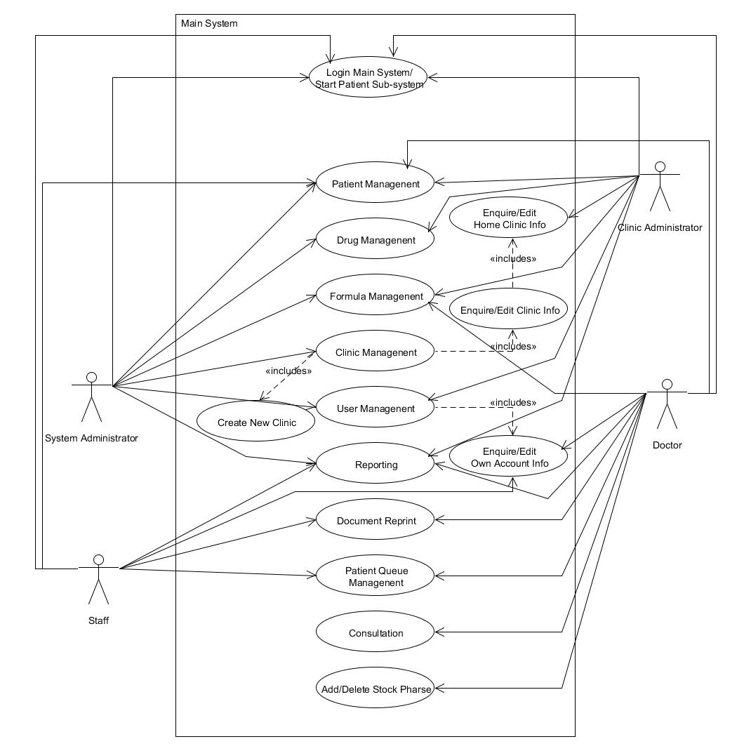

Fig . Use Case Diagram for the Main System (Human Actors)

## Functional Requirement

### Main System Login / Start Patient Sub-system

Staff, Doctor, Clinic Administrator and System Administrator can login or start the patient sub-system by entering their user name and password. As the system can support multi-clinics and multi-role for each user, they also need to provide the clinic and role information before they can login or start the patient sub-system.

### Patient Management

#### Create New Patient Records

All users including those who are using patient sub-system can create new patient records when the patients are not yet registered in the system. They can enter patient’s personal particulars, drug allergy history and the preference for sharing medical history across the system. The data will be stored in the database for further reference. No repeated registration for the same personal identification document (i.e. Hong Kong Identity Card or Passport) is allowed.

#### Enquire / Edit Patient Records

All users including those who are using patient sub-system can view and edit the patient records stored in the system. They can search the patient record by using patient’s Patient ID, personal identification document number and/or phone number. For user using patient sub-system, password is required before they can view the personal particulars and apply changes in order to prevent unauthorized retrieval and alternation on patient records.

### Drug Management

#### Add Drug / Sub-drug Items

System Administrator and Clinic Administrator can add new drug items to the system for making prescription and defining formula. They can enter the drug name, dosage limits, drug category, properties and contraindication for pregnant and Glucose-6-Phosphate Dehydrogenase (G6PD) deficiency patients. If the drug has sub-drug items like processed drug, user can enter those name to the system under the main drug item. No repeated drug names are allowed for registration.

#### Enquire / Edit Drug Information

System Administrator and Clinic Administrator can enquire and edit drugs information stored in the system. They can select the drug item and change the information. They also can mark the drug as deleted to hide the drug item from being used for prescription and formula. For sub-drug items, only the name can be changed.

#### Edit Incompatible Drug Information

System Administrator and Clinic Administrator can specify the incompatibility of drugs in the system. This information is stored in the system for the safety checking for prescriptions.

### Formula Management

#### Create New Predefined Formula

Doctor, Clinic Administrator and System administrator can store some frequently used or useful formula in the system for making prescription with ease. They can give a name for each formula. Each formula consists of drugs with their corresponding dosage and preparation/decoction method. Each formula should have a unique name for identification, therefore no repeated use of formula name is allowed.

#### Enquire / Edit Predefined Formula

Doctor, Clinic Administrator and System Administrator can enquire or edit formula stored in the system. They can change the name and ingredients of the formula. More than that, they can also mark formulas as deleted and make the formula not available for use in prescriptions.

### Clinic Management

#### Create New Clinic Records

System Administrator can create new clinic records. They need to assign a unique ID for the clinic. They also need to enter the clinic name, address and phone number(s) of the clinic as these information will be shown in the documents produced by the system in the clinics. They also can mark the clinic as suspended which means the clinic account is not activated yet.

#### Enquire / Edit Clinics Information

System Administrator can enquire and edit all the clinics information stored in the system while Clinic Administration only can enquire and edit the information of the currently login clinic. As the Clinic ID is a unique identifier for the clinic, it cannot be changed with this system, while other information can be changed.

### User Management

#### Create User Accounts

Clinic Administrator and System Administrator can create new accounts. They need to assign a unique user ID for each user. They also need to enter their name and password and assign a role and clinic for the account. If the account is granted with Doctor Role, the Chinese Medicine Practitioner registration number is also required. They can also set the account to “suspended” when creating the account. For Clinic Administrator, they can only grant user role permission for their own clinic while for System Administrator can grant all roles with all clinics to a user.

#### Enquire / Edit User Account(s) Information

Staff, Doctor, Clinic Administrator and System Administrator can enquire and edit their own account information like name and passwords but not user ID. Clinic Administrator can enquire and change the account information of users which have right to access the system with their clinics. System Administrator can enquire and change account information of all the users. Both administrators can suspend user accounts under their management but not the same account they login with.

#### Assign / Revoke Clinic and Role to Users

System Administrator can assign and revoke roles and clinics to all users but cannot revoke administrator roles of themselves. Clinic Administrator can assign roles of their clinic to all users and revoke assigned roles of their own clinics but not the administrator role of themselves. For adding Doctor Role, the user should have Chinese Medicine Practitioner registration number stored in their user account record.

### Patient Queue Management

Each clinic maintains their own patient queue for waiting for consultation. Staff, Doctor and Clinic Administrator can add and remove patient in the queue. When calling patient, Staff and Clinic Administrator can assign doctor in-charge to the patient while doctors will assign themselves as the doctor in-charge automatically.

### Consultation

#### Enter Medical Record

Doctor can enter medical record when meeting with patients. They can enter the symptoms, differentiation and diagnosis for the consultation. Also, they can record the acupuncture points that the patient received treatment. They can enter some remarks for the patient as a reminder. They can also give prescription(s) for the patients.

#### Make Prescriptions

Doctor can make prescriptions for patients during consultation. They can use formula as template for making prescription. They also can make up a prescription by their own using drugs stored in the system. Prescription safety check will be done at the end of the process. User will be notified for any violation of rules. User can choose to make changes to the prescription or not.

#### Issue Certificates and Official Records

Before the end of the consultation, the doctor can issue prescriptions, sick leave certificate, consultation certificate, pregnancy certificate and medical records when necessary. The information on the documents follows the common practices or standards of the industry.

#### Drug Stock Checking and Reservation (Co-operate with AU-YEUNG’s System)

When the Chinese Medicine Pharmacy Management System (CMPMS, AU-YEUNG’s final year project system prototype) works together, this system can query the stock by calling CMPMS’s function. If the stock availability is low or zero, a reminder will be shown to the doctor. If all the prescription(s) do not contain drug which is out of stock, the system can make a function call to CMPMS for drug reservation.

### Reporting

Different users can view different reports. It including listing report and statistical report. The rights for viewing the reports are as follows:

|  |  |  |  |  |
| --- | --- | --- | --- | --- |
| **Reports/Role** | **System Admin.** | **Clinic Admin.** | **Doctor** | **Staff** |
| User Listing |  |  |  |  |
| Clinic Listing |  |  |  |  |
| Drug Listing |  |  |  |  |
| Patient Listing |  |  |  |  |
| Suspicious Prescription Listing |  |  |  |  |
| Statistic Report of Daily Consultation in the Past 30 Days |  |  |  |  |
| Diagnosis Statistic in the Past 30 Days |  |  |  |  |

Fig . User Rights for Viewing Different Report

### Document Reprint

Staff, Doctor and Clinic Administrator can (re-)issue documents. These include Complete Medical Records, Single Consultation Medical Records, Prescriptions, Consultation Certificate and Sick Leave Certificate.

For Sick Leave Certificate, the issue time should be with-in 24 hours after consultation ends.

### Functional Requirements Related to Co-operation between CMCMS and CMPMS

Account in this system (CMCMS) can be used in CMPMS without another registration and vice versa. Only granting right is required. CMCMS can query CMPMS on drug availability or do drug reservation in the associated pharmacy of the clinic for prescriptions. CMPMS can query on drug items which exist in CMCMS. CMPMS can get prescription details from CMCMS by prescription IDs or other unique data combination. CMPMS can also query on procedures/treatments done in a consultation.

## Design

This system is in server client model. All the windows can instantiate corresponding data manager to get the required entities or prepare data for entering the database. The data manager classes can instantiate a database manger which is responsible for communication between the windows application and the database. The data manager objects can create entities objects by data retrieved by database manager and pass to the calling windows form GUI. The following simplified analysis stereotype diagram illustrates the concepts.

Login

Corresponding

Main Menu

Patient Manager

User and Clinic

Manager

Consultation

Manager

Drug

Manager

Drug

Object

Permissible

Value

Objects

Functional

Windows

Form

Patient

Object

User

Object

Clinic

Object

DB

Manager

DB

Fig . Simplified Stereotype Class Diagram for the Application

For database design, it consists of 3 schemas, namely cmcms, cmcis and cmpms. Cmcms is the main database schema for this system. Cmcis is the schema for sharing data between this system and CMPMS. Cmpms is the schema belongs to CMPMS, which is designed and implemented by AU-YEUNG Wing Shing. CMCMS can use the schemas cmcms directly for retrieving data. It also can retrieve data from schema cmpms through calling stored procedures in cmcis which are written by AU-YEUNG.

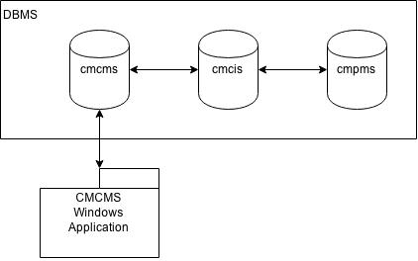

Fig . High-level design of the database

# Detailed Methodology and Implementation

## Methodology

### Drug Name

Drug names are not strictly standardized in the TCM industry in Hong Kong. In this system, a drug list is provided for users to select from for entering drug related information like prescriptions. In order to provided drug names which can be recognized by most of the users in Hong Kong, the drug items information incorporated to the system is based on a reference book, 常用中藥學 (成都中醫學院, 1964),which applicable for the professional examination.

### WHO Terminologies and Standards

In this system, terminologies for diagnosis, symptoms, acupuncture points, treatment methods and case differentiation is provided for user to select in order to reduce the word typing effort when using the system. However, there are no agreed standard being used in the TCM industry in Hong Kong.

For the current systems in the HA, the terminologies for diseases and procedures are following some International standards. For Modern Medicine, International Classification of Diseases (ICD) 9th Revision (ICD-9), ICD-10, ICD-9-Clinical Modification are used. However, traditional medicine is not yet covered by the currently published version, i.e. ICD-10, and it will be covered in the new version of ICD, ICD-11 which is due by 2017 (World Health Organization, 2014). At the moment, one of the standard using by the HA for TCM terminologies is another standard published by WHO, WHO International Standard Terminologies on Traditional Medicine in the Western Pacific Region (ZIEA, 2012).

In this system, acupuncture points also be recorded if the patient has received acupuncture as treatment. Therefore, this system provided a list of acupuncture points for doctors to choose from. World Health Organization has published a standard for acupuncture named WHO Standard Acupuncture Point Locations in the Western Pacific Region (WHO Regional Office for the Western Pacific, 2009). This standard listed out 361 acupuncture points that used for education, research, medication and knowledge exchange. This standard should be suitable for Hong Kong’s Practitioner.

In the foreseeable future, the electronic health record (eHR) sharing system developed by the Hospital Authority (HA) for the Hong Kong Government will ready for the TCM industry. In order to enable data sharing from the system to the eHR system which ease, WHO standards should be used. At the development time of the system prototype, ICD-11 beta is available. However, the data is keep changing and it is not yet used by the HA. As both standards are developed by WHO, they should not be contradicting to each other and could be easily convert from one to another. Therefore, WHO International Standard Terminologies on Traditional Medicine in the Western Pacific Region (WHO Regional Office for the Western Pacific, 2007) and WHO Standard Acupuncture Point Locations in the Western Pacific Region (WHO Regional Office for the Western Pacific, 2009) would be used as the reference for the terminologies and acupuncture points stored in the system in advanced respectively.

## Implementation

### Login Form

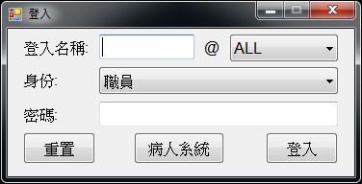

Fig . Screenshot of the Login Form

User can do the following by using this form:

* Login to the system
* Start patient sub-system

#### Login to the System

System Administrator, Clinic Administrator, Doctor and Staff can enter their user name and password and choose the login clinic and user role to login the system. The reason why users are required to choose the login clinic and user role to login is due to the same user can work in multiple clinics with multiple roles. This will be further discussed in Section 5.2.8.1. When the combination of the four items is incorrect, an error message will be shown. At the first time of using this system, only the system administrator account (user name: SYSADM) with access clinic ID “ALL” is exist in the system. When successfully login, the client application will store the user and clinic information as data for other windows forms until logout.

#### Start Patient Sub-system

Clinic Administrator, Doctor and Staff can Start Patient Sub-system and show the Patient’s Menu to patients for self-access to register, edit personal particulars and queue up. This action also require user to enter the user name, clinic ID, user role and password in order to ensure the application is launched with the correct clinic with an authorized person.

### Drug Selection Panel

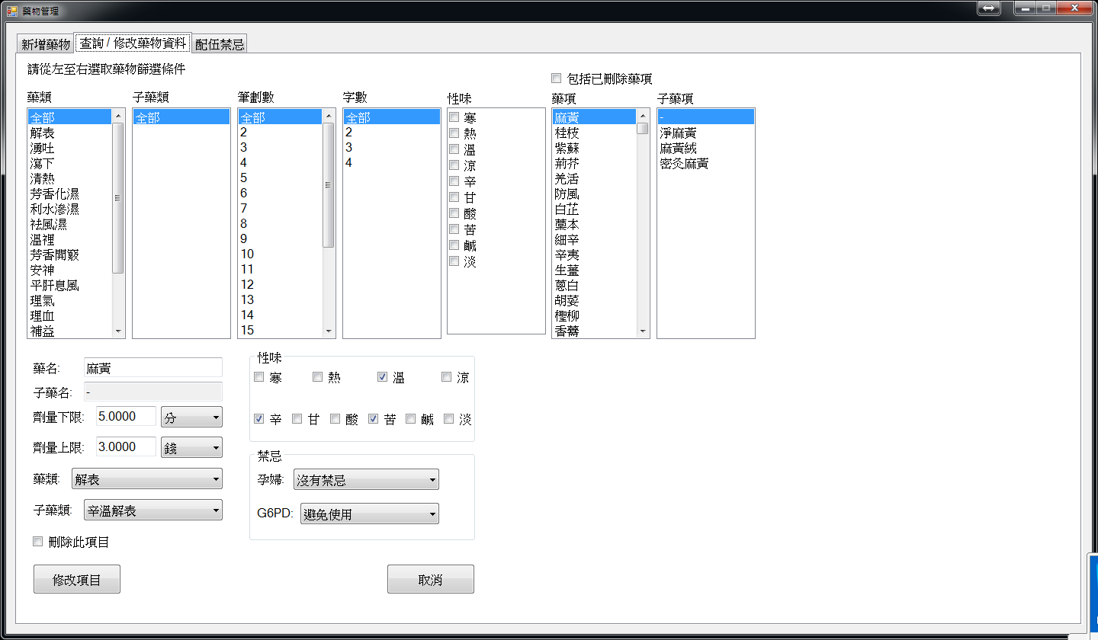

Fig . Screenshot of Drug Selection Panel

This panel is used for user to select drug and/or sub-drug without typing any words. The checkbox for showing deleted drug and the list box for sub-drug items is hided from user if it is not applicable to the function. Change of the value selected for each criteria list box will lead to update of permissible values on its right. Each list box associated with a stored procedure for retrieving the permissible values.

### Patient Management

#### Patient Search Panel

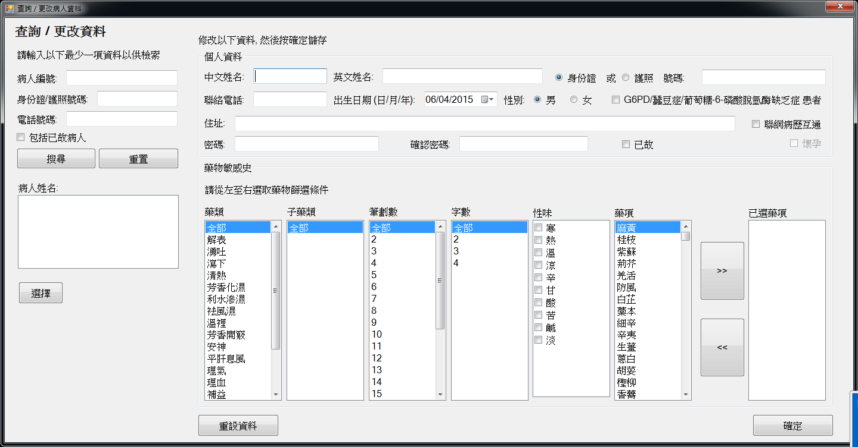

Fig . Screenshot of Patient Search Panel

All the functions that related to patient search are using the above panel. It allows user to search patient with the patient’s patient ID, personal identification document number and phone number. Any patient records match all the criteria entered will be shown in the list box at the bottom for user to select. By default, the result will include any patient who are marked as deceased. A checkbox is provided for include those result.

#### New Patient Registration

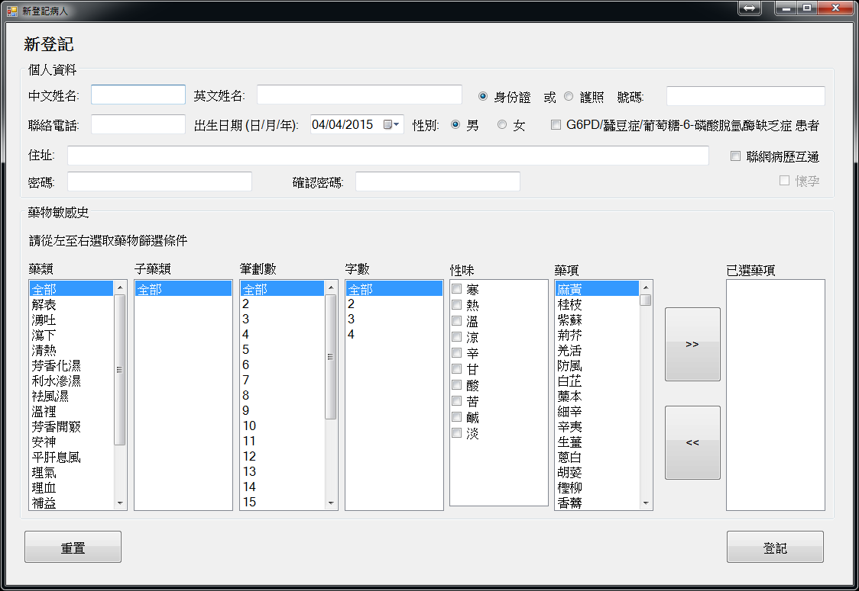

Fig . Screenshot of New Patient Registration Windows Form

This form can be used by all users including those using Patient Sub-system. User can enter patient’s particulars including Chinese name (optional), English name, personal identification document number (Hong Kong ID Card or passport number), phone number, date of birth, gender, address and password. Two checkboxes will be provided for user to check if the patient has Glucose-6-Phorsphate Dehydrogenase Deficiency (G6PD) or pregnant. The pregnant checkbox will on enabled when the gender is chosen as female as it is extremely rare for male to become pregnant. This status can be change by doctor during consultation no matter the patient is male or female. If the patient has known drug allergy history, the drug name can be entered to the system by choosing from the drug selection panel. Before passing the data to the database, the password will be hashed with SHA-256. Once the register button is pressed, if the personal identification document selected is HKID, the system will check whether the HKID number is valid. If it is invalid, the registration will be rejected. Then the system will check whether the identification document number exist in the system. If exists, the registration will be rejected. If the patient is successfully registered, the record will be inserted to the patient record table in the database and the patient ID will be shown on the screen. All the checking is done in a stored procedure before inserting the record to the table.

#### Enquire / Edit Patient Information

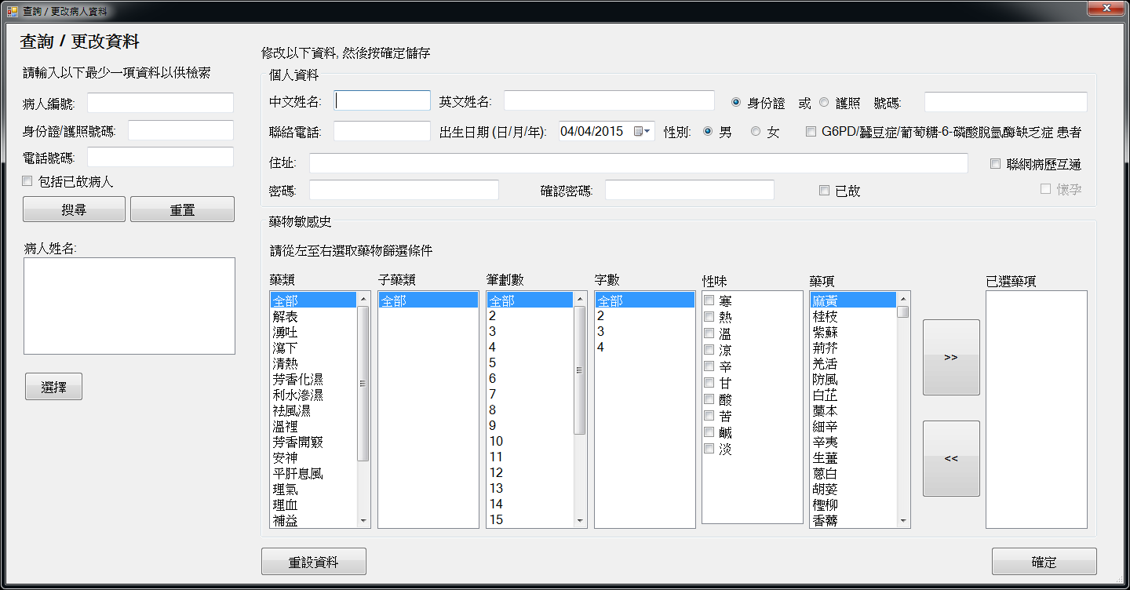

Fig . Screenshot for Enquire / Edit Patients’ Personal Particulars

This form can be used by all users including those using Patient Sub-system. First, user can search the patient using the patient search panel. A checkbox will be provided for searching patients who are marked as deceased and the checkbox is hided when using Patient Sub-system. The search result will be shown in a list box. User can select the record that is needed. Then, the patient information will be shown in a similar panel as the one in patient registration, the only different is a deceased checkbox is available for staff to mark the patient as deceased and that checkbox is hided when using Patient Sub-system. Before passing the data to the database, the password will be hashed with SHA-256. When confirm button is clicked, the database record will be updated. For using Patient Sub-system, user will be requested to enter the patient’s password before showing the information and confirm the change in order to prevent unauthorized access and alternation on patients’ personally identifiable information (PII).

#### Database

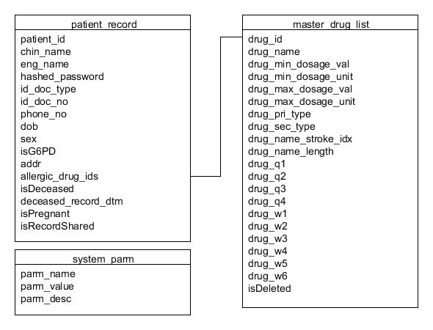

Fig . Database Table of Patient Record

Patient records are stored in the patient record table (patient_record). The data are includes patient ID (patiend_id), Chinese name (chin_name), English name (eng_name), hashed password (hashed_password), personal identification document type (id_doc_type), personal identification document number (id_doc_no), phone number (phone_no), date of birth (dob), gender (sex), flag for G6PD (isG6PD), address (addr), drug allergy history (allergic_drug_ids), flag for deceased patient (isDeceased), date/time of deceased recored (deceased_record_dtm), pregnant flag (isPregnant) and flag for sharing medical records (isRecordShared). The patient ID is generated by a function based on the value of an entry in the system parameter table (system_parm). The entry is used for holding the largest / latest patient ID, and the entry with parameter name (parm_name) “pat_id_cnt”. After each generation of patient ID, the parameter value (parm_value) will be updated to the one just generated. This generation method can make the generation of patient ID more flexible, not restricting it only be integer serial number. It can be change to other generation method easily.

For drug allergy history, it is stored in VARCHAR format. It is formed by concatenating all the allergic drug IDs (see Section 5.2.4.4) with “||” as delimiter. For this table, read is more than write. Creating an extra table would causing extra join operation, which may increase the seek time. Thus, keeping it together with the patient record in this format may be a better choice for a better performance.

### Drug Management

#### Add Drugs

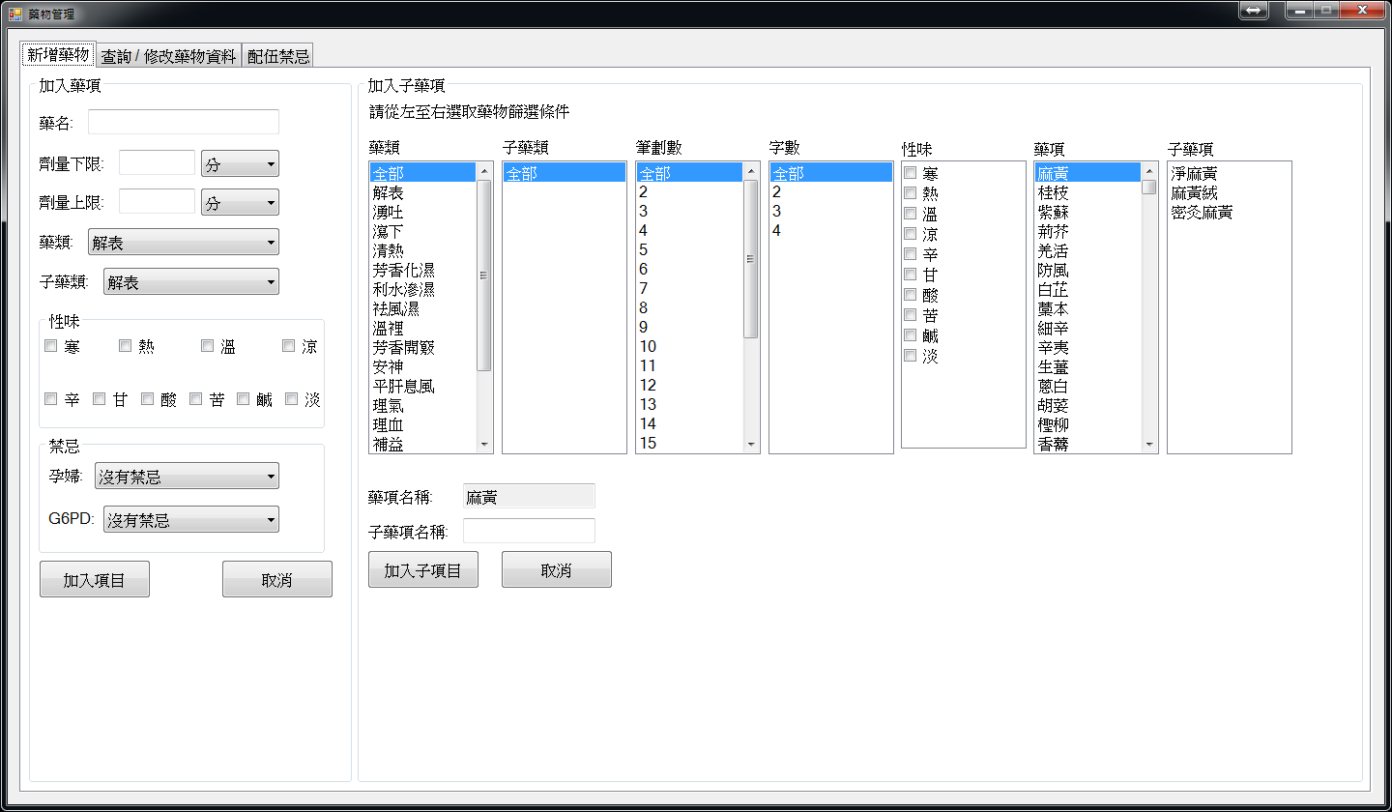

Fig . Screenshot of Drug Management Form with Add Drug Tab Page Selected

System Administrator and Clinic Administrator can enter drug entry to the system by this tab page. They can enter the name, dosage limits, category, properties and contraindication of the drug. After clicking the added button, a stored procedure in the database will be called and check whether the drug name is exists in the database and the dosage limits are valid. If the name exist or invalid dosage limits, the entry will be rejected. If not, the entry will be added to the database and the corresponding drug name will be shown in the drug selection panel. If the drug item possesses with sub-drug, for example prepared drug, user can select the drug item by the drug selection panel and enter the sub-drug name into the textbox provided. Those sub-drug name cannot be repeated.

#### Enquire / Edit Drug Information

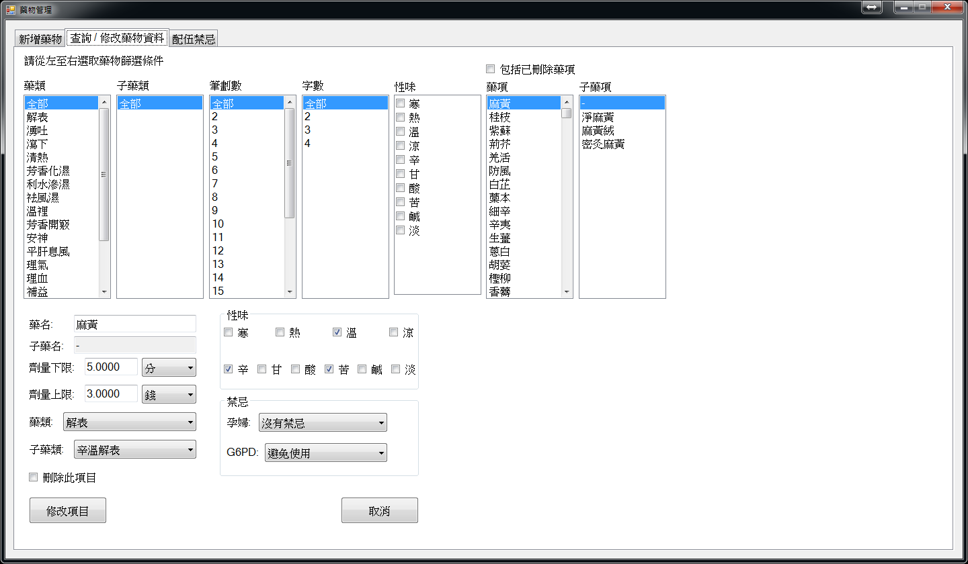

Fig . Screenshot of Drug Management Form with Enquire/Edit Drug Information Tab Page Selected

System Administrator and Clinic Administrator can select the drug or sub-drug to view or edit information with the above tab page. For amending drug items, all the information except sub-drug name can be changed. After clicking the amend button, a stored procedure in the database will be called. Checking on dosage limits will be done. If the data are valid, the record will be updated. For sub-drug items, only the sub-drug name can be changed. Both drug and sub-drug items can be marked as deleted to make them not available for using in formula and prescription. In the formula contain the deleted drug, the formula will be marked as system suspended and cannot be used in prescription.

#### Drug Incompatibility

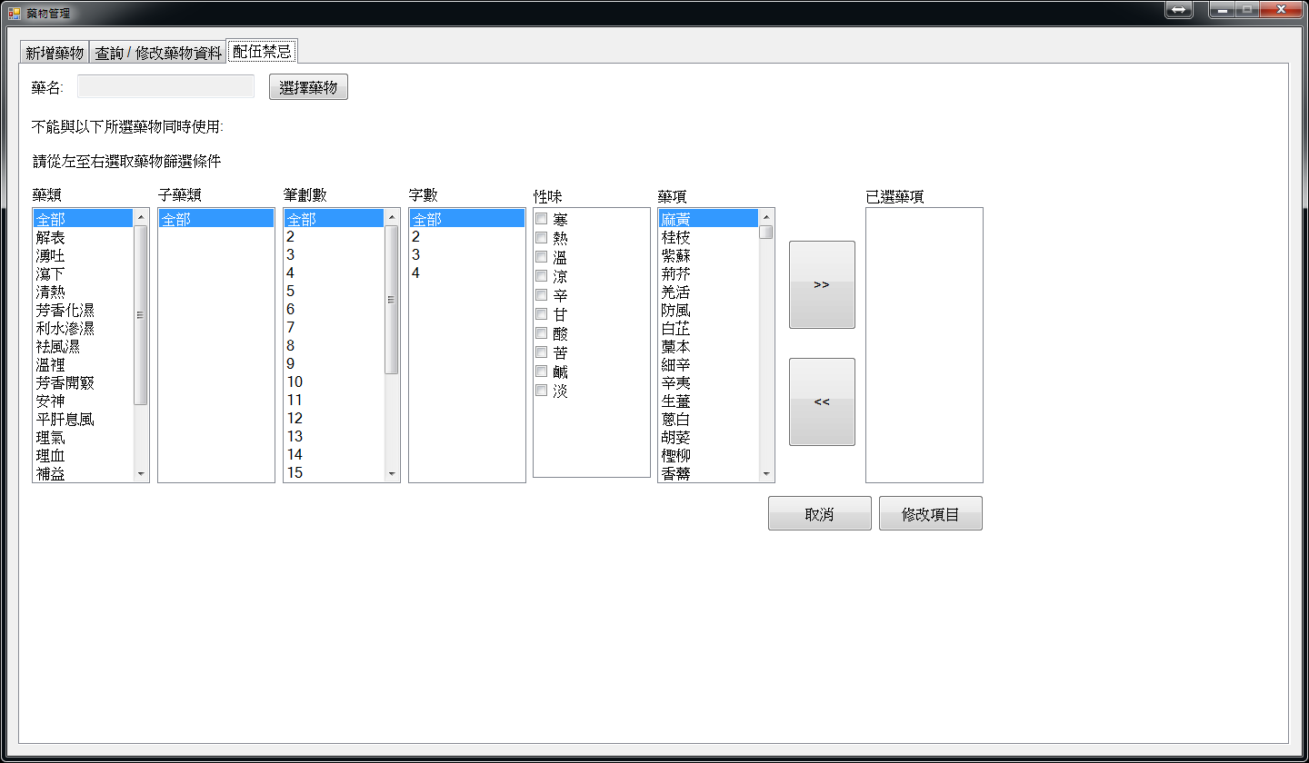

Fig . Screenshot of Drug Management Form with Drug Incompatibility Tab Page Selected

System Administrator and Clinic Administrator can specify the drug-drug interaction contraindication in this tab page. When clicking the select drug button, a drug selection panel will be shown for user to select drug. Then, they can select drug(s) that are not compatible with the selected one in the above panel. Drug cannot select more than once and the drug cannot be incompatible with itself. When amend button is clicked, the incompatible record will be added / removed in the both drug records.

#### Database

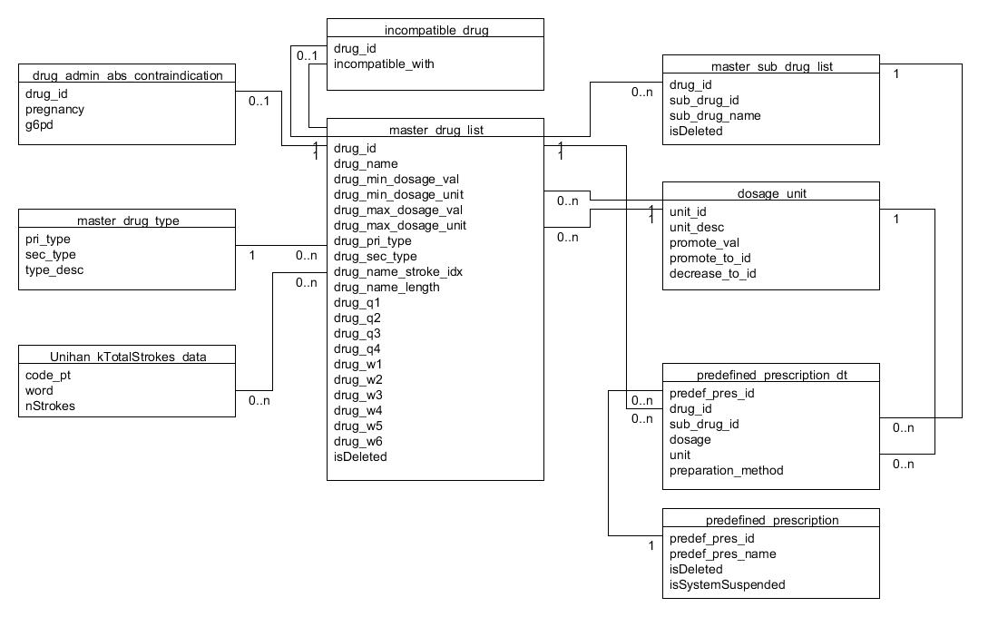

Fig . Database Tables Related to Drug Management

Drug data will be stored in the database with two tables. One is called master drug list (master_drug_list) and another one is called master sub-drug list (master_sub_drug_list). When the drug is prepared with different method, its name and usage may have different. The sub-drug name (sub_drug_name) and sub-drug ID (sub_drug_id) of that prepared drug will be stored in the master sub-drug list with its original drug ID (drug_id). And its original drug information will be stored in the master drug list. The information including its properties, suggested dosage range. For stroke number of the first character of the name, it will be based on the data provided by Unicode, Unihan_DictionaryLikeData which stored in the table Unihan_kTotalStrokes_data. For primary drug type (drug_pri_type) and secondary drug type (drug_sec_type), they are based on data in master_drug_type where sec_type is equals to 0 and not equal 0 respectively. For unit of the dosage limits (drug_min_dosage_unit and drug_max_dosage_unit), they are the unit_id stored in the table dosage_unit where dosage_unit stored the unit name, ID and unit conversion related data.

If the drug should be avoided or must not be used for G6PD or pregnant patient, a record will be added to the absolute contraindication table (drug_admin_abs_contraindication) with the drug ID and the level of contraindication (pregnancy and g6pd).

For drug incompatibility data (incompatible_drug), the drug ID is based on the drug ID stored in master drug list. The incompatible_with field is a varchar data make up by concatenating those incompatible drugs’ ID with “||” as delimiter. When the stored procedure responsible for update this table added “Drug A is incompatible with Drug B”, the reverse combination “Drug B is incompatible with Drug A” will also be added to the table. And it will do the similar action for removal of the incompatibility rules. The data are stored in the above format can allow the matching of drug item IDs using and string functions like regular expression and replace instead of complex manipulation or complicated SQL statements.

If the isDeleted field of drug or sub-drug changed to “1”, i.e. marked as deleted, the related formula (entries in predefined_prescription) will be marked as system suspended (isSystemSuspended change from “1”), and vice versa. Further discussion on formula will be in Section 5.2.6.3.

### Prescription Panel

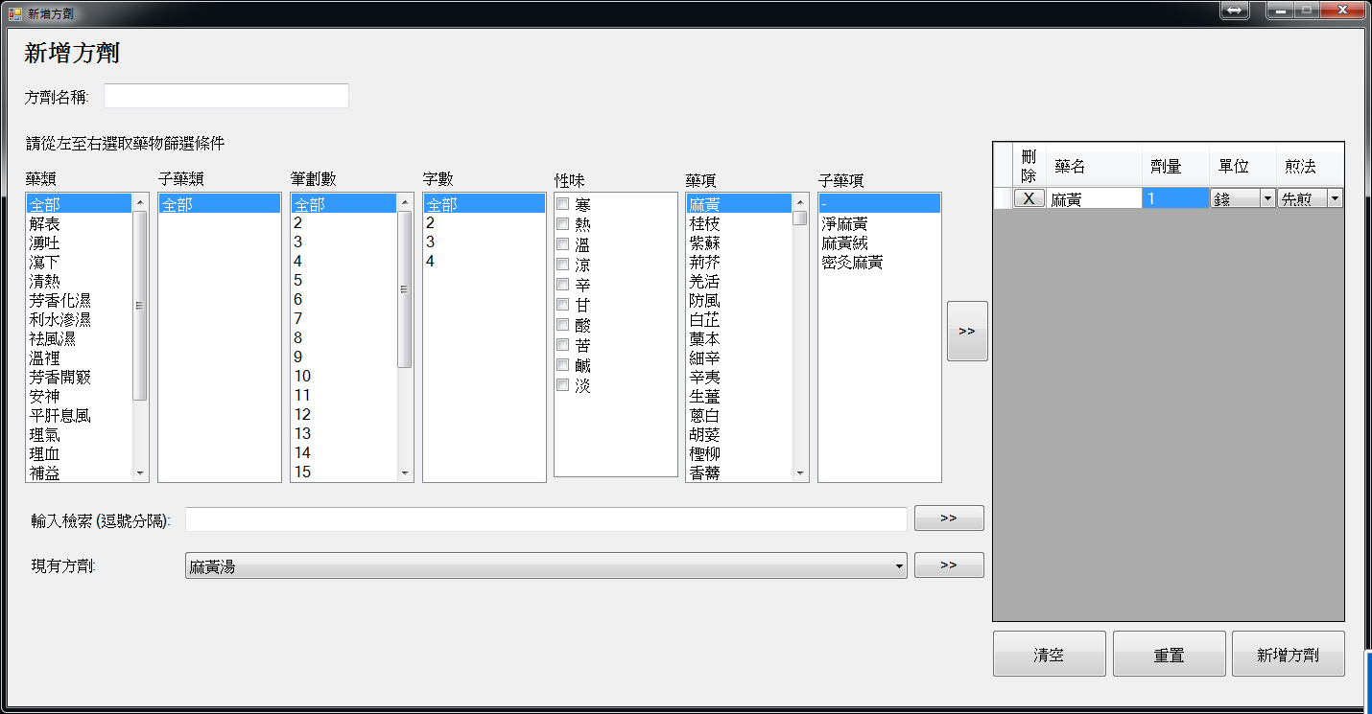

Fig . Screenshot of Prescription Panel

The panel provides three ways for user to select drug for making a prescription or formula. The three ways are select drug using drug selection panel, text-based search and use existing formula. When the drugs are selected, the item will be shown on the data grid view and user can enter or alter the dosage, unit and decoction/preparation method like decoct first and decoct later for each drug item.

### Predefined Formula (Formula)

#### Add Formula

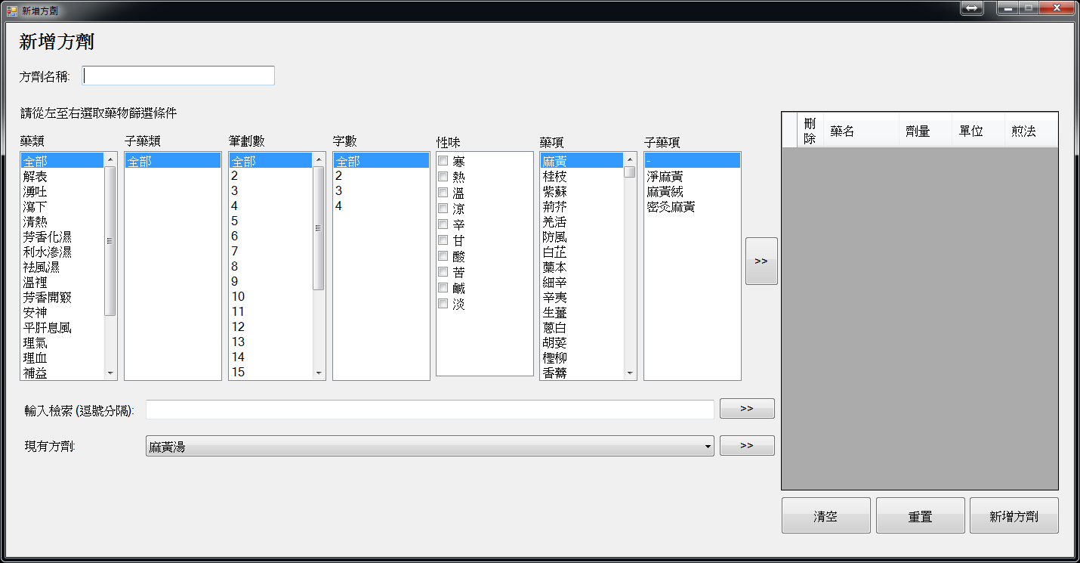

Fig . Screenshot of Add Formula Form

System Administrator, Clinic Administrator and Doctor can use the above form to create new formula. This form consists of a textbox and a prescription panel for users to input data. The textbox at the top is for users to enter the formula name and the prescription panel for user to enter the formula. When “add formula” button is clicked, the system will check whether the formula name exists in the system. If it exists, the action will be rejected. If not, then record will be inserted to the database. When adding a formula, the system will not check any rule regarding drug safety in order to allow users to enter some uncommon or folk formula.

#### Enquire / Edit Formula

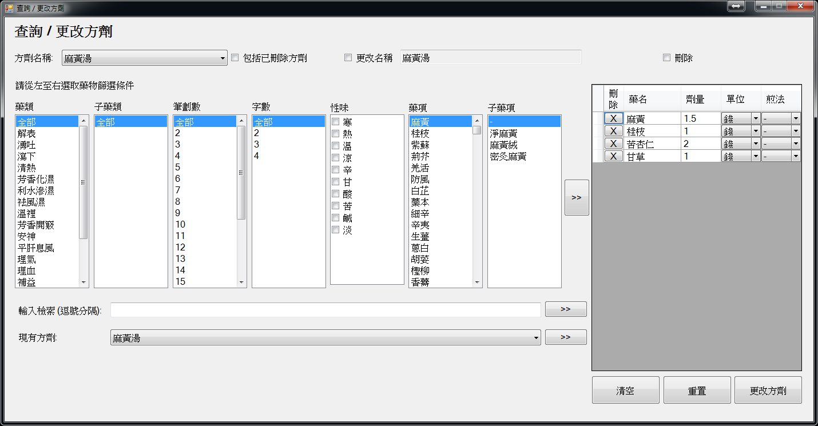

Fig . Screenshot of Edit Formula Form

System Administrator, Clinic Administrator and Doctor can use the above form to view or edit formula. A dropdown list will be provided for users to select the existing formula. Then, they can change the formula name, by checking the checkbox change name. They also can alter drug items and dosage or to mark the formula as deleted. When update button is clicked, the system will do the similar checking as new formula and update the database records.

#### Database

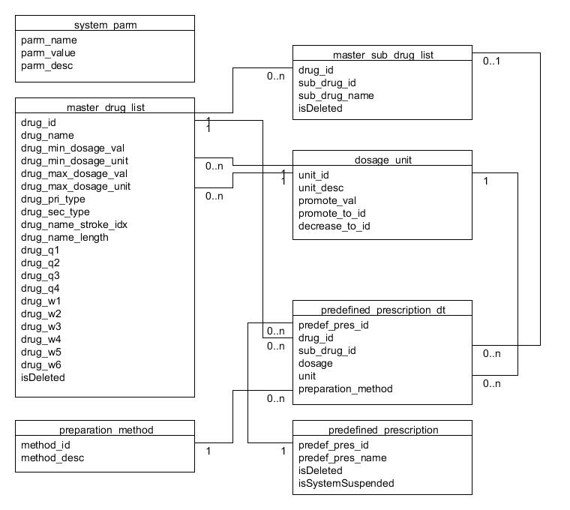

Fig . Database Tables Related to Formula

The database stores the formula data mainly with two tables, namely formula table (predefined_prescription) and formula detail table (predefined_prescription_dt).

The formula table stores the formula ID (predef_pres_id), formula name (predef_pres_name), delete flag (isDeleted) and system suspend flag (isSystemSuspended).

The formula ID is generated by a function based on the value of an entry in the system parameter table. The entry is used for holding the largest / latest formula ID, and the entry with parameter name “predef_prescription_cnt”. After each generation of formula ID, the parameter value will be updated to the one just generated. This generation method can make the generation of formula ID more flexible, not restricting it only be integer serial number. It can be change to other generation method easily

Formula detail table stores the formula details, includes the formula ID, drug ID (drug_id), sub-drug ID (sub_drug_id), dosage value (dosage), dosage unit ID (unit) and preparation method ID (preparation_method). The drug ID and sub-drug ID are based on data in the master drug list and master sub-drug list (see Section 5.2.4.2.). For sub-drug ID equals to 0, it is stands for the item is a drug while for sub-drug ID is a non-zero integer means the item is a sub-drug. For dosage unit ID, it is based on the data stored in the table dosage_unit. For decoction method ID (preparation_method), it is based on the data stored in the decoction method table (preparation_method).

### Clinic Management

#### New Clinic

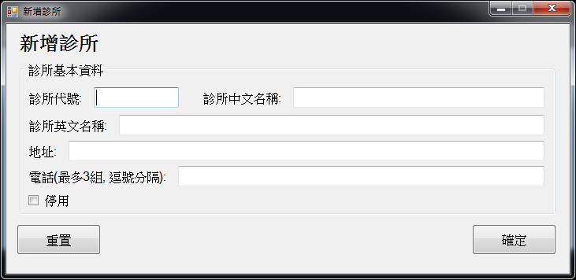

Fig . Screenshot of New Clinic Form

System Administrator can use the above form to add new clinic entry to the system. It allows to enter clinic ID, names, address and phone number(s) for the new clinic. A checkbox also provided for users to select whether the clinic is suspended or in use. When confirm button is clicked, the system will check whether the clinic ID is exists. If it exists, the action will be rejected. Clinic ID is a key field for the clinic table and also for user to have an easier reference to the clinic as clinic names can be repeatedly used. For example, a Doctor, say Dr CHAN Siu Ming, have 2 clinics. Both of them are called Dr. CHAN Siu Ming TCM Clinic. Then, user may have difficulties to distinguish two different clinics. At this moment, Clinic ID can help. The one in place A can have the Clinic ID as CSM1 and the other one in place B can have the Clinic ID CSM2. So that, user and the system can distinguish between the two clinics without referring to the details of the clinic record.

#### Enquire / Edit Clinic Information

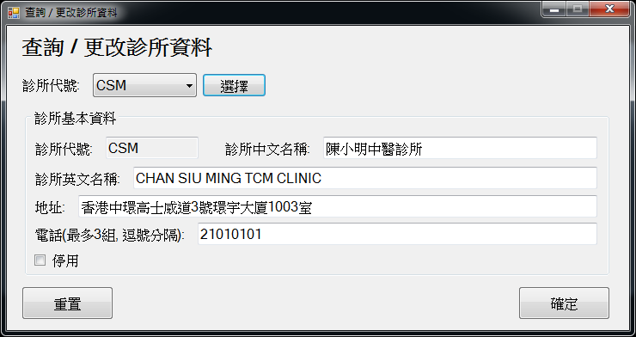

Fig . Screenshot of Enquire / Edit Clinic Information Form

System Administrator can use the above form to view or edit clinics’ information and Clinic Administrator can use it to edit the current login clinic’s information. This form is similar to the one use for create new clinic. A dropdown list is provided for users to select the clinic ID. The system allows user to change all the items entered when creating the clinic entry except clinic ID. When confirm button is clicked, the system will update the entry in the database.

#### Database

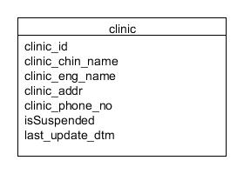

Fig . Database Table Clinic

Database stores all the clinics data in the clinic table (clinic). The data are clinic ID (clinic_id), Chinese name (clinic_chin_name), English name (clinic_eng_name), address (clinic_addr), phone number(s) (clinic_phone_no), suspended flag (isSuspended) and the last update date/time (last_update_dtm).

### User Management

#### Relationship between User, Clinic and Role

This system supports multi-clinics and multi-users. Each user can work in one or more clinics. Each user can possess with more than one role under the same clinic and different role(s) in different clinics. Therefore, their role would associate with the corresponding clinic to specify which role is belongs to which clinic.

In this system, basically provides 4 roles, namely System Administrator, Clinic Administrator, Doctor and Staff. This account provides a special role for restricting the account owner from login the system with the associated clinics even if he/she has other role(s) in that clinic, and it is named “No Access”. The use for this role is to suspend the access of the user from a certain clinic for some reasons. For examples, the staff has do something wrong and the clinic administrator would like to suspend the staff’s work to have further investigation or the user taking a long holiday and the administrator wants to suspend the account for security reason. Then, the administrator can apply the “No Access” Role to the staff account during the period of suspension instead of revoke all the roles granted to the staff, in order to prevent any access to the system using the account.

Regarding the clinic-role combination, the special clinic for System Administrator with ID “ALL” can only combine with the System Administrator even not the “No Access” Role and other clinics can associate with all the other roles.

#### New User Account

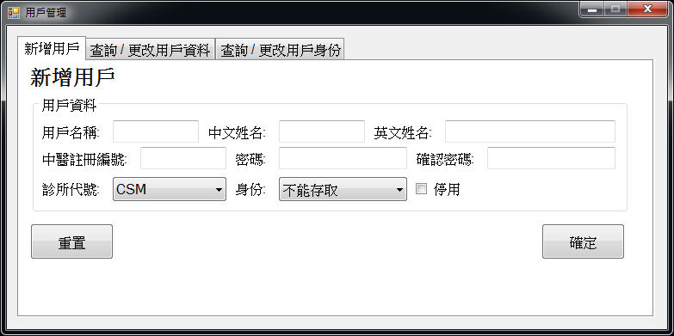

Fig . Screenshot of User Management with New User Tab page Selected

System Administrator and Clinic Administrator can use the above tab page to create new user accounts. The system requires users to assign a unique user name for each user account. It also requires user to enter the Chinese and English name, password for the new account owner and assign a role and clinic for him/her. For System Administrator, they can assign any clinic for the user. For Clinic Administrator can only assign the current login clinic for the user. If the account owner is a registered Chinese Medicine Practitioner, i.e. assigned with Doctor Role, the registration number must be entered. Otherwise, the creation of account will be rejected by the system. A checkbox is provided for user to indicate the account is in use or not. Before passing the data to the database, the password will be hashed with SHA-256. When confirm button is clicked, the system will check whether the user ID and registration number is exists. If it exists, the action will be rejected. If not, the record will be inserted to the database.

#### Enquire / Edit User Information

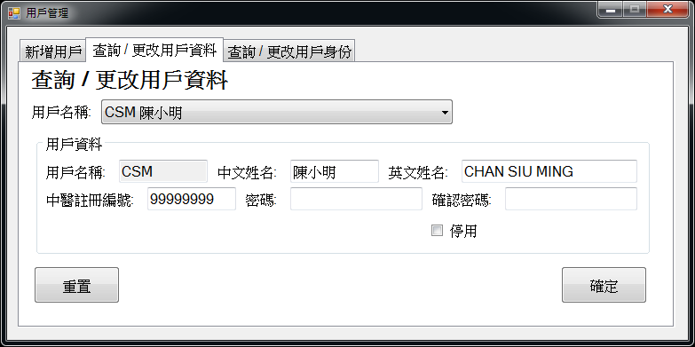

Fig . Screenshot of User Management with Enquire / Edit User Information Tab page Selected (For System Administrator and Clinic Administrator)

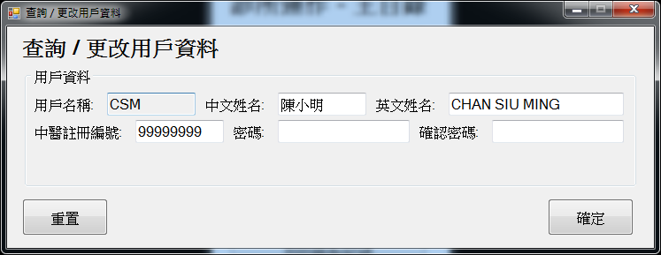

Fig . Screenshot of Enquire / Edit User Information Form (For Doctor and Staff)

System Administrator and Clinic Administrator can use the tab page shown in Fig 5.16 to view and edit user accounts information including themselves. Doctor and Staff can use the form shown in Fig 5.17 to view and edit their account information. The main body for the two user interface are similar, they both allow user to view the user ID and view and edit the Chinese and English name, Chinese Medicine Practitioner registration number and password.

For the one used by System Administrator and Clinic Administrator, a dropdown list will be provided for them to choose which account to be viewed or edited. Only the account under his/her management will be shown and can be selected in the list. For System Administrator, all the accounts including those created in CMPMS, are under their management. For Clinic Administrator, only the accounts with roles associated with their clinic are under their management.

Users can change all the information for the selected account except user ID. He/she cannot suspend his/her own account. Before passing the data to the database, the password will be hashed with SHA-256. When confirm button is clicked, the system will check whether the Chinese Medicine Practitioner registration number is used by other account if it is not blank. If it is used by other account, the update will be rejected, else the record will be updated.

#### Enquire/Amend User Role

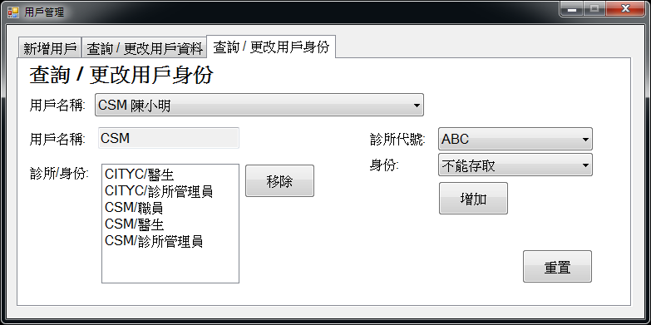

Fig . Screenshot of User Management with Enquire / Amend User Role Tab page Selected

System Administrator and Clinic Administrator can use the above tab page to manage user roles. A dropdown list will be provided for users to choose which account to be viewed or amended. All the accounts in the system, including those created in CMPMS, will be shown and can be selected in the list. The authority of the user role granted to the account should not higher than the user’s current login role, i.e. System Administrator can grant all the roles and Clinic Administrator can grant all the roles except System Administrator Role. The clinic associated to the role should under his/her management.

#### Database

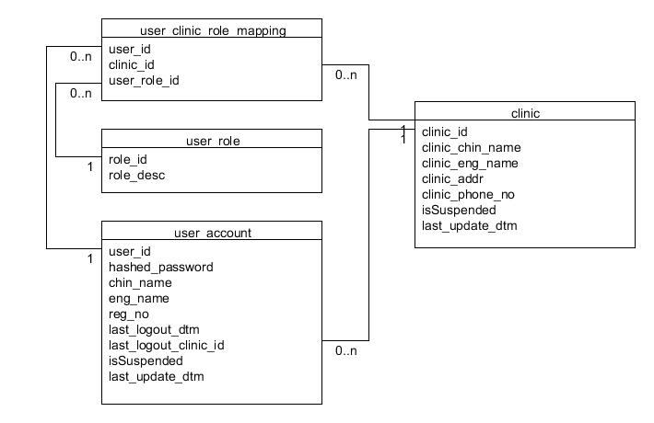

Fig . Database Tables Related to User Management

There are four tables related to the user and role management. They are user account table (user_account), clinic table (clinic), user role table (user_role) and user-clinic-role mapping table (user_clinic_role_mapping).

Clinic information is stored in the clinic table.

User role table is a constant table and maintained by the system developer and database administrator. It stores the role ID (role_id) and role description (role_desc). As patient do not need to login the system by their own patient account, the system only have the role representation for clinic staff users, it means only the roles for clinic staff is stored in the user role table. The content in descending order of role authority are as follow:

|  |  |
| --- | --- |
| **Role ID** | **Description** |
| 40 | System Administrator |
| 30 | Clinic Administrator |
| 20 | Doctor |
| 10 | Staff |
| 0 | No Access |

Fig . User role table content

Role 0 is a special role. When it is applied to the account, the account cannot login to the system with the corresponding clinic even if he/she has some high authority role in that clinic. The use for this role is to suspend the access of the user from a certain clinic for some reasons. For details, see Section 5.2.8.1.

Account information entered is stored in the account table. The last logout Clinic ID (last_logout_clinic_id) and last logout date/time (last_loguout_dtm) field will be updated when the user logout. The last logout Clinic ID is based on the data stored in clinic table.

User-clinic-role mapping table is a table storing the information about which clinic and role that the user possesses with. It has three fields, user ID (user_id), clinic ID (clinic_id) and role ID (user_role_id), which are based on the information stored in user account table, clinic table and user role table respectively. This table is used, instead of storing the clinic and role item with the user account entry, is because each user can work in different clinics with different and multiple roles. For example, Doctor A has his own clinic and he is the clinic administrator, he will have Role 20 and 30 for Doctor A’s clinic. Besides, he also can work in his friend’s clinic, say Clinic B, as a doctor. Then, he also will have the Role 20 for Clinic B. This can reduce the redundancy of data stored.

### Patient Queue

This system maintains patient queue for each clinic and each queue is independent from each other. The patient queue shown to users are based on the login clinic. Patient can enter or leave the queue by using the Patient Sub-system or in the help of any clinic staff using the main system. The followings are the screenshots of user interface related to patient queue.

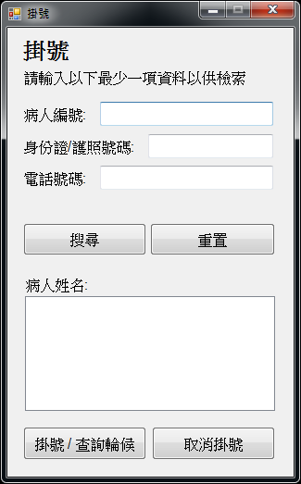

Fig . Screenshot of Registration Form for Patient Queue in Patient Sub-system

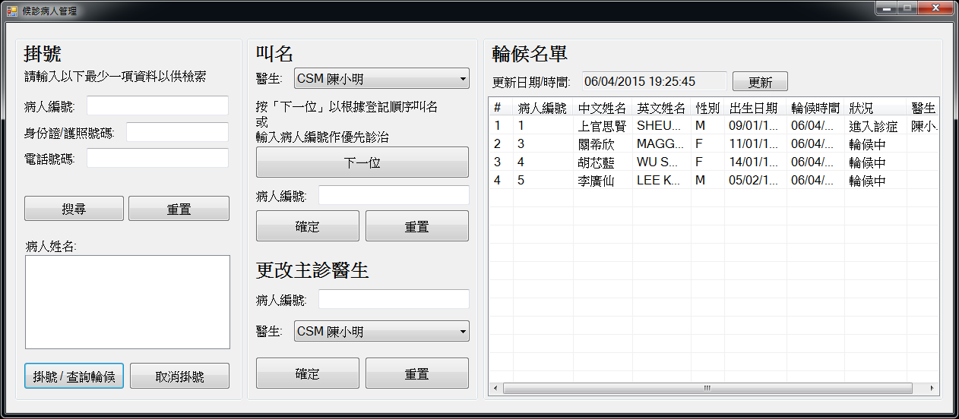

Fig . Screenshot of Patient Queue Management Form for Clinic Administrator and Staff

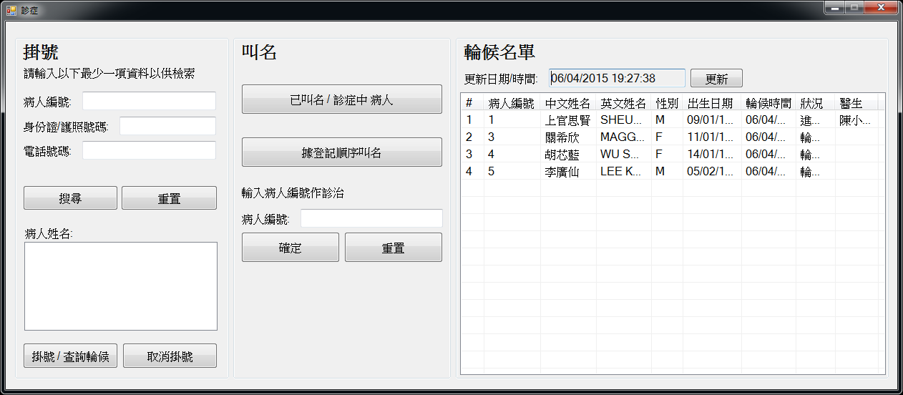

Fig . Screenshot of Patient Queue Management Form for Doctor

Each patient is assigned with a status to indicate he/she is in which stage of the workflow. The status are “Waiting”, “Calling”, “Entering Consultation”, “In Consultation” and “Consult Later”. Patient’s status in this system can only be changed as the following figure (The enlarged version see Appendix B.)

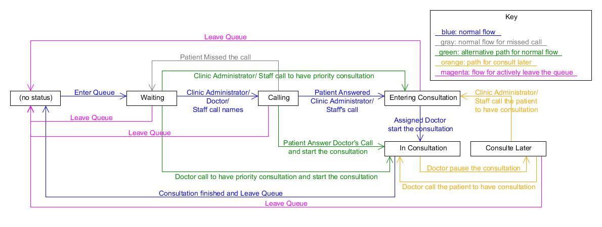

Fig . Patient Status Flow Diagram

When a patient enters the queue, he/she will be assigned the status “Waiting”. Then, when any clinic staff calls his/her names for consultation, the status will be changed to “Calling”. If he/she missed the call, the status will go back to “Waiting”, else the status will proceed to “Entering Consultation”. Then the assigned doctor starts the consultation, and the status changes to “In Consultation”. If the calling procedure is done by Doctor, the status will change to “In Consultation” directly instead of pass through “Entering Consultation”. If the patient is given for a priority consultation, the flow will step over the “Calling” status. When the consultation finished, the patient will leave the queue. If the consultation need to be pause due to some reason, say take an X-ray examination in Laboratory, the patient status will be changed to “Consult Later” and the consultation can be restart by any staff in the clinic. At any status except “In Consultation”, patient can leave the queue actively.

#### Enter / Leave Waiting Queue and Position Enquiry

The three user interfaces shown in Fig 5.22, Fig 5.23 and Fig 5.24 are possess with a patient search panel and 2 buttons namely “Register and Check Position” and “Unregister”. Users can use the form provided for them to add patient to or remove patient from the patient queue and check the patient’s position in the queue. User can search and select patient with the patient search panel. When patient is selected and register button is clicked, the patient will be put into the waiting queue of the currently login clinic and the position will be shown. The patient cannot double register to the same queue, i.e. in the same clinic. When the patient is selected and unregister button is clicked, the patient will be removed from the queue if he/she exists in the queue. Message will be shown to notify the user no matter the action is successful or not. Both actions will trigger the update of the waiting list shown on the windows form if the action is done with the user interface for Clinic Administrator, Staff and Doctor.

#### Calling Name and Change Doctor-in-charge

When the patients are going to be seen by the doctor, their name will be called.

For Clinic Administrator and Staff, they have a dropdown list to choose which doctor is going to see the next patient in their user interface. Only the doctor who have doctor role in that clinic will be shown in the list.

For all the clinic staff, they can click the next patient button to start the calling procedures. A mechanism in the system will control only one staff logged in with that clinic can execute this procedure at the same time. When the button is clicked, the dialog box will ask whether the first patient in the queue is in the clinic. Then the user can call the patient’s name. User can click “Yes” for the patient answer he/her call, “No” for not here or no response from patient and “Cancel” to stop the calling procedure. If “Yes” is selected, the patient status will be updated. For Doctor’s call, the status will change “In Consultation”. For others, the status will change “Entering Consultation”. If “No” is selected in the dialog box, the second patient’s information will be shown and so on until all patient have been called and the procedure will stop or one of the patient answered the call and clicked “Yes”. When the procedure stop, the missed call counter of all the patient have called with response “No” will be increased by one. And this counter is for further development to implement some penalty mechanism for too much miss call.

A textbox is provided for all the staff to enter the patient ID which exist in the queue and with status “waiting” to have a priority consultation or continuous for the unfinished consultation which the patient with status “Consult Later”. All the patient with status “Consult Later” can only use this function to have consultation as the system cannot determine when is ready for the patient to continue the consultation.

When the patient status is in “Entering Consultation, he/she has assigned a doctor in-charge. For the assigned Doctor, he/she can click “Called Patient/In Consultation Patient” button to start the consultation. At each time, at most one called / in consultation patient for one doctor exists in the queue. After any start consultation action has been done successfully, a consultation form will be shown for the doctor to do the consultation.

Any calling action with doctor has assigned with patient in status of “Entering Consultation” and “In Consultation” will be rejected.

In case of Clinic Administrator or Staff select the wrong doctor, there is a change doctor in-charge function for them to do the correction. However, this change can only be done when the doctor is not assigned to any patient with “Entering Consultation” or “In Consultation” status. For those changes cannot be done, the status will remain unchanged and wait for the doctor assigned to have consultation with them or use the change doctor in-charge function when the correct doctor has finish the current consultation.

In case of accidentally close of the program by doctor, the called patient button will serve to retrieve the patient who is “In Consultation” and in-charge by that doctor and get back the consultation form just closed.

Once the consultation is done, the patient will be removed from the queue.

The system allows doctor and non-doctor staff to do the calling because the system need to fit for different practices. For clinics with only the doctor and no other staff, then the doctor should do the calling. For some larger clinics, staff will help managing the queuing patients and calling the names. Then, the doctor has no need to call names but only get the called patient.

#### Database

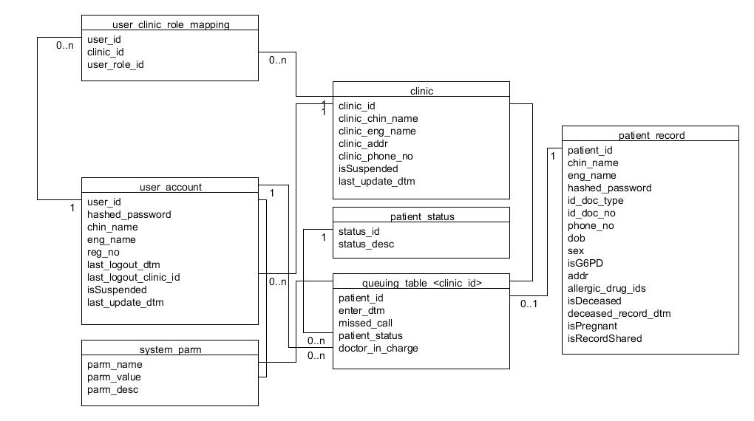

Fig . Database Tables Related to Patient Queue

Each clinic would have its own queuing table and flag for calling process. The name of queuing tables are queuing_table_<clinic_id> and the lock will be an entry in the system parameter table (system_pram) with parameter name (parm_name) as queuing_table_<clinic_id>_LOCK for controlling the concurrent calling name activities. The clinic ID are based on the entries in clinic table. If the clinic ID is CSM, the queuing table name and the parameter name are queuing_table_CSM and queuing_table_CSM_lock respectively. The parameter value (parm_value) would either be the user ID who are using the queuing table or null for no one is using. When first access to the queuing table and the table is not exist in the database, the stored procedure accessing the table will create it and add the corresponding entry to the system parameter table using dynamic SQL, i.e. SQL statement prepared at execution time. In the queuing table, it records the patient ID (patient_id), entering date time (enter_dtm), patient’s status (patient_status), assigned doctor (doctoe_in_cherge) and number of missed call (missed_call). Patient ID is based on the entries in patient record table (patient_record), which holds all the patient records in the system.

Patient status table (patient_status) holds all the permissible statuses for patients in the queue. The contents are the five status mentioned in Fig 5.25. Patient status in queuing table is the ID referring to patient status table.

Doctor in-charge field is the user ID in user account table which assigned to the patient and having the Doctor role (Role 20) with corresponding clinic in user-clinic-role mapping table.

Number of missed call field in queuing table is for future development to implement penalty mechanism.

Before any calling name activities start, first the stored procedure will try to check the system parameter for the clinic queuing table. If the parameter value is the user ID of the actor, then the calling name activities can proceed. If the value is null, then the stored procedure will acquire the lock by change the vale null to the actor’s user ID. If the value is other user ID, a massage will be shown to the actor to notify him/her another colleague is calling name. After the calling name activity, i.e. one of the patient answered the call or all the patient missed the call, the lock will be released by setting to value null.

The reason why this concurrent access control is handled programmatically instead of by the database’s default mechanism only is because the calling name activities is done by multiple times of stored procedure call. The connection will killed after each call in order to release unnecessary resources for other jobs while waiting for user’s response. Thus, the concurrent access control cannot only be done by the default database mechanism as it is not done by single connection and in one call.

### Consultation

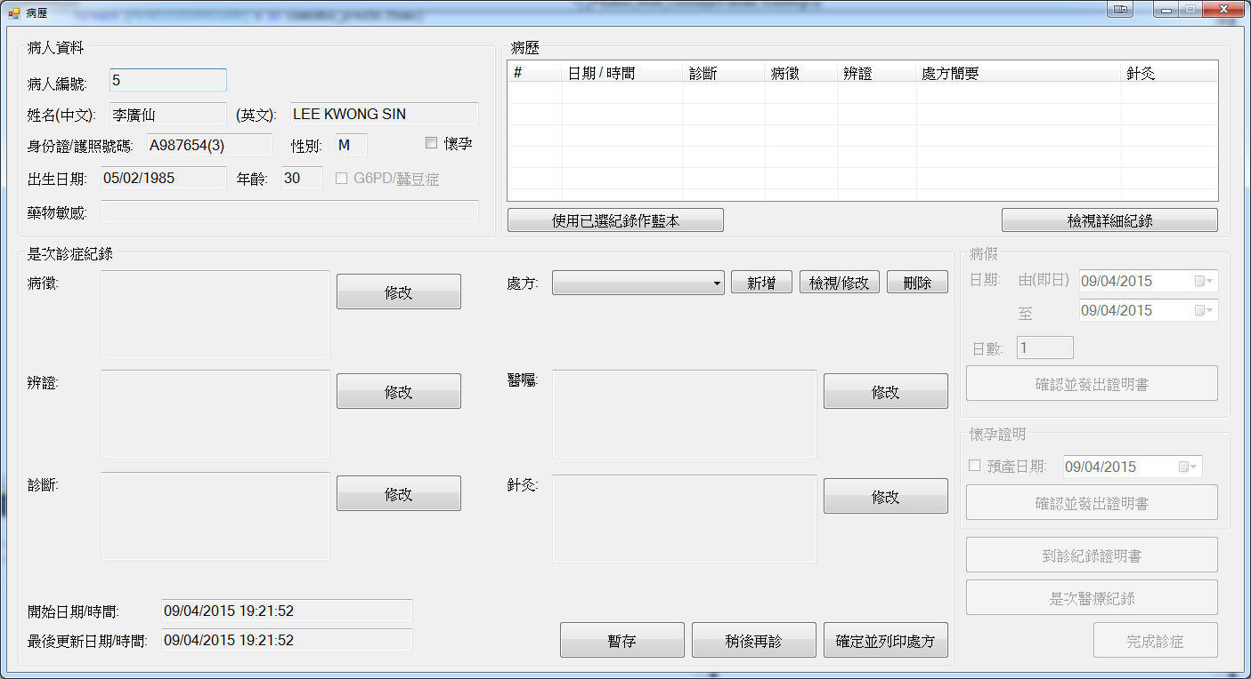

Fig . Screenshot of Consultation Form

In consultation form, doctor can view patient’s personal particulars, drug allergy history and medical records. He/she can enter consultation information for the current one, including symptoms, differentiation, diagnosis, prescription and remarks. He/she can issue sick leave certificate, pregnancy certificate and consultation certificate. He/she can also change the pregnancy flag of the patient in this form. If the patient is not a new patient, his/her past consultation record in this clinic or entered by this doctor will be listed out in descending order of consultation date time. If the patient has chosen to share medical records, the records in other clinics entered by other doctors to the system will also be shown. The doctor can choose one of the record as the template for the current consultation record. The old record will be copied to the database as the current consultation. The old record will not be affected. After the consultation, user should click the finish button in order to remove the patient from the waiting queue. If the patient is required to leave temporarily for some reasons, say to take an X-Ray examination, the doctor can click consult later and go on with another patient first. The status of the patient will change to “Consult Later”. When the form is closed with the close button at the top right corner, the information in the form will be saved to the database and the patient status will change to “Consult Later”.

After confirm and print prescription(s), the documentation generation functions (disabled in Fig 5.29) will be enabled. The documents are sick leave certificate, pregnancy certificate, consultation certificate and medical record for the current consultation. These documents will be further discussed in Section 5.2.11.

#### Symptoms, Differentiation and Diagnosis

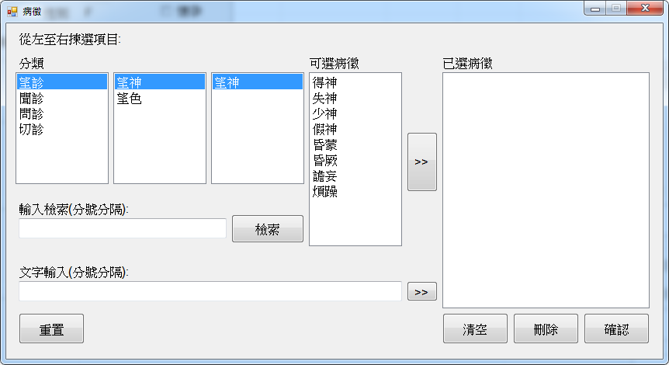

Fig . Screenshot of Symptoms Selection Form

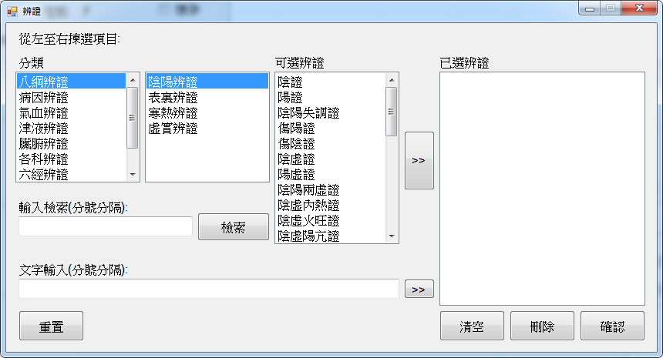

Fig . Screenshot of Differentiation Selection Form

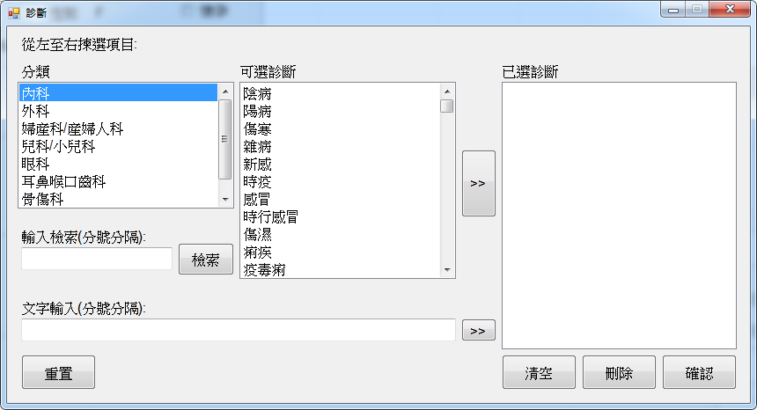

Fig . Screenshot of Diagnosis Selection Form

Doctor can use the forms above for entering symptoms, differentiation and diagnosis for the consultation. For these three items, doctor can use stored phrases based on WHO standard by choosing from the list boxes provided or text-based search. They also accept free-text entry. The free-text entry can be in Chinese phrase or single English word. No phrases can be used more than once in the same consultation. Both the display text string and the code for the phrase will be stored in the consultation record. The display text string is stored because it might be changed from time to time or as a result of changing in standard. To ensure same record is retrieved at any time and the document can be regenerated, the display text strings are kept.

#### Prescription

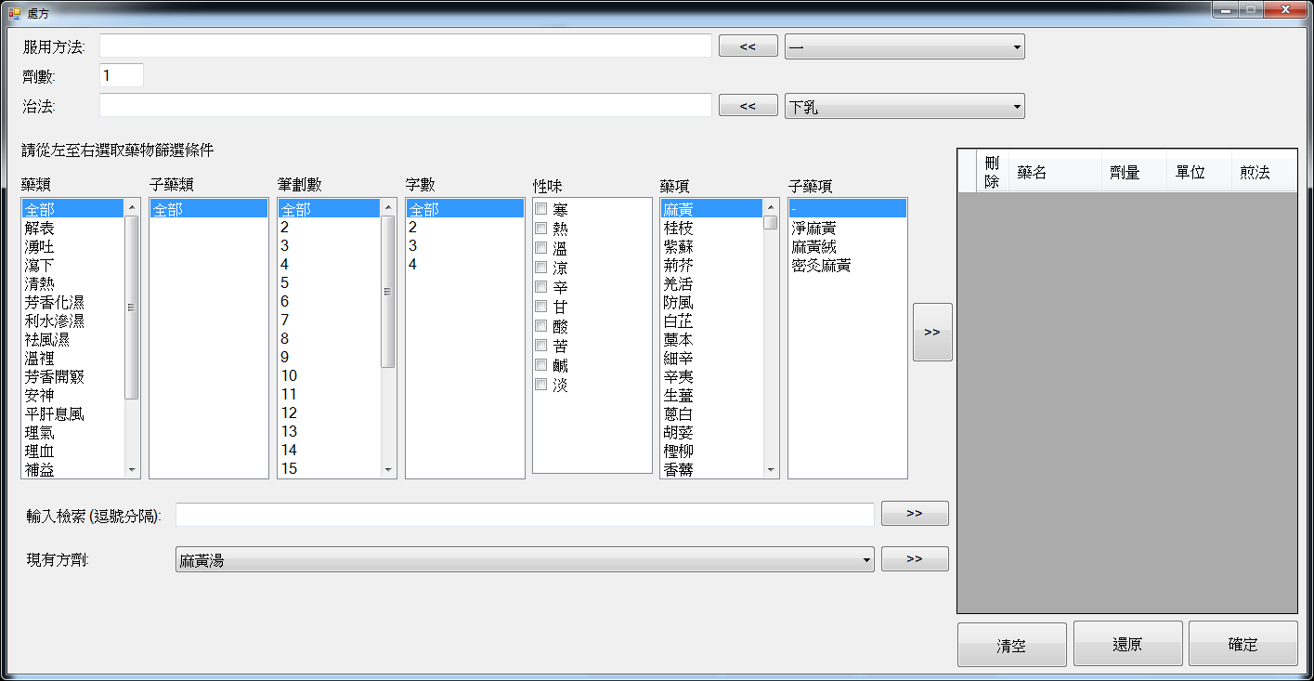

Fig . Screenshot of Prescription Form

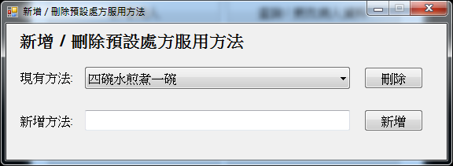

Fig . Screenshot of Add / Delete Stored Phrase for Prescription Using Directions Form

Each consultation can have more than one prescription. The prescription ID will be shown in the dropdown list in the consultation form. Doctor can click the amend button to view or amend the prescription, delete button to remove the prescription and new button to create a new prescription. In the above prescription form, doctor can enter the using direction and treating method by free-text or select some stored phrases from the dropdown list next to it. The stored phrase for prescription using directions can be added or deleted using the stored phrase for prescription using directions form. Doctor should also enter the number of dose of drugs that pharmacy should dispense to the patient. In this form, a prescription panel will be provided for user to make prescription. When user finish entering the prescription, the information will be stored to the database and perform safety checking and the prescription ID will be added to the dropdown list in the consultation form.

This system equipped with prescription safety checking. The checking can check drug incompatibility, contraindication for G6PD deficiency and pregnant patient, matching patient’s drug allergy history and dosage checking. If any rules is violated, a message will be shown to notify user the prescription has violate safety rule(s) and a log record will be kept. User can choose to edit the prescription or ignore the warning. If the clinic is associated with a pharmacy using CMPMS, stock checking will be performed. A stored procedure that provided by AU-YEUNG’s system in schema cmcis will be call to check whether the pharmacy possesses with enough stock for the prescription. If the data returned are low/no stock of certain drugs, message will be shown to notify the user. User can choose to change the prescription or not.

Before confirm and print prescription(s), the system will perform safety check again to prevent user using past medical record to by-passed the safety checking implemented in stored procedures for making prescriptions.

Before the consultation finished, a drug stock check will be performed again if the clinic is associated with a pharmacy using CMPMS. User can still choose to edit the prescription if some drug used in those prescriptions are in low stock level or out of stock. If no drugs are out of stock, user can choose to reserve drug in the pharmacy. Stored procedure provided by AU-YEUNG’s system in schema cmcis will be called for drug reservation. The system will notify the user with the reservation result.

#### Doctor’s Remark

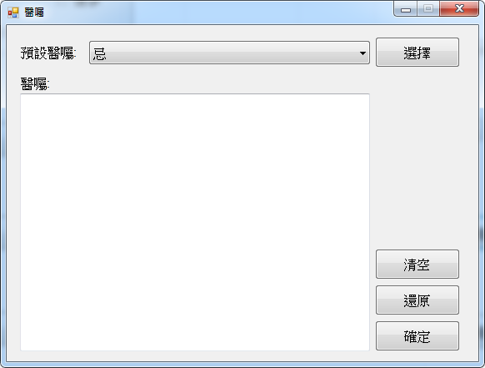

Fig . Screenshot of Doctor’s Remark Entry Form

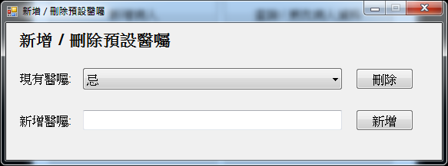

Fig . Screenshot of Add / Delete Stored Phrases for Doctor’s Remark Form

Usually, doctor will give some remarks or reminders to the patient in order to have a better treatment result. Doctor can enter the remark by free-text or choose stored phrase from the dropdown list. The stored phrases for doctor’s remark can be added or deleted using the add / delete stored phrases for doctor’s remark form

#### Acupuncture

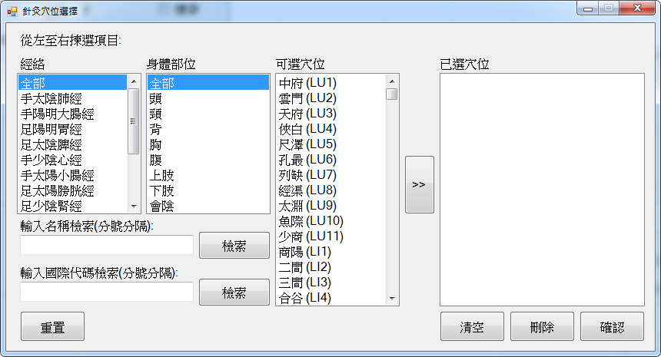

Fig . Screenshot of Acupuncture Point Selection Form

Nowadays, Chinese Medicine is not only providing drug for treatment but also acupuncture. Doctor can choose acupuncture point for treatment from the above form. There are three ways for choosing points. The first one is choose by selecting criteria using the list boxes. The other two are search by name and international code respectively. The data provided are based on WHO standard. Therefore, no free-text input or addition of points is allowed by user.

#### Database

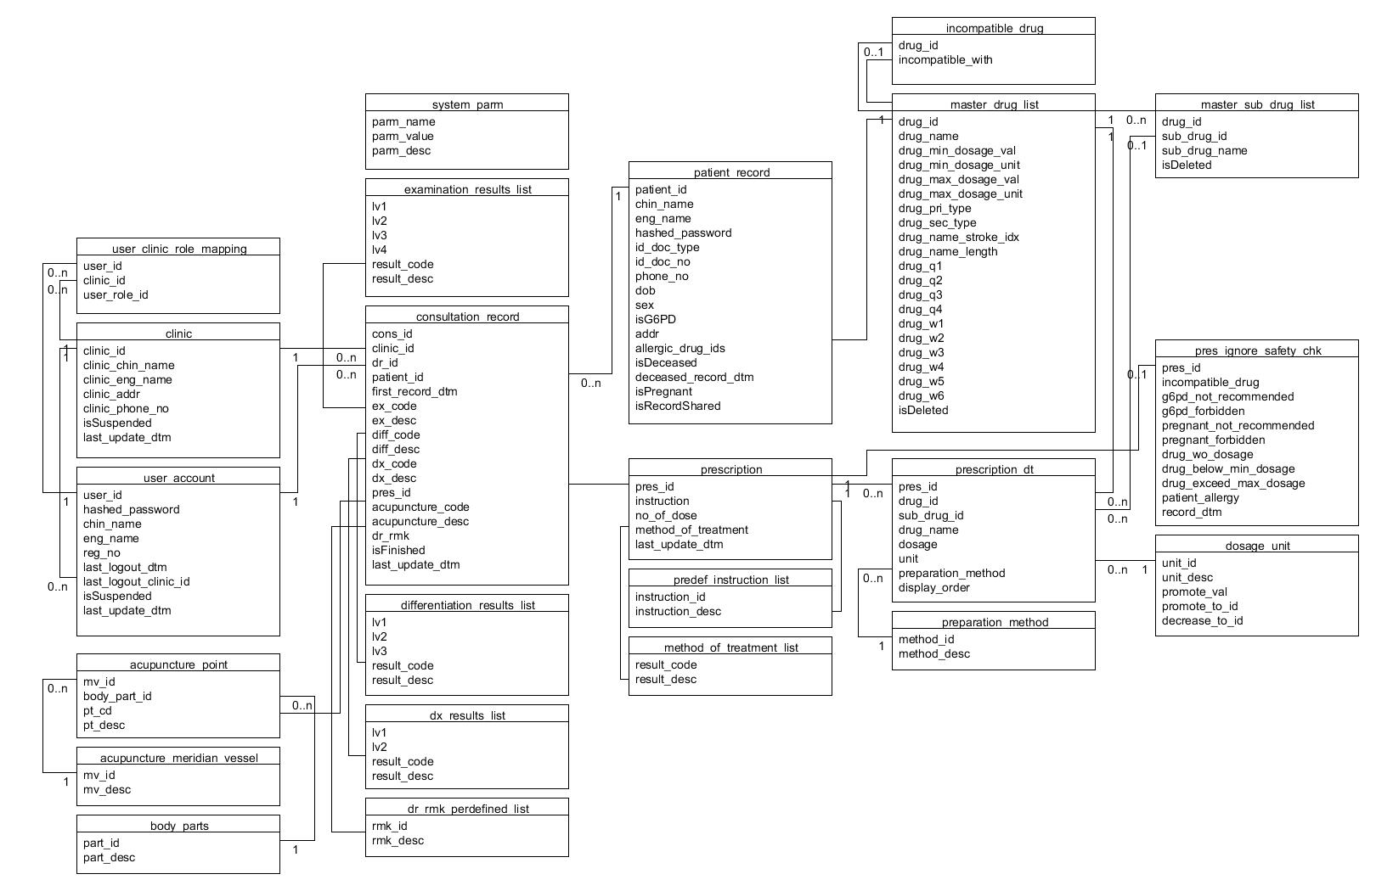

Fig . Database Tables Related to Consultation

Consultation records are stored in Consultation record table (consultation_record). The consultation ID are generated by a function based on the value of an entry in the system parameter table. The entry is used for holding the largest / latest consultation ID, and the entry with parameter name “consultation_cnt”. After each generation of consultation ID, the parameter value (parm_value) will be updated to the one just generated. This generation method can make the generation of consultation ID more flexible, not restricting it only be integer serial number. It can be change to other generation method easily. The clinic ID (clinic_id) are based on the login clinic, which should be an entry in clinic table. The doctor ID (dr_id) is based on the login user ID, which should be an entry in user account table with doctor role with the login clinic in the user-clinic-role mapping table. The patient ID is based on the data in patient record table. The symptom code (ex_code) and symptom description (ex_desc) are based on the data in symptom list (examination_results_list) if they are selected from the list. The differentiation code (diff_code) and differentiation description (diff_desc) are based on the data in differentiation list (differentiation_results_list) if they are selected from the list. The diagnosis code (dx_code) and diagnosis description (dx_desc) are based on the data in diagnosis list (dx_results_list) if they are selected from the list. If they are free text, the code will be “FreeText”. The codes for symptoms, differentiation and diagnosis are stored by concatenating all the code selected with delimiter “||” and the description for them are concatenated with “; ” as delimiter. The prescription IDs (pres_id) are stored by concatenating all the related IDs with “||” as delimiter. The acupuncture code and description (acupuncture_code and acupuncture_desc) are based on the acupuncture point table (acupuncture_point). The acupuncture code are stored by concatenating all the code selected with delimiter “||” and acupuncture description are concatenated with “; ” as delimiter. The doctor’s remarks (dr_rmk) are stored in plain text. The finish flag (isFinished) are with values -1, 0, 1 or 2. -1 means the consultation not finished but the patient leaved. 0 means the consultation started but not yet finished. 1 means the consultation data has been confirmed and prescription printed. 2 means the consultation is successfully finished. When the consultation starts, the record is inserted with value 0 for the finished flag. Each update on the record or prescription will trigger the update of the last update date time (last_update_dtm) field. Plain text description are stored is for ensuring the information is reproducible at any time.

The way of storing prescription data are similar to that of formula. The two tables are prescription table (prescription) and prescription detail table (prescription_dt). Prescription table stores prescription ID (pres_id), using directions (instruction), number of dose (no_of_dose), method of the treatment (method_of_treatment) and the last update date time (last_update_dtm). Prescription detail table stores data like formula detail. The different is prescription detail stores 2 more data, they are the drug name and display. This two field is used for ensuring the information is reproducible at any time and resistance to changes of data in the drug data tables.

Any prescription which cannot pass the safety check, an entry will be add to the ignore safety check log (pres_ignore_safety_chk). This table will stored the prescription ID, rules violated and the record date time.

All the prescription removed in consultation form or not confirmed to add to the consultation record will not be removed immediately after the consultation. The prescription are removed by a schedule job which runs every day. The schedule job calls a stored procedure to remove those prescription with last update date time earlier than 24 hours before the current date time. The 24 hours buffer time is used for prevent any consultation is not yet confirmed, which have prescription not yet added to the prescription ID field for reference. After cleaning up the prescription tables, 2 parameters in system parameter table will be updated. They are “pres_clean_up_to_dtm” and “pres_clean_up_error”. The first one records the current clean up covers up to which date time. This will make the following runs faster as it only need to clean prescriptions with last update date time later than this. The second one is a flag for database administrator or developer to know any error occurred during the last clean up.

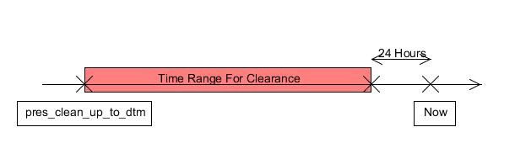

Fig . Prescription clean up time range

### Documents and Reports

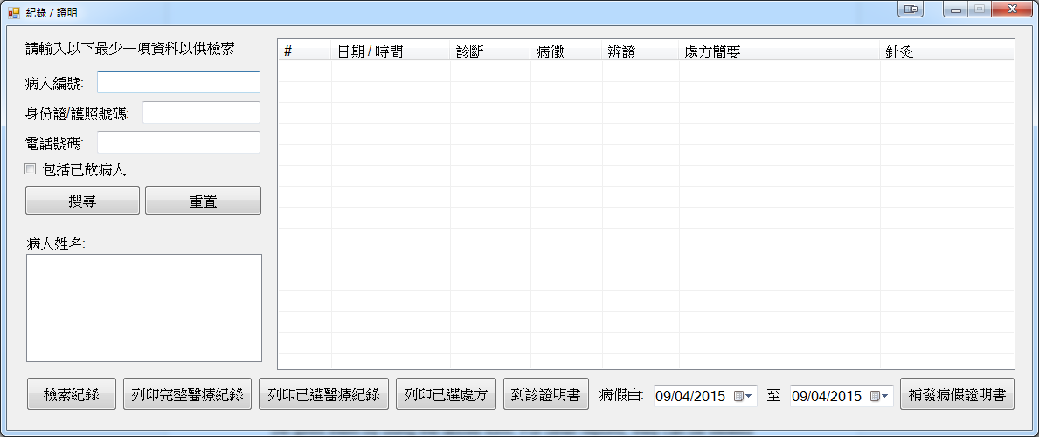

Fig . Screenshot of Record / Certificate Issue Form

This system can produce numbers of documents and reports. Some of them can be re-printed or re-issued. For those related to consultations except pregnancy certificate, Clinic Administrator, Doctor and Staff they can be (re-)print them by using the above form. For other reports, they can be viewed or printed by using the main menu or reporting menu depends on roles. All the documents will be viewed and printed through an embedded Crystal Report Viewer. All documents possess with a header showing the clinic information.

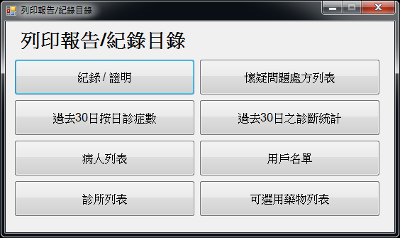

Fig . Screenshot of Reporting Menu for Clinic Administrator

#### Prescription

Prescriptions can be printed during consultation using consultation form by the doctor. They can be reprinted using the form shown in Fig 5.40 by Clinic Administrator, Doctor and Staff.

The prescription possess a section showing the consultation details including consultation ID, patient and doctor’s name, diagnosis and last update date time. Under this section will be the prescription detail including the prescription ID, treatment method, drug items with corresponding dosage, using directions and number of dose prescribed. If the consultation does not have prescription, this section will be replaced by message “This consultation does not have prescription”. Then, the next section will be doctor’s remark and placeholder for doctor’s signature. The following sections would only be shown when the consultation have prescription. At the end of each prescription, a barcode is provided. This barcode is for the related pharmacy using CMPMS to get the prescription details or procedure done in the consultation with verification. Stored procedures are compiled in schema cmcis for these purpose. If the clinic associated with pharmacy using CMPMS and the address of the pharmacy is not the same as the clinic, the pharmacy will be printed under the barcode for reference. For the sample of prescription, see Appendix C.

The barcode data format is <clinic ID>/<doctor ID>/<patient ID>/<consultation ID>/<prescription ID>/<last update date time in yyyyMMddHHmmss format>. These data will be pass to the stored procedure for retrieving the required data. If all the data can match with the record in the database, the prescription hardcopy is valid and the prescription detail and procedures done in the consultation will be returned to the caller depends on which stored procedure is called. If the data cannot match with the record in the database, the prescription hardcopy may be outdated or not issue from the same system. The details will not return to the caller.

#### Consultation Certificate

Consultation certificate can be printed during consultation using consultation form by the doctor. They can be reprinted using the form shown in Fig 5.40 by Clinic Administrator, Doctor and Staff.

The certificate would possesses with patient’s name, personal identification document number, consultation date, diagnosis, date of issue and a placeholder for doctors signature. This certificate is to proof the patient has visited the clinic for consultation instead of using sick leave certificate as sometimes may not prescribed with sick leave. For the sample of the certificate, see Appendix D.

#### Sick Leave Certificate

Sick leave certificate can be printed during consultation using consultation form by the doctor. They can be reprinted using the form shown in Fig 5.40 by Clinic Administrator, Doctor and Staff.

User can select the sick leave inclusive start and end date using the date pickers provided. The total number of days will be calculated and shown to the user if using the consultation form. According to the Reference Guide on Issuance of Sick Leave Certificate by Registered Chinese Medicine Practitioners (Chinese Medicine Council of Hong Kong, 2003), doctor shall not issue a date back sick leave certificate. Therefore, the sick leave start date cannot be set to date before the consultation start date. After selecting the dates can clicking the “issue” button, the certificate information will be inserted to the sick leave certificate table in the database and a Crystal Report viewer with the certificate will be shown. For re-issue of the certificate, the issue time should within 24 hours after the consultation ends. The 24 hours buffer time is balanced for some patient forget to request for the certificate during consultation and prevent date back the certificate. The following illustrate the time validity regarding sick leave certificate.

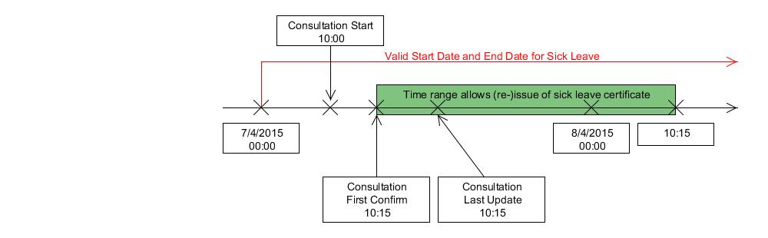

Fig . Time Validity Regarding Sick Leave Certificate

According to the Reference Guide on Issuance of Sick Leave Certificate by Registered Chinese Medicine Practitioners (Chinese Medicine Council of Hong Kong, 2003), sick leave certificate should include patient’s name, ID number, diagnosis, date range, number of days, clinic and doctor’s information. The certificate issue by this system would follows the above standard. For the sample of sick leave certificate, see Appendix E.

The database will record the certificate data in the sick leave certificate table (sick_leave_cert). It include certificate ID (cert_id), consultation ID (consultation_id), start date (start_date), end date (end_date), number of days (nDays) and a voided flag (isVoided). The certificate ID are generated by a function based on the value of an entry in the system parameter table. The entry is used for holding the largest / latest certificate ID, and the entry with parameter name “sick_leave_cert_cnt”. After each generation of certificate ID, the parameter value will be updated to the one just generated. This generation method can make the generation of certificate ID more flexible, not restricting it only be integer serial number. It can be change to other generation method easily. The consultation ID is based on data in consultation record table. The voided flag is used for further development to void some wrongly issued certificate.

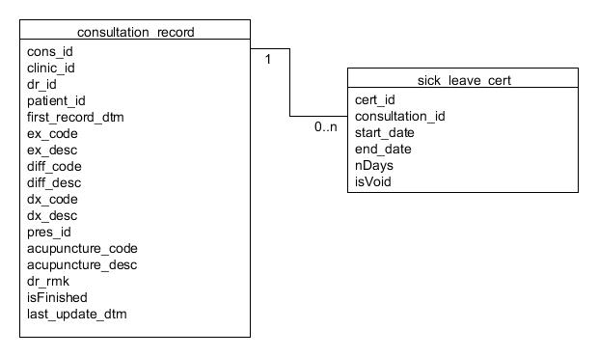

Fig . Database Tables Related to Sick Leave Certificate

#### Pregnancy Certificate

Pregnancy certificate can only be printed during consultation using consultation form by the doctor.

If the patient is pregnant (pregnant checkbox is checked), the checkbox and date picker for estimated date of confinement (EDC) will be enabled in the consultation form. Doctor can choose to enter the EDC information to the certificate. When “confirm and issue” button is clicked, the certificate information will be inserted to the pregnancy certificate table in the database and a Crystal Report viewer with the certificate will be shown to the doctor. For patient is not pregnant, a certificate certify he/she is not pregnant will be issued.

According to the Reference Guide on Issuance of Sick Leave Certificate by Registered Chinese Medicine Practitioners (Chinese Medicine Council of Hong Kong, 2003), pregnancy certificate should include patient’s name, date of consultation and confirmed pregnancy and the date of issue. If EDC is confirmed, the certificate can include the EDC. For the sample of pregnancy certificate, see Appendix F.

The database will record the certificate data in the pregnancy certificate table (pregnant_cert). It include certificate ID (cert_id), consultation ID (consultation_id), pregnant flag (isPregnant), EDC (edc) and a voided flag (isVoided). The certificate ID are generated by a function based on the value of an entry in the system parameter table. The entry is used for holding the largest / latest certificate ID, and the entry with parameter name “preg_cert_cnt”. After each generation of certificate ID, the parameter value will be updated to the one just generated. This generation method can make the generation of certificate ID more flexible, not restricting it only be integer serial number. It can be change to other generation method easily. The consultation ID is based on data in consultation record table. The voided flag is used for further development to void some wrongly issued certificate.

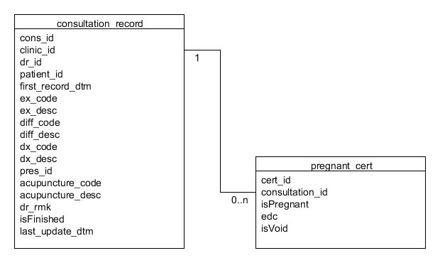

Fig . Database Tables Related to Pregnancy Certificate

#### Medical Record and Consultation History

Medical records can be printed using the form shown in Fig 5.40 by Clinic Administrator, Doctor and Staff. Single medical record for the current consultation can be printed during consultation using consultation form by the doctor.

This document provides a more detailed information about consultations. It includes consultation ID, doctor’s name and registration number, start and end date time, symptoms, differentiation, diagnosis, acupuncture, doctor’s remark and prescription details for each consultation. For the sample of medical record, see Appendix G. A similar unofficial document, Consultation History, which used for viewing the past consultation history with the home clinic or other clinic during consultation for doctor’s reference, and its sample is in

#### Suspicious Prescription Listing

All the prescription which violated safety rules will be logged in ignore safety check log (see Section 5.2.10.5). This report is for Clinic Administrator to view these log records. The sample of the report is in Appendix I.

Records in the ignore safety check log where the prescriptions are issue in the viewing clinic will be shown in the report. Only those records associated with completely consultation will be shown, i.e. finish flag equals 2 which cannot be altered with the user interfaces. The record details include the prescription ID, doctor’s name, patient ID, consultation ID, rule(s) violated and the record date time. The rules are as follows.

1. Prescription contains incompatible drugs
2. Prescription contains not recommended drug(s) for G6PD deficiency patient where the patient possesses with G6PD deficiency
3. Prescription contains prohibited drug(s) for G6PD deficiency patient where the patient possesses with G6PD deficiency
4. Prescription contains not recommended drug(s) for pregnant patient where the patient is pregnant
5. Prescription contains prohibited drug(s) for pregnant patient where the patient is pregnant
6. Prescription contains drug(s) with 0 dosage
7. Prescription contains drug(s) with dosage lower than the suggested minimum dosage limit
8. Prescription contains drug(s) with dosage exceeding the maximum dosage limit
9. Prescription contains drug(s) which matched the record in patient’s drug allergy history

#### Statistic Report of Daily Consultation in the Past 30 Days

This report can be viewed by Clinic Administrator and Staff. The report shows the number of patient headcount, number of prescription issued, number and percentage of patient headcount with prescription issued and acupuncture treatment. This report can let the Clinic Administrator and Staff to have an overview on the business. The report sample is in Appendix J.

#### Diagnosis Statistics in the Past 30 Days

This report shows the statics for patient headcount with certain diagnosis. The numbers are include system total headcount, system new case headcount, clinic total headcount, clinic new case headcount and clinic new case included in system new case headcount for certain diagnosis in the past 30 days using consultation start date time as reference date. The definition the items are as follows.

Study Period:

Previous 30 days using report running as reference.



Fig . Study Period for Diagnosis Statistics in the Past 30 Days

System Total Headcount:

Total number of patient headcount who have received consultation within the study period and having the diagnosis code in any clinics in the system.

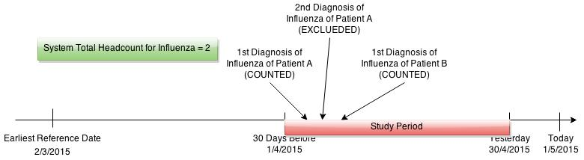

Fig . System Total Headcount for Diagnosis Statistics in the Past 30 Days

System New Case Headcount:

Number of patients with same diagnosis is not found in the 30 days before the first diagnosis within the study period in any clinics in the system.

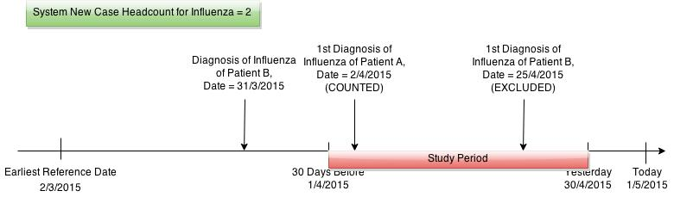

Fig . System New Case Headcount for Diagnosis Statistics in the Past 30 Days

Clinic Total Headcount:

Total number of patient headcount who have received consultation within the study period and having the diagnosis code in the report running clinic.

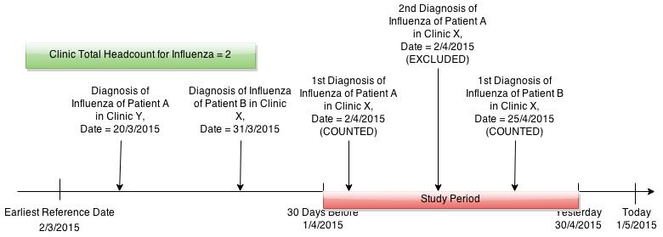

Fig . Clinic Total Headcount for Diagnosis Statistics in the Past 30 Days

Clinic New Case Headcount:

Number of patients with same diagnosis is not found in the 30 days before the first diagnosis within the study period in the same clinic.

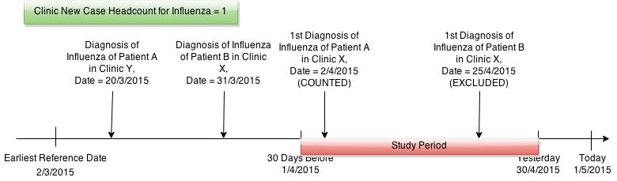

Fig . Clinic New Case Headcount for Diagnosis Statistics in the Past 30 Days

Clinic New Case Included in System New Case Headcount:

Number of patient both counted in System New Case and Clinic New Case.

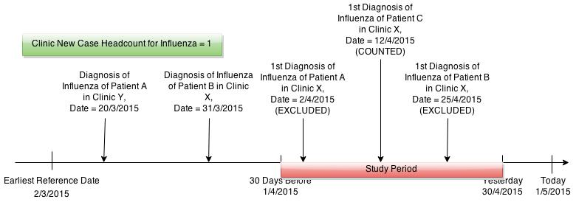

Fig . Clinic New Case Included in System New Case Headcount for Diagnosis Statistics in the Past 30 Days

This report can let users to know what cases are the clinic’s doctor following and also can help in detecting any outbreak and predict the trends of a certain diseases like influenza. By comparing the system-wide and clinic-wide data, user can know it is an individual surge in a clinic or a community. As this report included some system-wide data, only Clinic Administrator can generate this report. However, they can circulate it in the clinic with other colleagues. For the sample of this report, see

#### Patient Listing

This report can be viewed by System Administrator, Clinic Administrator and Staff. System Administrator can retrieve all the patient records in the system while Clinic Administrator and Staff can only retrieve patient records that those patient have had consultation in the current login clinic before. The report is aims at letting the user know who are recorded in the system, therefore only parts of the records are listed out in order to protect personally identifiable information (PII). The data includes patient ID, Chinese and English name, phone number, date of birth, sex, G6PD deficiency flag, address, last consultation date and decease flag. For the sample of the report, see Appendix L.

#### User Listing

This report can be viewed by System Administrator and Clinic Administrator. Only the user account under his/her management will be listed. The user ID, Chinese and English name, Chinese Medicine Practitioner Registration Number, last update date time, suspended flag, last logout date time and clinic and clinic-role mapping of the user account will be listed out. For Clinic Administrator’s version, only the clinic-role mapping with currently login clinic will be shown and the last logout clinic will be masked as “***” if the clinic is not the current one. For the sample of the report, see Appendix M.

#### Clinic Listing

This report can be viewed by System Administrator and Clinic Administrator. All the clinics in the system will be listed. The clinic ID, Chinese and English name, address, phone number(s), suspended flag, last update date time and number of users of the clinics will be shown. For Clinic Administrator’s version, the number of users will be masked as “***” if the clinic is not the current one. For the sample of the report, see Appendix N.

#### Drug Listing

This report can be viewed by System Administrator, Clinic Administrator and Doctor. It list out all the drug and sub-drug items which are available or have been available in the system with their dosage limits. As Doctors cannot perform drug administrator, this report may be useful for them as a reference. For the sample of the listing, see Appendix O.

# Review

## User Testing

The system prototype has given to few potential users for trial use. Questionnaires are done and feedback are collected. The sample of questionnaire question can refer to Appendix P.

From the questionnaire result (see Appendix Q), users quite happy with the system prototype. The functions provides for each roles are relatively enough for their works, especially for System Administrator and Doctor. Most of the function implemented are suitable for the users. User interfaces provided are not difficult to use. The user interfaces provided for Doctors are suitable and easy to use. The system can issue adequate types of documents for daily routine works.

The followings are feedbacks from the users:

* For drug selection panel, an extra list box should be added for selection of batch or origin as it affects the drug effectiveness and price a lot
* For free-text input regarding consultation related functions, English phrases input should be supported
* For prescription form, allowing selection of stored phrase instead of typing words is useful and convenient. However, when add phrase to the textbox, the selected phrase should insert to the cursor position or replace the highlighted words instead of append at the end.
* For the prescription print-outs, function for selection of pharmacy can be added for user as sometimes doctors may refer the patient to other pharmacy instead of the associated pharmacy for some better quality of drugs
* Design of sick leave certificate is good
* It is great to have a report for diagnosis statistics in the past 30 days
* System message can be more specific and use more layman terms
* Better to support screen with low resolution

## Limitations

### Not Supporting Monitors with Low Resolutions

As there are a lot of information need to be shown in a single windows form, it is packed with a lot of controls and panels. The largest windows size for this application can just fit into a monitor of a normal notebook computer with resolution 1366 x 768 pixels. If user using a monitor with resolution lower than that, inconvenient may cause or some functions cannot be used.

### Security Threats when Connecting Database through Internet

This system are handling sensitive data and PII and stored those data in the database. The database and the network should be host and maintained by a trustable party. Therefore, the suggested setting and connection to the database is within an Intranet. If the scope is extended to Internet, extra effort should be put on handling the security issues.

### Change Supporting Database by Users is not Available

The function and panels for user to change supporting database is not yet implemented. Each change would lead to a deployment or compilation of the application.

### Customization is not Fully Supported

Some selection items like drug categories and dosage units are static items and they cannot not be changed and added by users through the application’s user interfaces. Those changes requires database administrator to alter the table content directly to the database.

### User Authorities and Roles are Fixed

In this system, only four roles with fixed authorities are provided for users to choose. The authorities and roles may be varied for different clinics. As it does not support customization, it may cause some inconvenient to users.

# Conclusion

## Achievements

In conclusion, this application can help Chinese Medicine Practitioners and related staff for their daily routine works.

This system provides various panels and controls for user to enter information with ease. User can stored some frequently use items like different phrases and formulas for fast entry. Most of the data input in consultation function, the most important part of this system, can be done by using various selection panels like drug selection panel. Even user with low ability in Chinese input, they still can use with ease. This can also encourage experience doctors for using IT solutions.

Medical record sharing is the trends in healthcare services. This system can allowing sharing of the records across different clinics within the system. It allows the doctors to have a more complete picture on patients’ situation and provide better treatments.

Reporting functions can help user with their works. This system provides different listing and statistic reports which can help user in managerial work and disease control work. For example, the diagnosis statistic report provided can help user the figure out any outbreak of infectious diseases. Then, user can take action actively to do some preventive and controlling measures.

As this system allows user to use free-text input for some items, the data collected can used for finding some commonly used terminologies and help in figuring out a standard for Hong Kong’s Practitioners.

## Future Improvement

### Support Multiple Language for Document Print-outs

Nowadays, people in Hong Kong are come from all over the world. For Westerners, they may also use TCM services provided in Hong Kong. However, they may not able to read Chinese. They have the right to know what drug they are going to take and what the documents is about. Therefore those documents should be available in different language, at least in English.

### Auto Generation for User ID and Clinic ID

When number of user and clinic increase, it will be difficult for user to think of any unused User ID and Clinic ID. The system can generate those ID with some systematic methods like using the initial of the user with a number count of user using the initial to make up a new User ID.

### Functions for Patients

Functions for patients like registration and booking services can go online or mobile apps can be developed. In Hong Kong, people would like to do a lot of things in a very limited time. If online system or mobile apps are available to patients, they can book or queue for consultation without waiting in the clinic and waste time.

### Implement Penalty Mechanism for Missing Calls

Some patients may register for consultation before their available time. And this trick can let them have the consultation immediately when they enter the clinic which is not fair to other waiting patients. In order to prevent this trick, mechanism should be implemented for missing calls over a certain number. For example, over 5 missed calls will be removed from the queue.

### Implement Functions for Verifying and Voiding Certificates

Final receiver of those certificates may want to verify that the certificate is a true and valid copy or not. For this prototype system, it is not equipped with function for verify the certificate(s). Moreover, if the certificate(s) are issue incorrectly, the mechanism for voiding them are not implemented. These can only be recorded and done manually.

### Allow Customization for Different Clinics

Different clinics may have different practices. For example, the penalty mechanism suggested in the previous part. Some may not want to have this feature, some may want to have this feature triggered at different missed call counts and some may want to have different penalty. Therefore, one practice cannot fit all clinics. Customization for clinics can be provided.

### Support Different Screen Resolution

Different scale and types of business would use different types of computers for their works. They usually possess with screens of different resolutions. It may be important to support those with low resolutions and enlarge the content for those with high resolution for easier reading.

### Improve Drug Selection Panel

The origin of the drug would greatly affect the effectiveness and price. Take *Panax ginseng* (人參) as an example. The price for the one from Jilin, China and the one from Korea may differ in 5 to 10 times. When comparing the effectiveness, one is totally stronger than the other. Therefore, a list box should be added for user to specify the origin of the drug.

### Connect to eHR

The eHR sharing system developed by the HA for the government is launched for Modern Medicine. And it is going to support TCM in the future. Once it is ready, this system can connect to it and have the ability to get a more comprehensive profile of the patients. Thus, to provide a better healthcare service.

# References

Census and Statistics Department. (2014, August 12). *Chart 001 : Population | Census and Statistics Department*. Retrieved October 20, 2014, from Census and Statistics Department: http://www.censtatd.gov.hk/hkstat/sub/sp150.jsp?tableID=001&ID=1&productType=9

Chinese Medicine Council of Hong Kong. (2003). 與簽發病假證明書有關的一般事項. In *Reference Guide on Issuance of Sick Leave Certificate by Registered Chinese Medicine Practitioners (December 2003).* Retrieved February 6, 2015, from http://www.cmchk.org.hk/pdf/public_sickleave_general_c.pdf

eHealth Consortium Limited. (2009, September 22). 全港首次中醫診所電腦化趨勢調查 [Press release]. Retrieved October 18, 2014, from http://www.ehealth.org.hk/survey/cmp_press_release_2009.pdf

eHealth Consortium Limited. (2010, May). 第二次中醫診所電腦化趨勢調查 [Press release]. Retrieved October 18, 2014, from http://www.ehealth.org.hk/survey/cmp_press_release.pdf

Food and Health Bureau. (2014). *The Administration’s Response to the follow-up issues arising from the discussion at the meeting on 26 May 2014 (Other follow-up issues).* Hong Kong: Food and Health Bureau. Retrieved October 19, 2014, from http://library.legco.gov.hk:1080/articles/1167581.245510/1.PDF

Health, Welfare and Food Bureau, & Hospital Authority. (2007). *Development of Chinese Medicine Clinics in the Public Sector.* Hong Kong: Health, Welfare and Food Bureau. Retrieved October 20, 2014, from http://library.legco.gov.hk:1080/articles/1051441.49959/1.PDF

Hospital Authority. (2011, March 22). *Introduction to HA Chinese Medicine Service*. Retrieved October 20, 2014, from Hospital Authority Chinese Medicine Service Website: http://www.ha.org.hk/chinesemedicine/intro.asp?lan=en&cid=

Hospital Authority. (2011). *Progress Update on Major Clinical Information Technology System Development.* Hong Kong: Hospital Authority. Retrieved October 25, 2014, from http://www.ha.org.hk/haho/ho/cad_bnc/HAB_P163.pdf

Hospital Authority. (2013, July). Tips for Minimizing Incidents due to Known Drug Allergy. *RISK ALERT*(30), p. 7. Retrieved October 25, 2014, from http://www.ha.org.hk/haho/ho/psrm/SHARA30th.pdf

Hospital Authority. (2014). *Response of the Hospital Authority to the Health & Medical Development Advisory Committee Report “Building a Healthy Tomorrow”.* Retrieved October 22, 2014, from http://www.ha.org.hk/haho/ho/pad/204845en.pdf

IT Force (Hong Kong) Limited. (2014). 中醫診所管理系統 [Brochure]. Retrieved October 26, 2014, from http://hkitforce.com/ChineseMedicinePOS/wp-content/uploads/2014/07/CCM_full-brochure_website.pdf

IT Force (Hong Kong) Ltd. (2014). *中醫診所管理系統 功能特點*. Retrieved October 26, 2014, from 中醫診所零售系統: http://hkitforce.com/ChineseMedicinePOS/?page_id=18

Jia, Q. (n.d.). *Traditional Chinese Medicine Could Make "Health for One" True.* Retrieved October 13, 2014, from Commission on Intellectual Property Rights, Innovation and Public Health (CIPIH), World Health Organization: http://www.who.int/intellectualproperty/studies/Jia.pdf?ua=1

Leung, R., Lam, C., & Ziea, E. (2012). Integrating Modern Technology with Traditional Chinese Medicine, Sharing Information across Hong Kong. *2012 IEEE 14th International Conference on e-Health Networking, Applications and Services (Healthcom)* (pp. 38 - 40). Beijing: IEEE.

Net Application.com. (2014, September). *Desktop Operating System Market Share*. Retrieved October 26, 2014, from NetMarketShare: http://www.netmarketshare.com/operating-system-market-share.aspx?qprid=8&qpcustomd=0

SAP. (n.d.). *SAP Crystal Reports, developer version for Microsoft Visual Studio*. Retrieved October 27, 2014, from SAP: http://www.sap.com/solution/sme/software/analytics/crystal-visual-studio/index.html

Solomon, S. (2008). *The Value of IT to Hong Kong's health system - Now and in the Future.* Retrieved October 25, 2014, from https://www.ha.org.hk/upload/presentation/47.pdf

TIBCO Software, Inc. (2014). *JasperReports® Library*. Retrieved October 27, 2014, from Jaspersoft® Community: https://community.jaspersoft.com/project/jasperreports-library

WHO Regional Office for the Western Pacific. (2007). *WHO International Standard Terminologies on Traditional Medicine in the Western Pacific Region.* Manila: WHO Regional Office for the Western Pacific. Retrieved from http://www.wpro.who.int/publications/who_istrm_file.pdf?ua=1

WHO Regional Office for the Western Pacific. (2009). *WHO Standard Acupuncture Point Locations in the Western Pacific Region.* Manila: WHO Regional Office for the Western Pacific.

World Health Organization. (2014). *The International Classification of Diseases 11th Revision is due by 2017*. Retrieved October 23, 2014, from World Health Organization: http://www.who.int/classifications/icd/revision/en/

ZIEA, E. (2012, March 22). 香港醫院管理局中醫總部 - 中醫的現況及未來發展. Retrieved February 15, 2015, from http://www.itc.gov.hk/ch/doc/area/Hospital_Authority.pdf

成都中醫學院. (1964). *常用中藥學.* 上海: 上海科學技術出版社.

國泰電腦有限公司, &國圓科技股份有限公司. (n.d.). *國泰中醫整合系統*. Retrieved October 26, 2014, from 國泰電腦有限公司/國圓科技股份有限公司: http://www2.ktop.com.tw/modules/xt_conteudo/index.php?id=23

# Appendix

## – Monthly Log

|  |  |
| --- | --- |
| Month/Year | Monthly Log |
| October 2014 | * Literature review * Requirement capturing * Interim Report I * Preliminary design |
| November 2014 | * Revise Interim Report I |
| December 2014 | * Coding for Patient’s Application and Administrator’s Application |
| January 2015 | The coding of basic functions of the followings have been finished:  For patient:   * patient registration and changing personal particulars * patient queuing   For all staff roles:   * patient administration (registration / amend patient information)   For all administrators and doctors:   * drug data administration (add / amend / suspend drug items) * pre-defined prescription administration (add / amend / suspend formula)   For system administrators:   * user administration (create / amend user account for all clinic) * clinic administration (add / amend / suspend clinic)   For clinic administrators:   * user administration (create / amend user account for own clinic) * amend clinic information for own clinic   For doctors:   * enter consultation record and prescriptions * view consultation history summary of the patient (same doctor or same clinic only) * use past consultation entry as template * print prescription, sick leave certificate and consultation certificate   For normal staff:   * Patient queuing management (calling patient for consultation / register for consultation) |
| February 2015 | * Print pregnancy certificate in consultation function * Bug fix * Shared patient record * drug compatibility checking Interim Report II |
| March 2015 | Development   * Prescription checking - absolute contraindication for pregnant and G6PD patient * Prescription checking - Drug allergy * Prescription checking - Dosage * Password check when patient amend personal information and leave waiting queue by using patient system * Add acupuncture items for consultation function * Add input validation * Prevent SQL Injection * Reprint Medical Certificates * Reporting - Complete Medical Record * Reporting - Statistic Report on Consultations in last 30 Days * Reporting - Statistic Report on Diagnosis in last 30 Days * Reporting - Suspicious Prescription Information Listing * Reporting - User Listing * Reporting - Clinic Listing * Reporting - Drug Listing * Reporting - Patient Listing * Prescription Clean-up stored procedure * Co-operate features * Bug fix   Documentation   * Final Report |
| April 2015 | * Bug Fix * User Testing * Final Report |

## – Patient Status Flow Diagram



Fig 5.21 Patient Status Flow Diagram

## – Prescription Sample

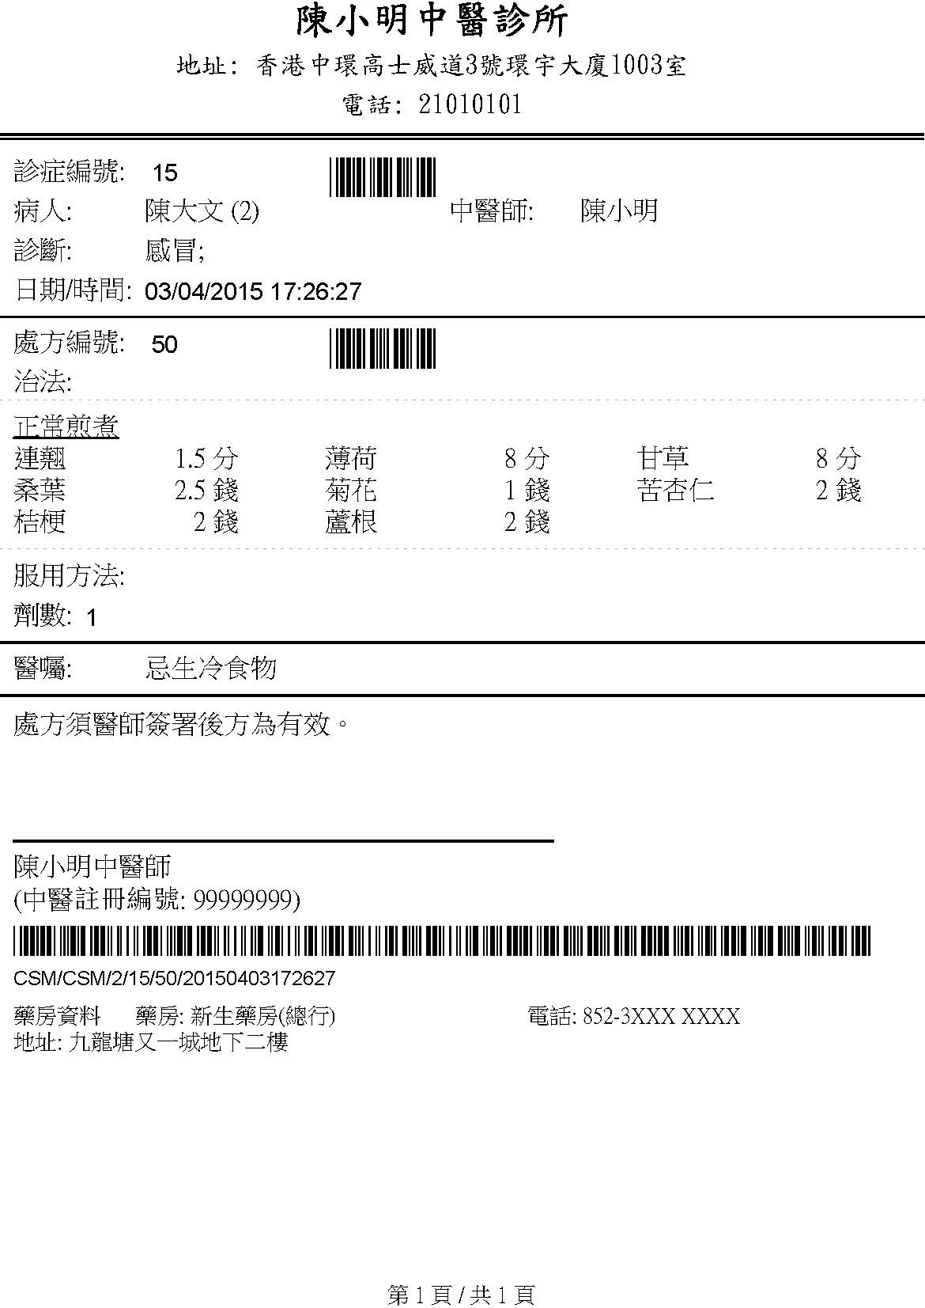

## – Consultation Certificate Sample

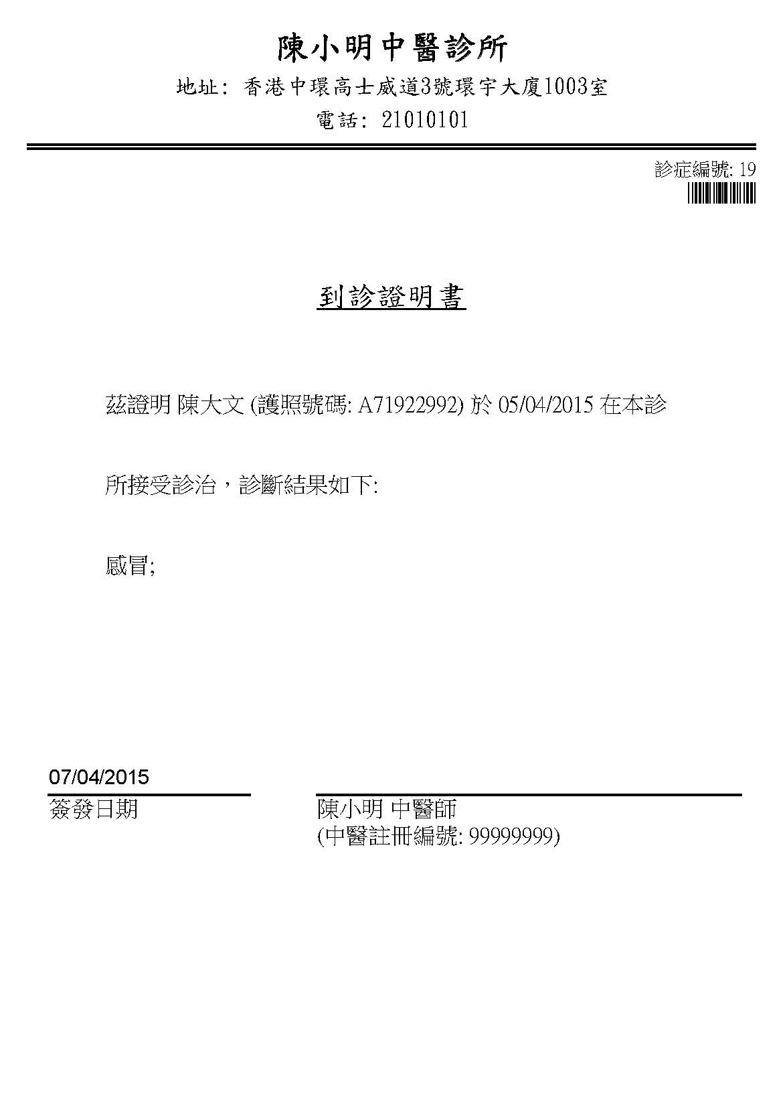

## – Sick Leave Certificate Sample

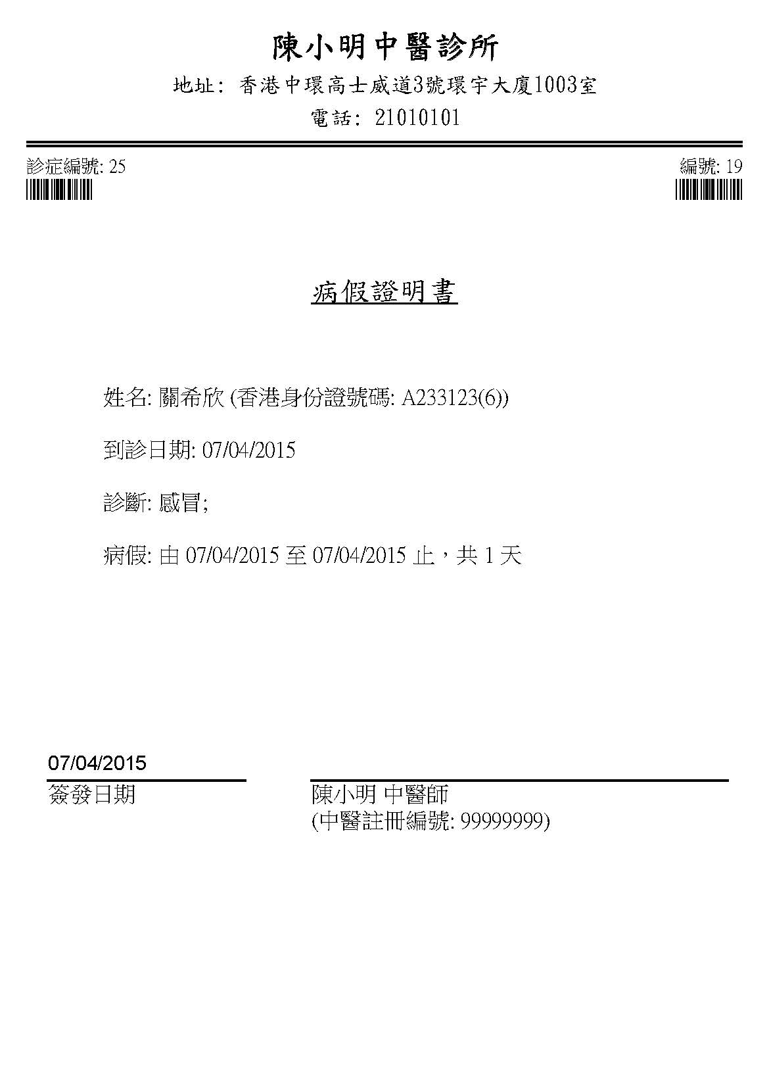

## – Pregnancy Certificate Sample

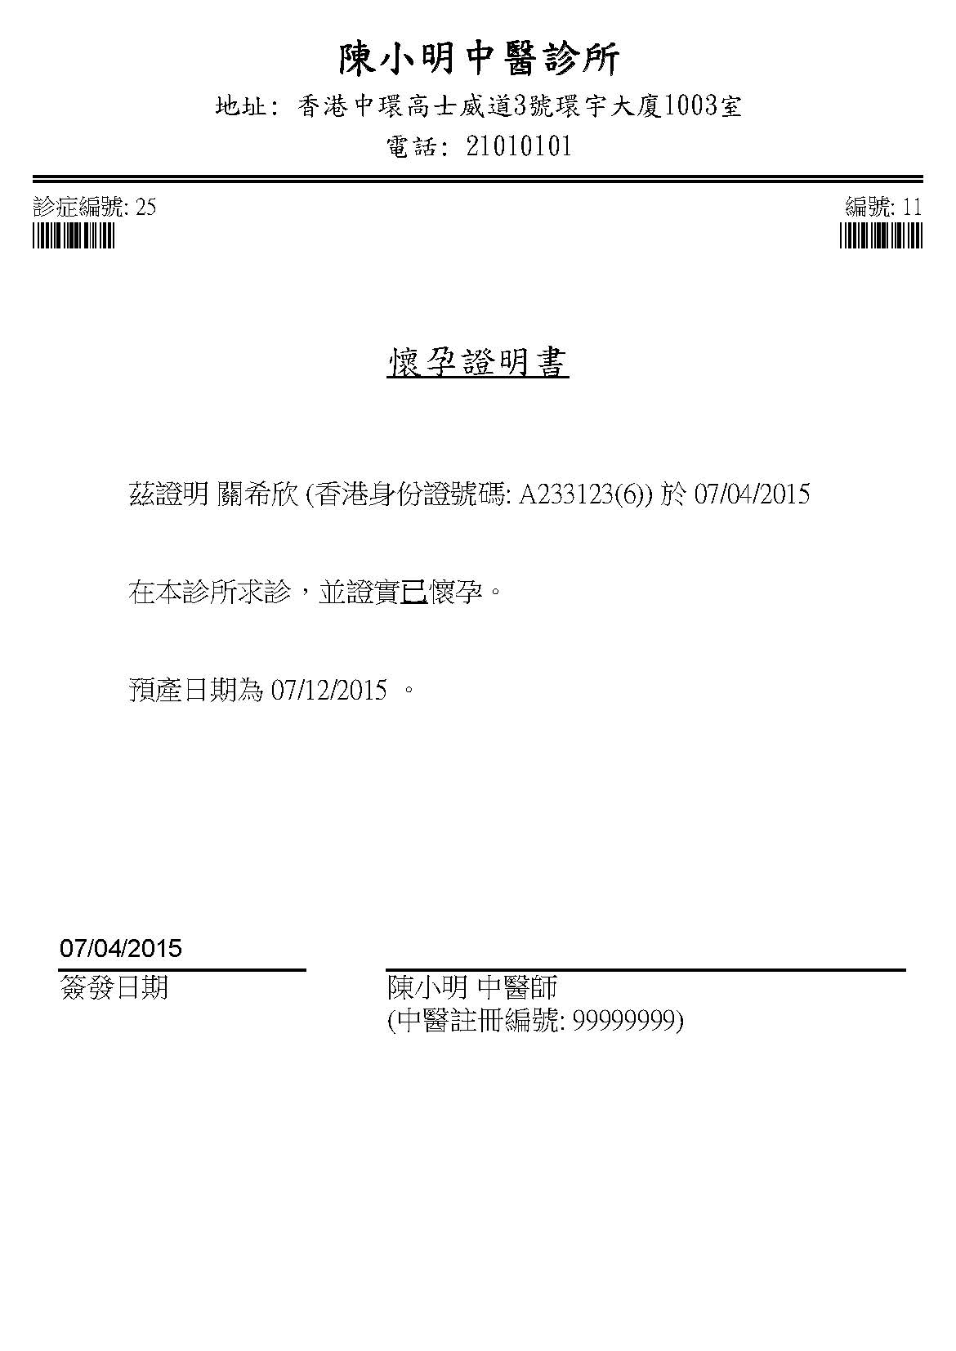

## – Medical Record Sample

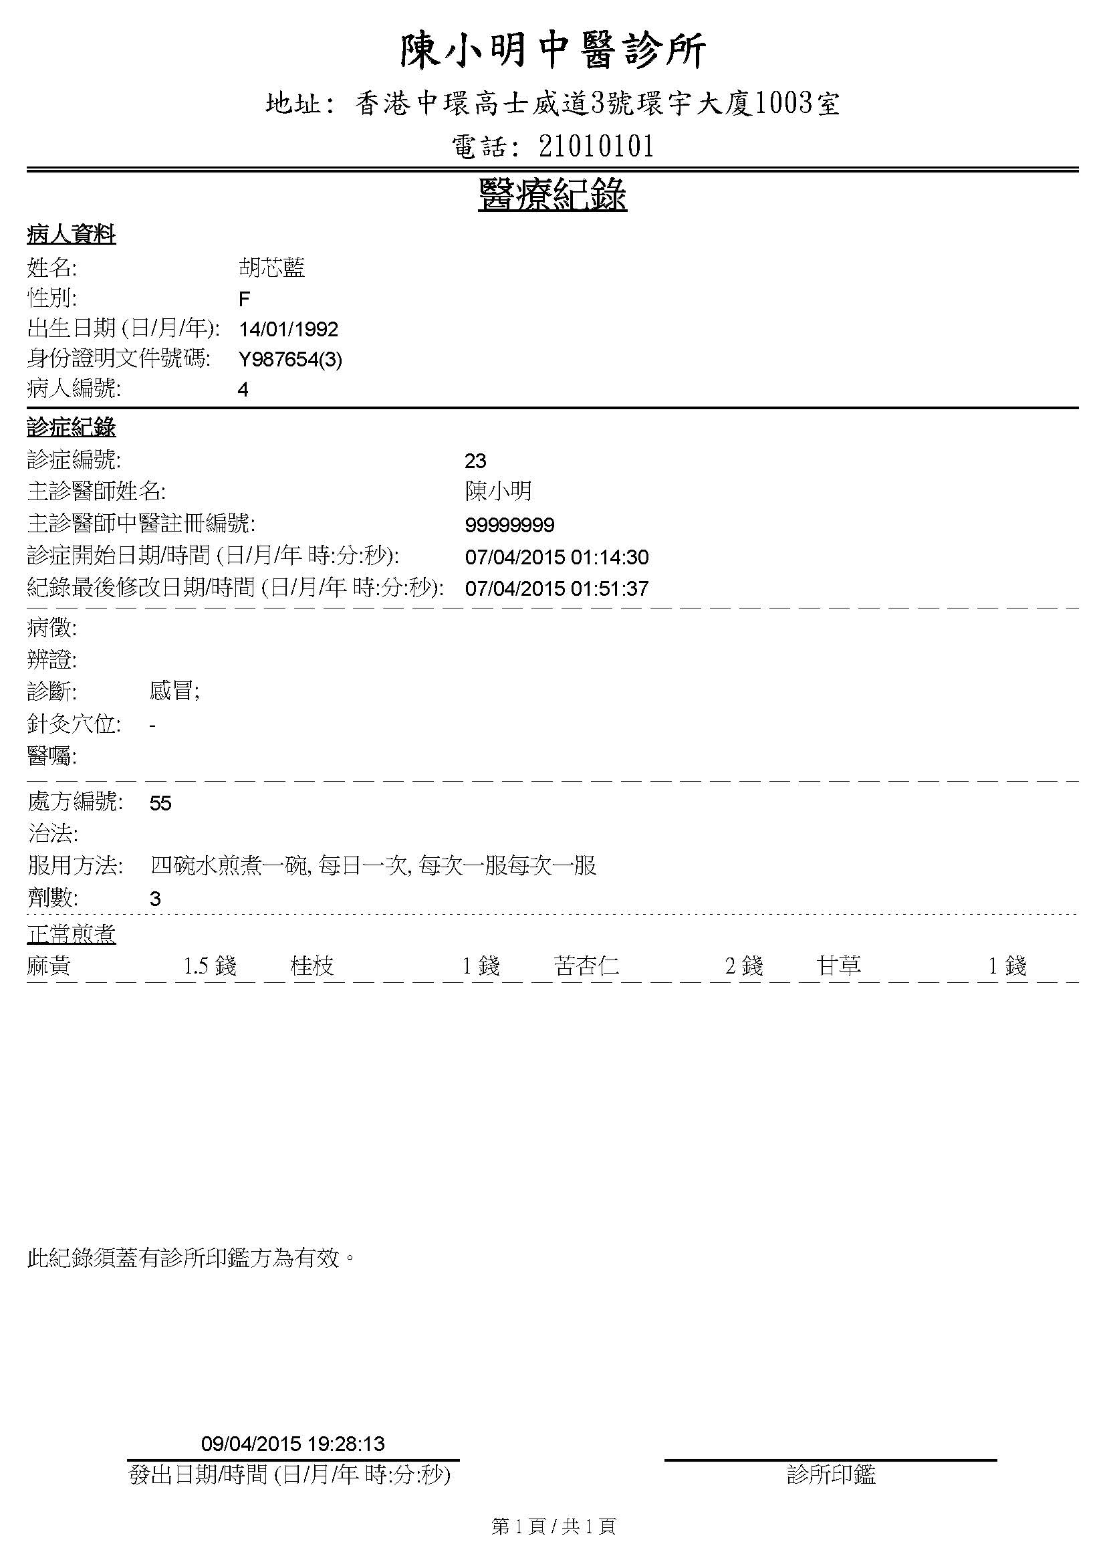

## – Consultation History Sample

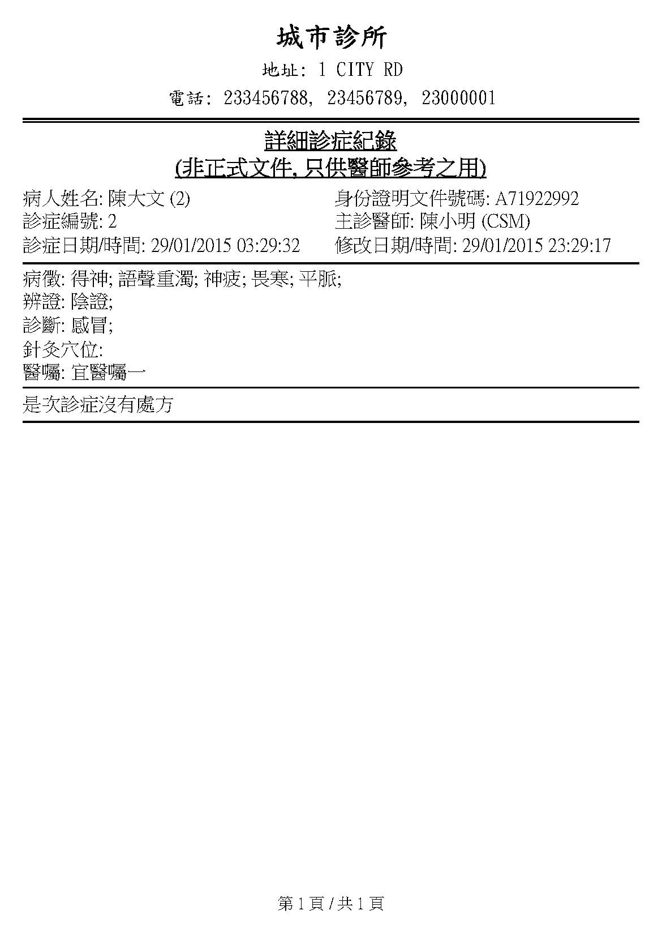

## C:\Users\TURTLE\Desktop\FYP\cmcms\etc\susPresListingDump.jpg– Suspicious Prescription Listing

## – Statistic Report of Daily Consultation in the Past 30 Days

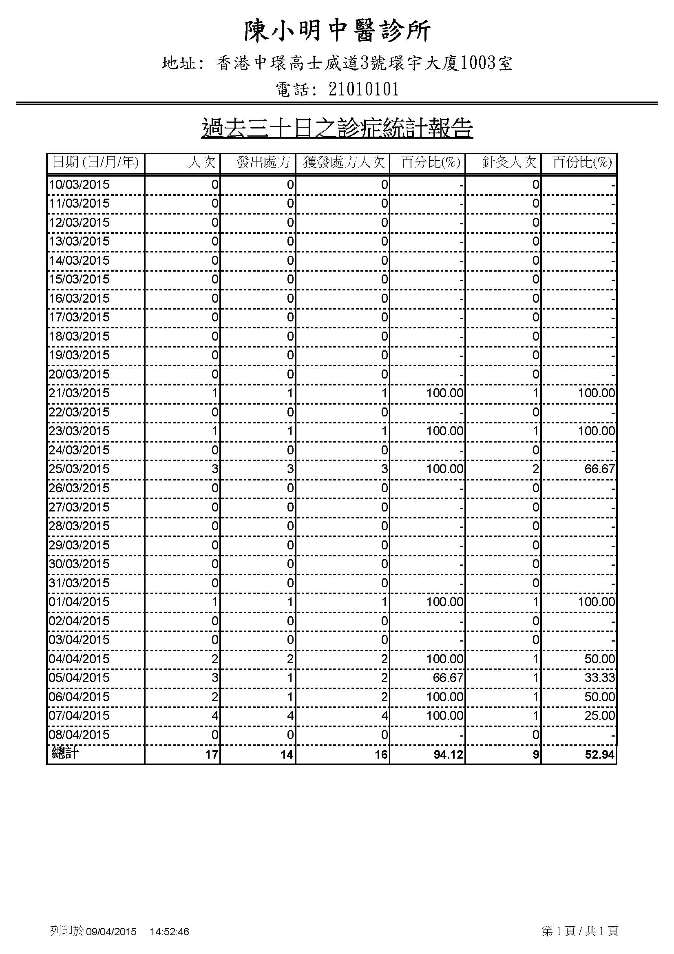

## – Diagnosis Statistics in the Past 30 Days Sample

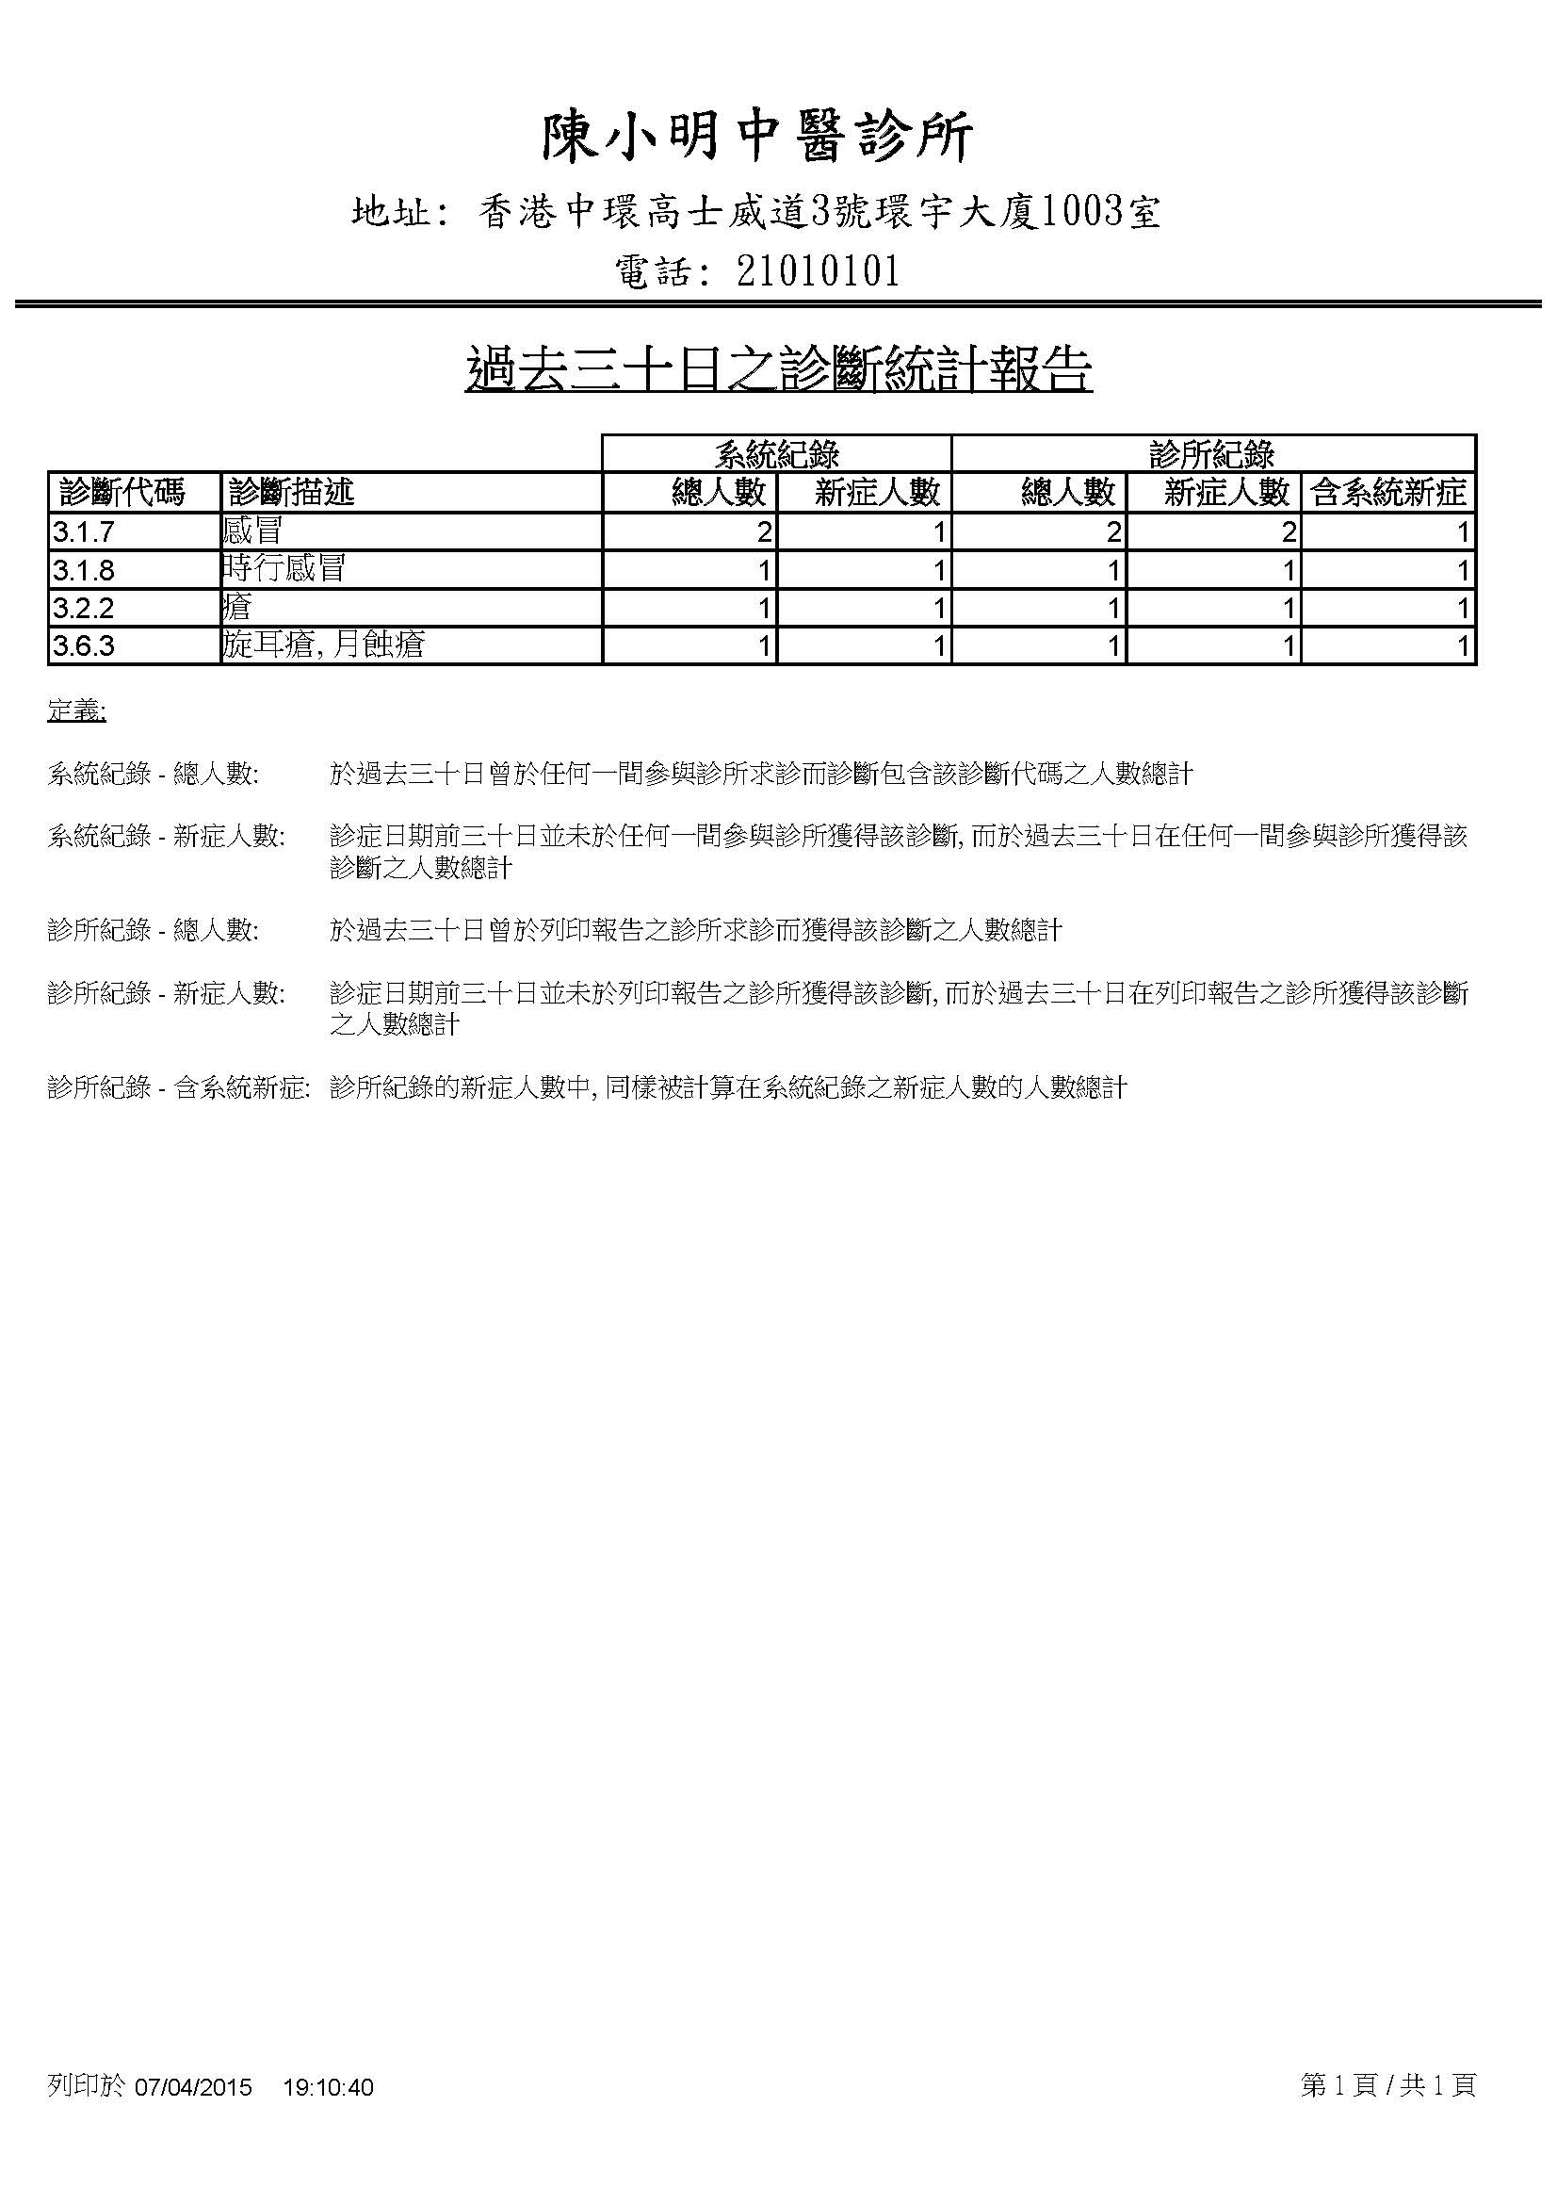

## C:\Users\TURTLE\Desktop\FYP\cmcms\etc\patListing.jpg– Patient Listing Sample

## C:\Users\TURTLE\Desktop\FYP\cmcms\etc\userListing.jpg– User Listing Sample

## C:\Users\TURTLE\Desktop\FYP\cmcms\etc\clinicListing.jpg– Clinic Listing Sample

## – Drug Listing Sample

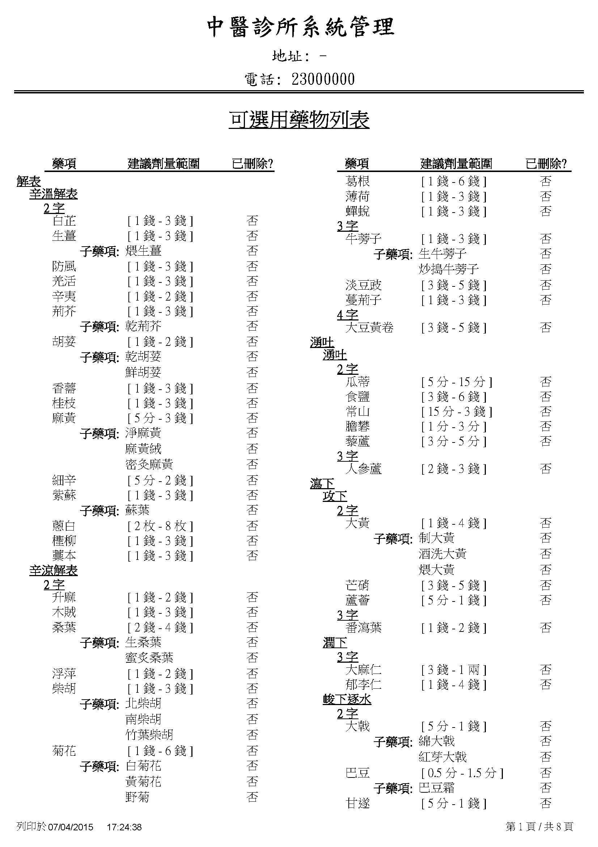

## – Questionnaire Sample

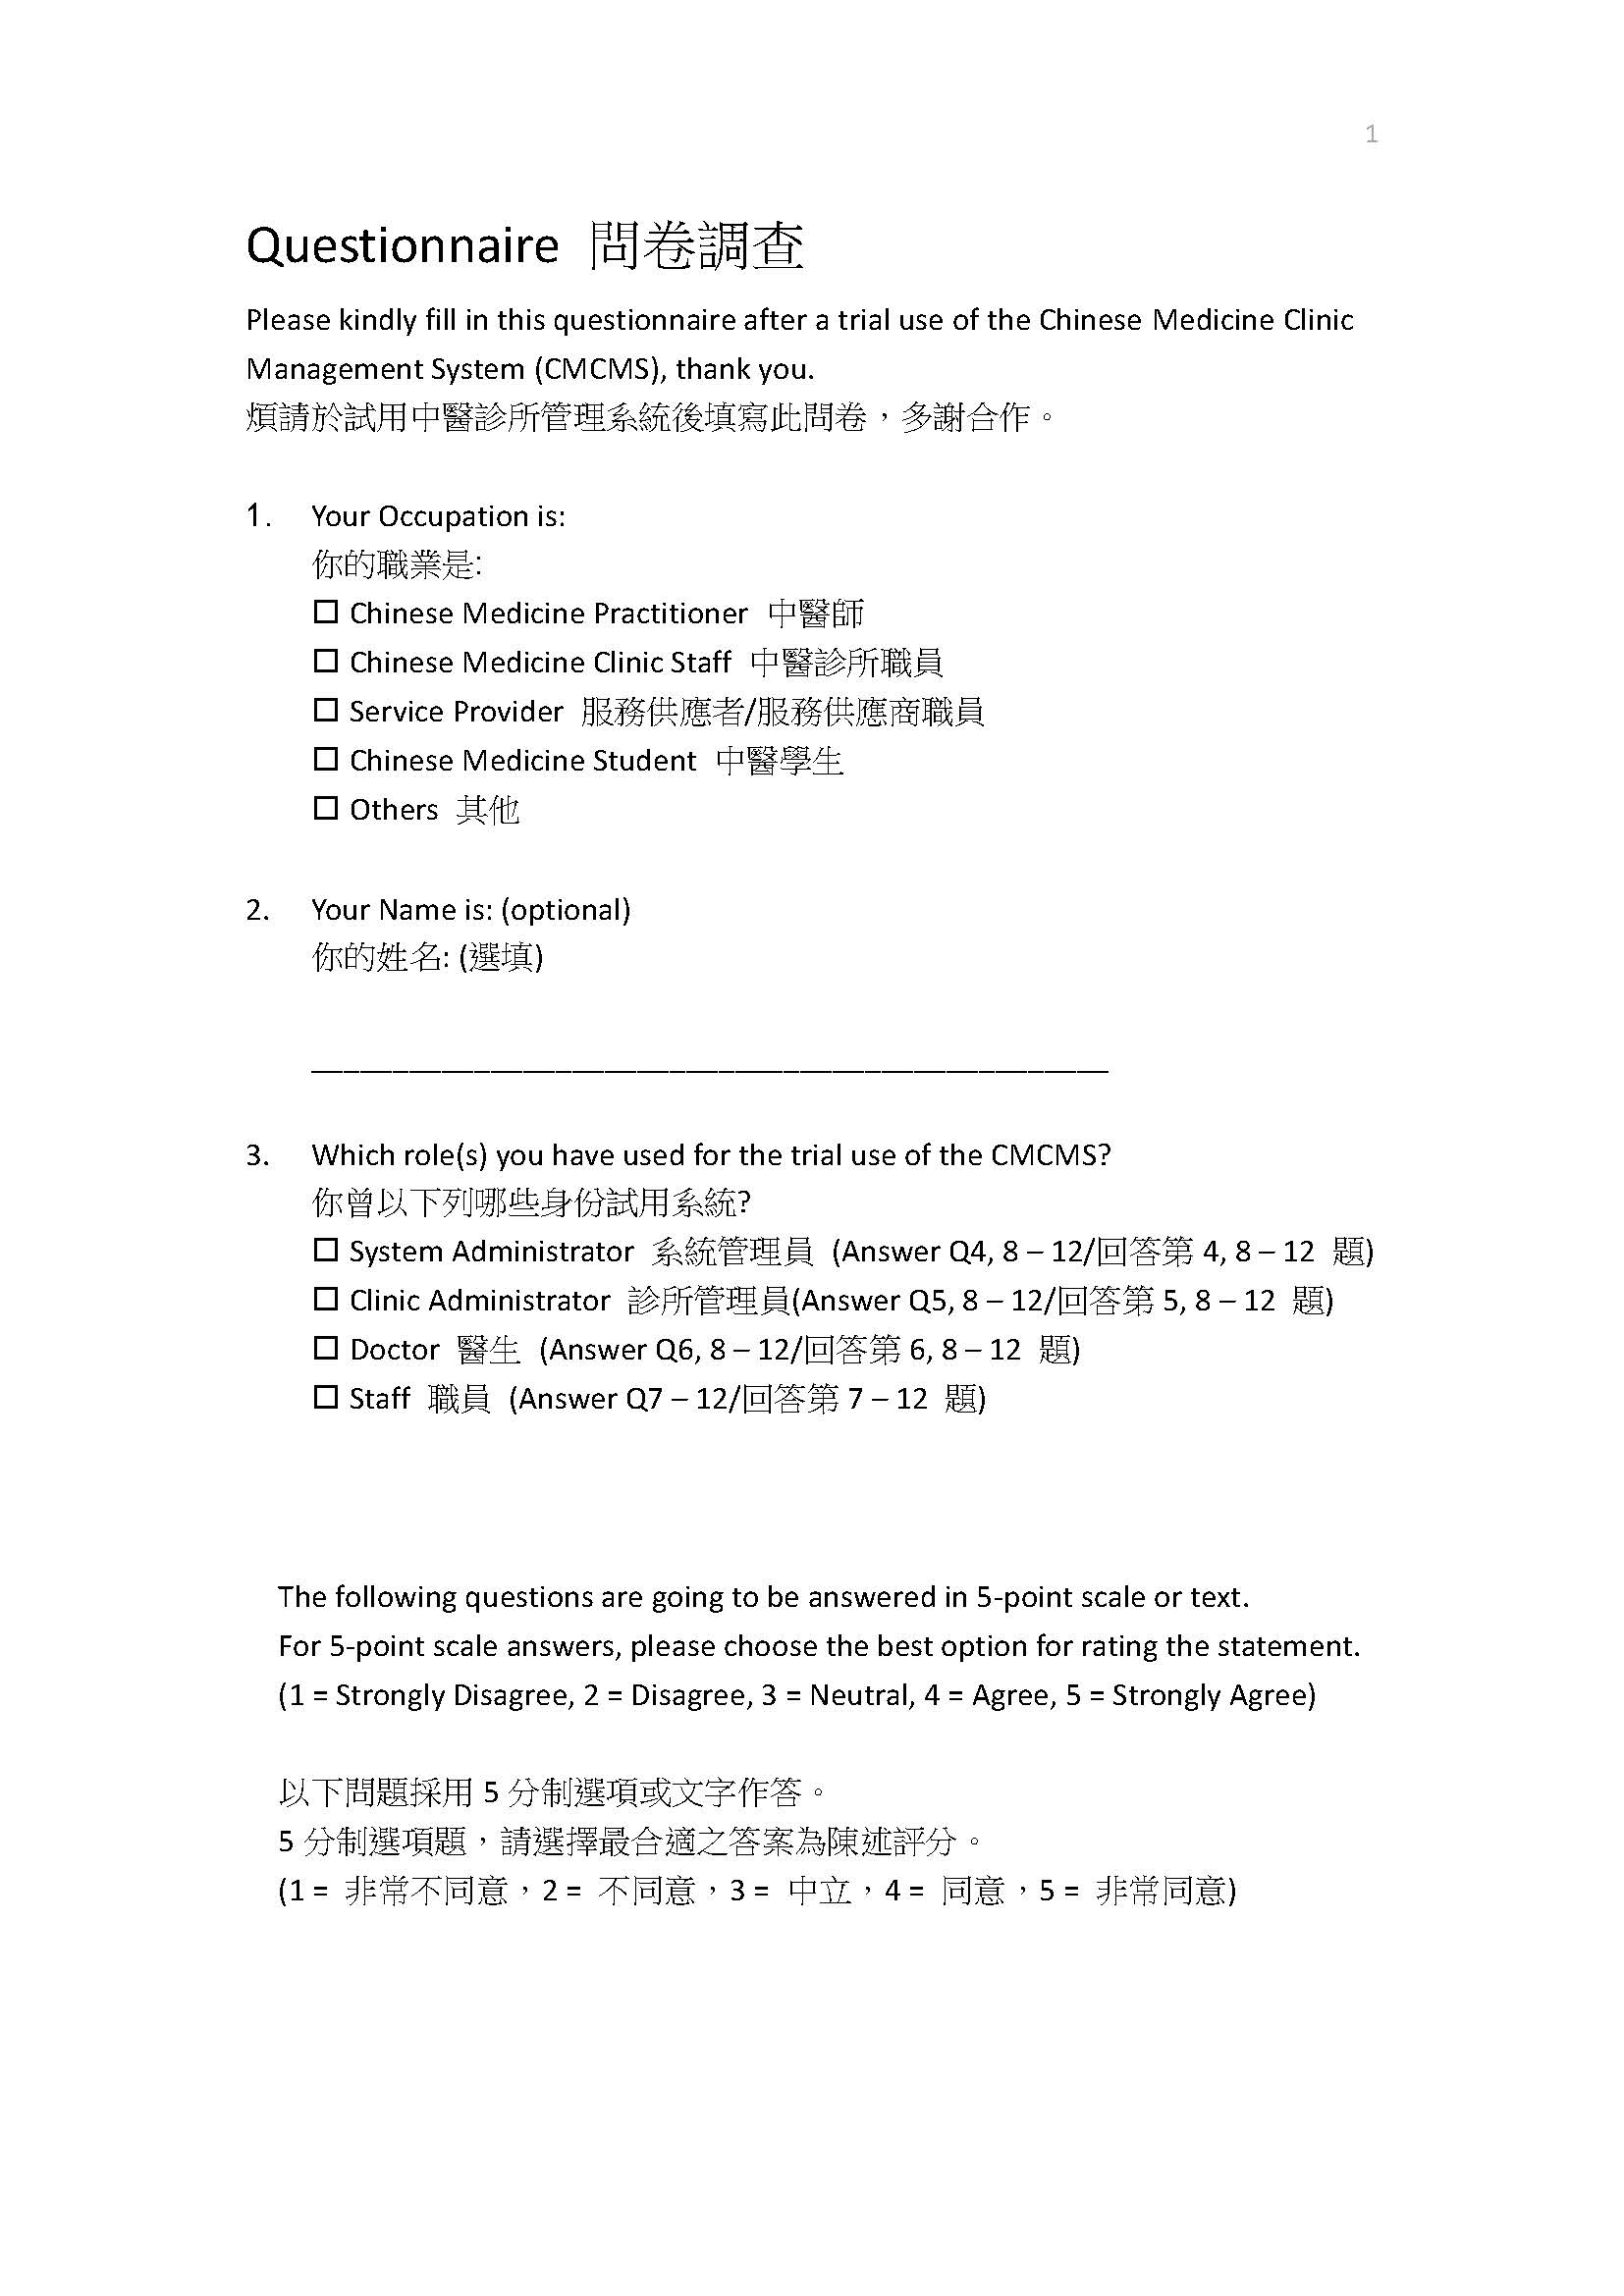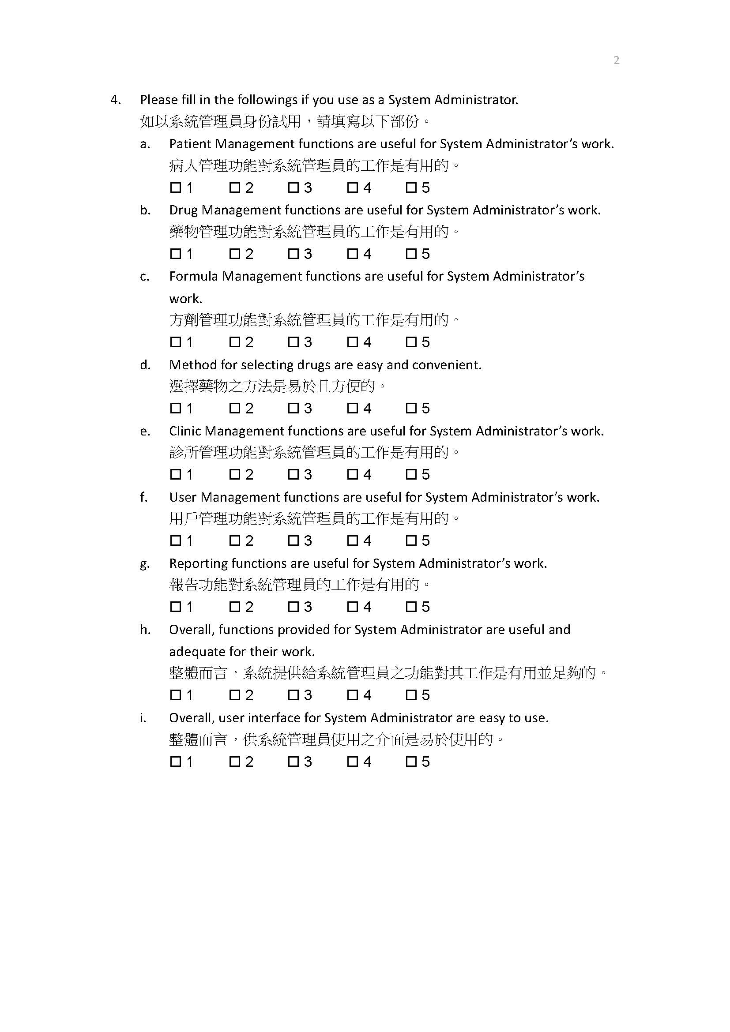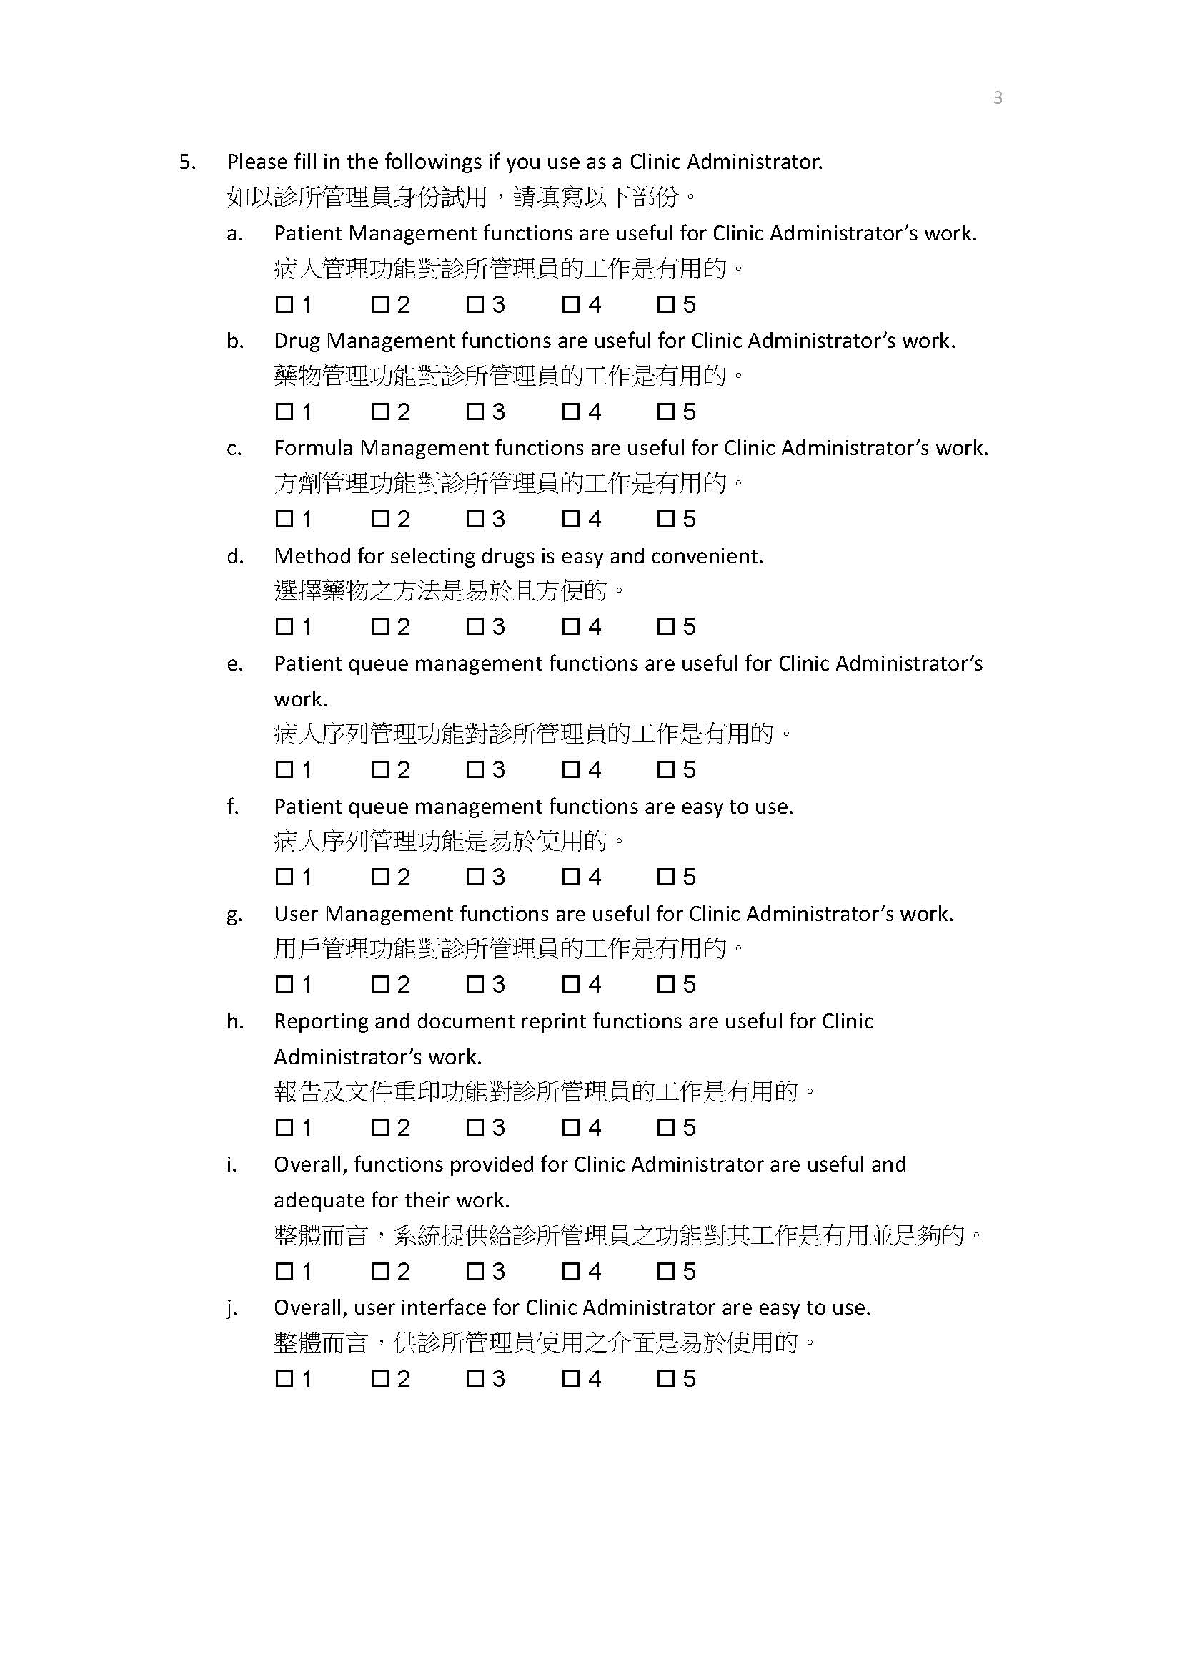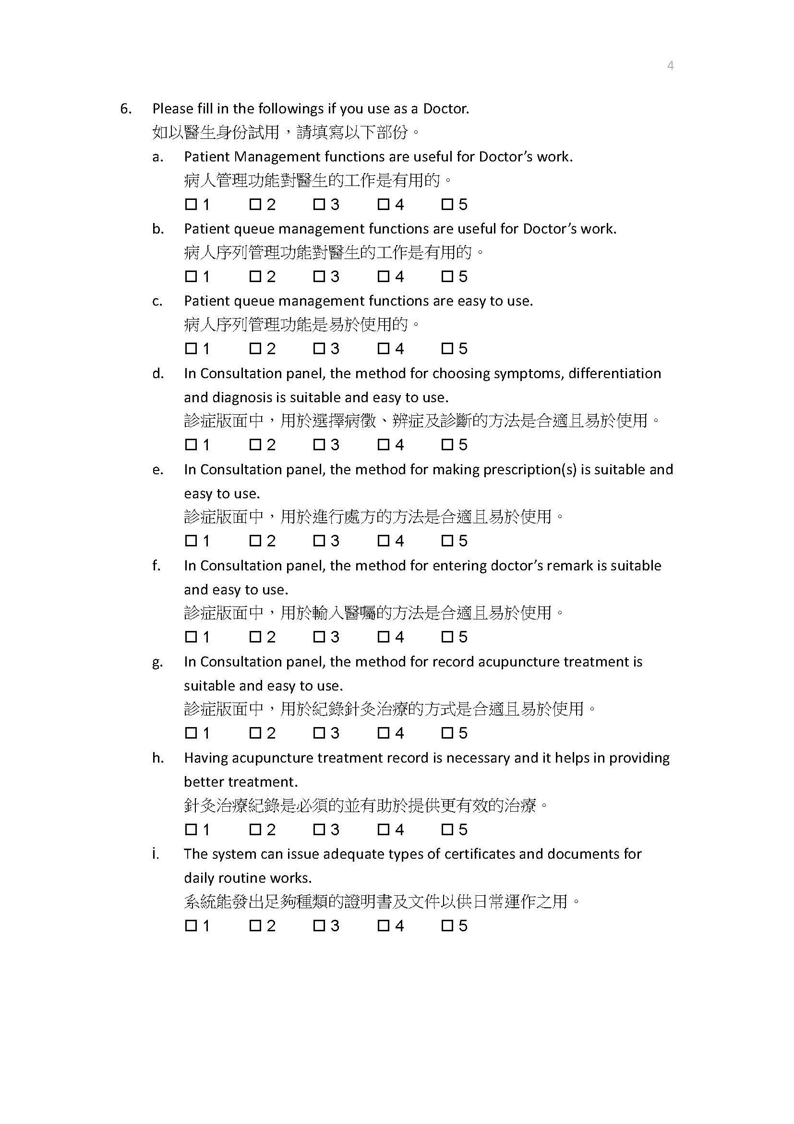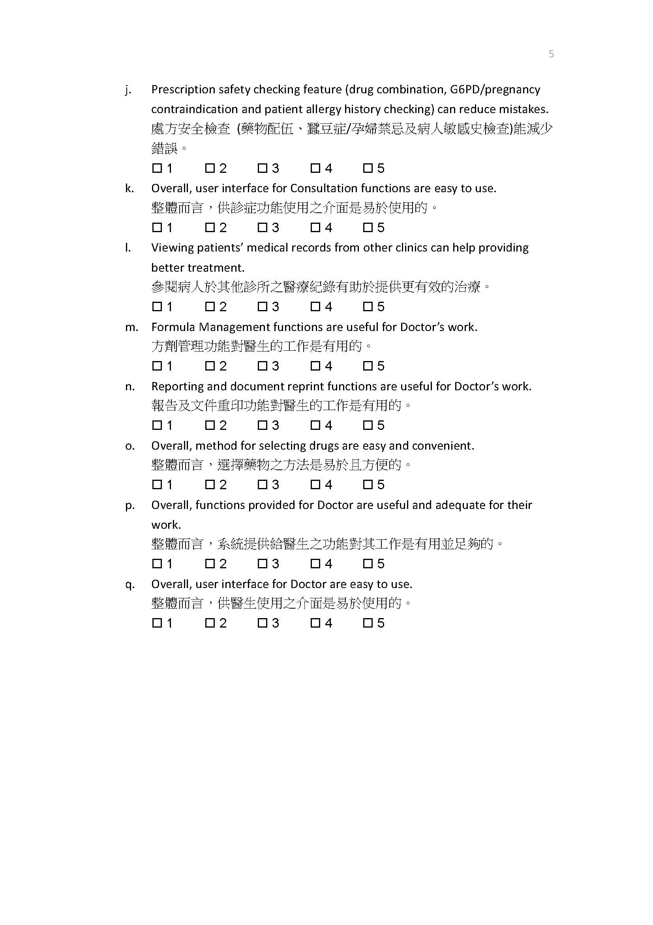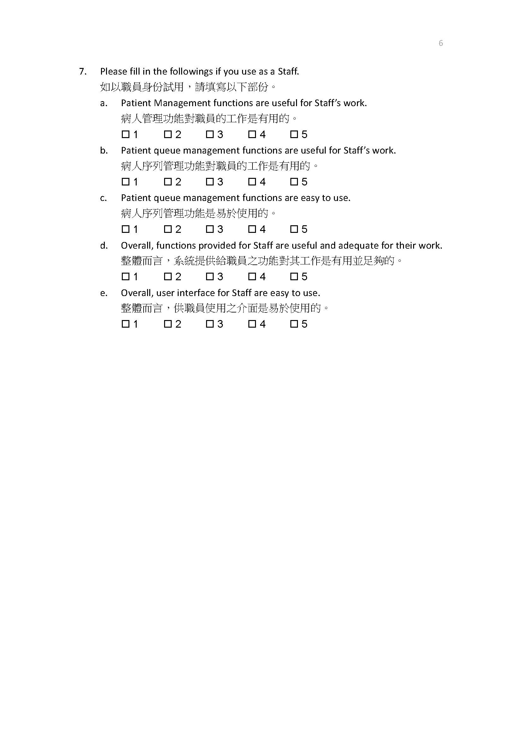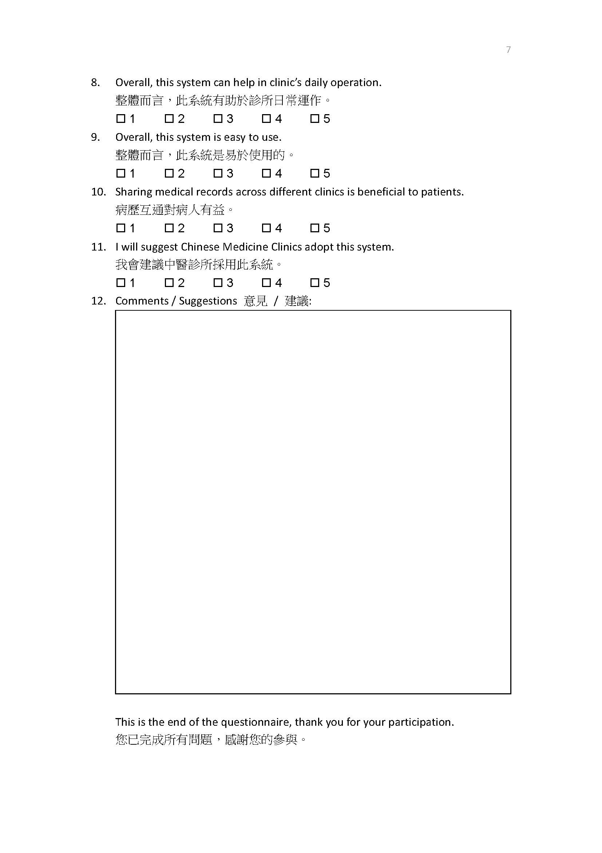

## – Questionnaire Result

| Question | Item | Average Rate (5 point scale) |
| --- | --- | --- |
| 4 | a | 4 |
|  | b | 4.25 |
|  | c | 4.25 |
|  | d | 4.25 |
|  | e | 4.25 |
|  | f | 4.25 |
|  | g | 4 |
|  | h | 4.25 |
|  | i | 3.75 |
| 5 | a | 4.25 |
|  | b | 3.75 |
|  | c | 3.75 |
|  | d | 4 |
|  | e | 4.75 |
|  | f | 4.5 |
|  | g | 4.25 |
|  | h | 4.5 |
|  | i | 4 |
|  | j | 4.25 |
| 6 | a | 4 |
|  | b | 4 |
|  | c | 4.33 |
|  | d | 5 |
|  | e | 4.33 |
|  | f | 5 |
|  | g | 4.33 |
|  | h | 4.67 |
|  | i | 5 |
| 6 | j | 4.67 |
|  | k | 4.67 |
|  | l | 4.67 |
|  | m | 4.67 |
|  | n | 5 |
|  | o | 4.33 |
|  | p | 4.33 |
|  | q | 4.33 |
| 7 | a | 5 |
|  | b | 5 |
|  | c | 4.5 |
|  | d | 5 |
|  | e | 4.75 |
| 8 | - | 4.75 |
| 9 | - | 4 |
| 10 | - | 4.75 |
| 11 | - | 4.5 |

For the question details, please refers to Appendix P.

## – Database Schema “cmcms”

